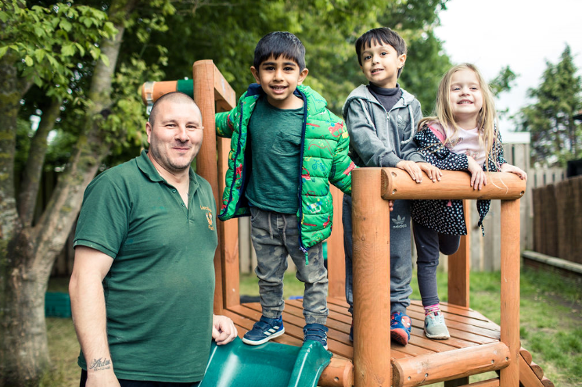 |  | Early Years and Prevention Service  - COVID-19
Recovery Planning for EArly Years and childcare providers |  | In This Issue: 9th June 2020

The Early Years Foundation Stage (EYFS) sets the standards that schools and childcare settings must meet for the learning, development and care of children from birth to 5 years old. Early years settings should use reasonable endeavours to deliver the learning and development requirements as far as possible in the current circumstances, as set out here.

The priorities at this time are helping young children to adapt to their new routines and supporting children to settle back into the setting, especially where there have been staffing changes. Continuing to support their early language and communication skills is essential. Children who have had limited opportunities for exercise should be encouraged to exert themselves physically.

Settings should use reasonable endeavours to deliver the EYFS learning and development requirements as far as possible in the current circumstances, as set out in guidance on the temporary changes to the EYFS requirements in light of coronavirus. This means continuing to provide an environment that invites learning across all 7 areas as far as is practicable during this time. Consider how stories, singing and games can be used to help children to socialise and resettle into familiar everyday routines.

Plan how children can learn in age-appropriate ways about how they can keep themselves safe, including regular handwashing and using tissues. Consider how to encourage children to learn and practise these habits through games, songs and repetition.

Consider new approaches that will need to be taken to minimise the sharing of resources between groups, for example for painting, sticking, cutting and outdoor construction activities, which should be thoroughly cleaned before and after use by different groups. Malleable resources, such as play dough, should not be shared between groups and public health advice is that, as sand pits cannot be thoroughly cleaned between uses, they should not be used at this time. Consider how resources can be used safely and in which circumstances and which items it might be more practical to remove during this time.

Plan how outdoor space, where available, can be used as much as possible. Consider how all groups of children can be given equal opportunities for outdoor learning, while ensuring outdoor equipment and toys are appropriately cleaned between being used by different groups.
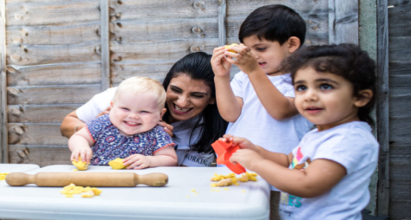

Recovery Planning

Early Years Foundation Stage
MENTAL HEALTH SUPPORT
Children and young people may be experiencing a variety of feelings in response to the COVID-19 outbreak such as anxiety, stress or low mood. It is important to understand that these are normal responses to an abnormal situation.

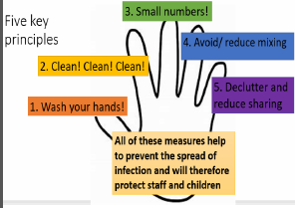
Guidance for Childcare and Educational Settings in the Management of COVID-19.
New flow chart summary from PHE South East Health Protection Team

Bursts for Learning…..

The Early Years sector has produced this guide with contributions from Children’s Centres and Maintained Nursery Schools to support you and your child during the Covid-19 lockdown period and beyond.

Learning through play The EYFS curriculum (Early Years Foundation Stage) is a play based curriculum that sets out what children must learn between the ages of birth and 5. It covers seven areas of learning; Personal, Social and Emotional Development,
Communication and Language, Physical Development, Literacy, Mathematics, Understanding the World, and Expressive Arts and Design.

The seven areas of learning fit under two main areas; the Prime Areas of Learning and the Specific Areas of Learning.

Prime Areas of Learning
• Personal, Social and Emotional Development
• Communication and Language
• Physical Development

Specific Areas of Learning
• Literacy
• Mathematics
• Understanding the World
• Expressive Arts and Design

The Prime and Specific Areas of Learning
The youngest children are expected to focus strongly on the three prime areas, which are the basis for successful learning in the four specific areas. The three prime areas reflect the key skills and capacities all children need to develop and learn effectively, and become ready for school. It is expected that the balance will shift towards a more equal focus on all areas of learning, including the four specific areas, as children grow in confidence
and ability within the three prime areas.

EYFS Bursts for Learning
In order to support learning through play, the Early Years sector have put together ‘Bursts for Learning’ that you and your child can take part in at home. These activities are set out under each area of learning, and under each age group of babies, toddlers and pre-school.

EYFS Bursts for Learning have been put together to keep you and your child on the move each day in your own time and at your
own pace. From Tummy Time, learning how to get dressed, to cooking, video clips, music, dance and Den Building, there will be something that you and your child can get stuck into daily whilst having some fun and ensuring continuity of the EYFS curriculum.

EYFS Bursts for Babies 0-12mths
Babies are born ready to learn, and their brains develop through use. So your child needs a stimulating environment with lots of
different ways to play and learn. Babies and young children learn best when they have warm, engaged and responsive relationships
with their main carers. So you have a vital role to play in helping your child learn through these early years. Your child learns best by actively engaging with their environment.
This includes:
• Observing things, watching faces and responding to voices.
• Listening to sounds, making sounds and singing.
• Exploring - for example, putting things in their mouth, shaking things and turning things around.
• Experimenting with textures, objects and materials like water, sand or dirt.
• Doing things that stimulate all of their senses - touch, taste, smell, vision and hearing.

EYFS Bursts for Toddlers 1-3 years
When your child is between 1 and 3 years old, he or she will probably be interested in everything and everyone, especially if it is new or different. They will want to be part of whatever you do. They will try to imitate you and also insist on trying to do many things by
themselves. Your toddler is very active between the ages 1 and 3. They will be using their new physical and verbal skills to explore
everything around them. As they grow, your toddler will spend less time exploring and more time playing. Some common ways that
young children explore their world are by:
• Climbing on furniture and crawling into small places.
• Playing with water, wherever they find it - in sinks, toilets, baths, fish bowls, and puddles.
• Opening cabinets and drawers, pulling out everything inside.
• Getting into purses, make-up cases, and other containers.
• Scooting away in stores to touch things on the shelves.
• Approaching other children to play.

EYFS Bursts for Pre-school 3-5 years
A child of 3-5 is considered a pre-schooler. So whether or not your child is attending a formal pre-school program, he or she is no longer a toddler! Pre-schoolers are different from toddlers in that they are developing the basic life skills, independence, and knowledge that they will need as they enter their school years. The pre-school years are an exciting time for young children. They will become more independent and begin to focus more on adults and children outside of the family. They will want to explore and ask about the things around them even more.
.

Bursts for learning
The Early Years sector has produced this guide with contributions from Children’s Centres and Maintained Nursery schools to support you and your child during the Covid-19 lockdown period and beyond. https://www.slough.gov.uk/schools-and-learning/early-years-and-childcare.aspx

H
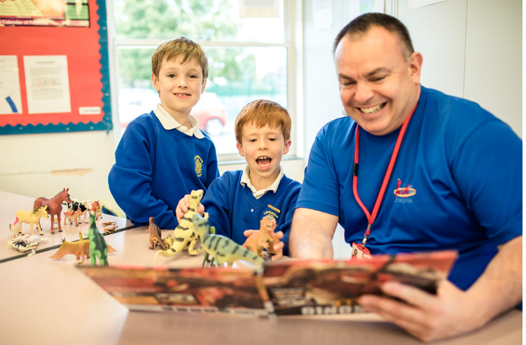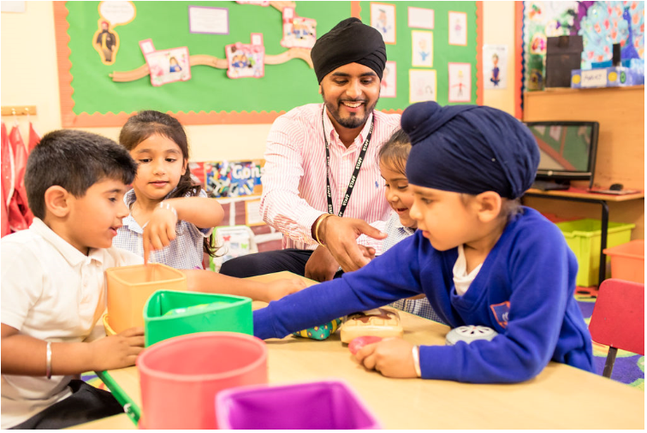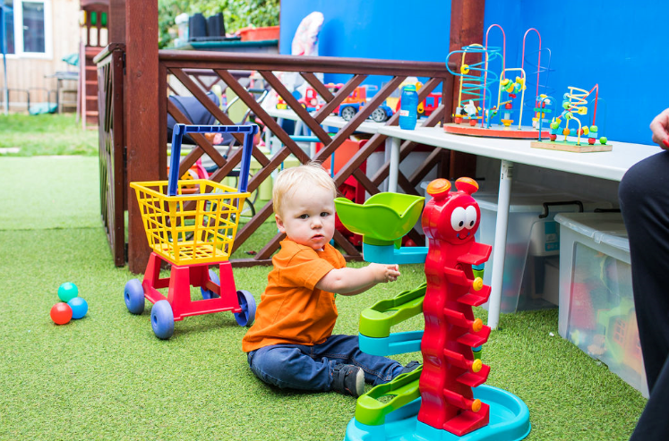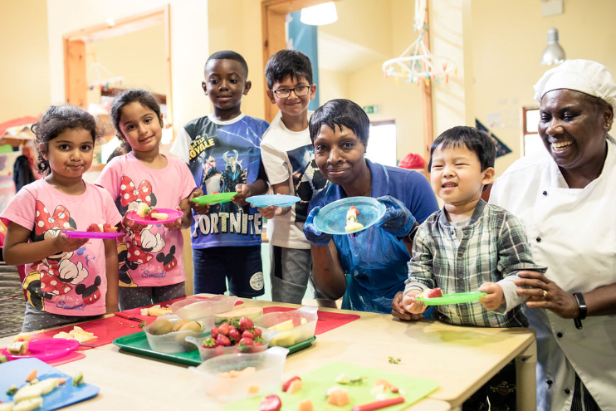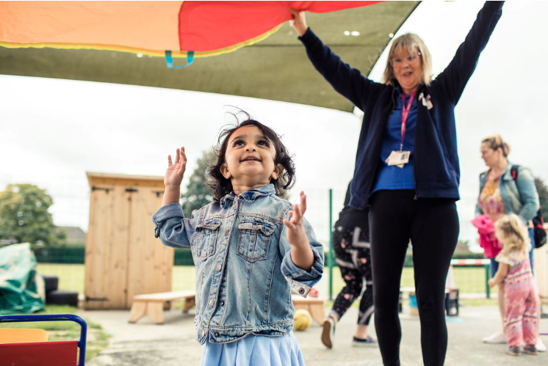

Anseri

ng your questions

Mental health support available for children and young people in England

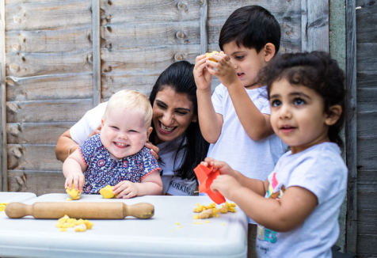
Children and young people may be experiencing a variety of feelings in response to the COVID-19 outbreak such as anxiety, stress or low mood. It is important to understand that these are normal responses to an abnormal situation. There is a large amount of mental health support available for children and young people, detailed in the table below.

Early Years
The network provides easy to read and easy to use guidance on supporting the mental health of babies, young children and their families.
The network was developed by mental health experts and shares practical and clinical expertise, and advice on using attachment-informed practice.
Links is https://www.annafreud.org/early-years/early-years-in-mind/ and sign up info is on this page.

NHS mental health services are still operating, and schools should still refer to their local NHS children and young people’s mental health service.

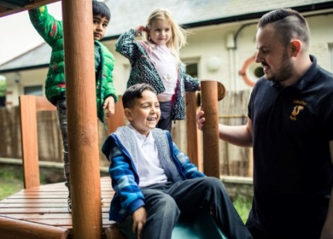
In relation to children and young people’s mental health, schools may find the following webpages useful:
- MindEd - a free educational resource for frontline staff from Health Education England on children and young people's mental health. Now includes a Coronavirus Staff Resilience Hub with materials on peer support, for managers and senior leaders, on stress and fear and trauma and bereavement. Pre-existing, bitesize content includes death and loss (for parents and carers with Easy Read PDF); loss and grief (for professionals including teachers); and trauma and coping (for parents and carers with Easy Read PDF)
- Good Thinking digital mental wellbeing resource for London, which breaks down advice for children and young people by specific groups
- Rise Above for Schools - a free website for teachers which hosts a range of mental health lesson plans suitable for Year 6, KS3 & KS4. Content is written by teachers and is accredited by the PSHE Association.
- Anna Freud Centre, particularly Mentally Healthy Schools resources and their Schools in Mind network on supporting young people’s mental health during periods of disruption.
- Place 2 Be on improving children’s mental health.
- The Childhood Bereavement Network includes content specific to COVID-19. The organisation also has a hub for professionals supporting bereaved children, with membership currently free until September.
- Local NHS mental health crisis support lines (for all ages) can be found via a simple age and postcode search here.

Schools may also wish to signpost the following resources to parents and carers:
- The Government’s online educational resources for home education with a section on mental wellbeing.
- PHE’s guidance on supporting children and young people’s mental health and wellbeing
- Virtual Oak National Academy for reception – Year 10 pupils, which offers daily online lessons, a weekly assembly with a pastoral focus and extra-curricular activities to help families maintain a routine at home (NB. intended to complement, not replace, existing schools’ online learning offers)
- BBC Education online learning content, also for reception to Year 10 pupils, to support home learning, with weekly wellbeing tips provided via their social media pages.
- The Think Ninja app has been made freely available to young people (aged 10-18 year olds) across the UK and updated with specific mental health and wellbeing content related to the pandemic.
- MindEd, Anna Freud or Place 2 Be webpages and the Starline parent helpline for home learning.
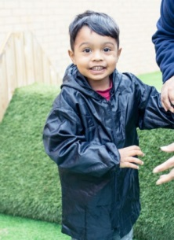
- Rise Above is a website co-created and produced by young people to help build resilience and support good mental health in those aged 10 to 16. The content has been adapted to the pandemic and includes new mental health content based on insights from young people who are learning from home.
- Every Mind Matters includes an online tool and email journey to support everyone to feel more confident in taking action to look after their mental health and wellbeing. It also includes a section for parents and carers on looking after children and young people during the pandemic.
- Children and young people who are caring for someone with a mental illness can self-refer to the NHS Volunteer Responders programme using this link if they are having issues shopping for food or picking up prescriptions.
- Children and young people can access free confidential support anytime from voluntary and community sector organisations; text SHOUT to 85258, calling Childline on 0800 1111 or the Mix on 0808 808 4994. Children and young people can also find online information on COVID-19 and mental health on the Young Minds website. For support with an eating disorder, children and young people can ring Beat’s Youthline on 0808 801 0711.
- Local mental health crisis support lines (for all ages) can be found via a simple age and postcode search here.

Additional advice and support for schools and colleges:
- Guidance for schools around remote education. Information, guidance and support is also available for parents/carers of children who are learning at home.
- The latest guidance from the department to support schools around reopening is available here. This is in addition to a planning guide for primary schools to support them as pupils return.
- The Government’s guidance for schools and colleges on keeping children and young people safe during the coronavirus (COVID-19) pandemic.

WHAT’S NEW

Thames Valley Guidance for Childcare and Educational Settings in the Management of COVID-19 - Flowchart - Version 04.06.2020
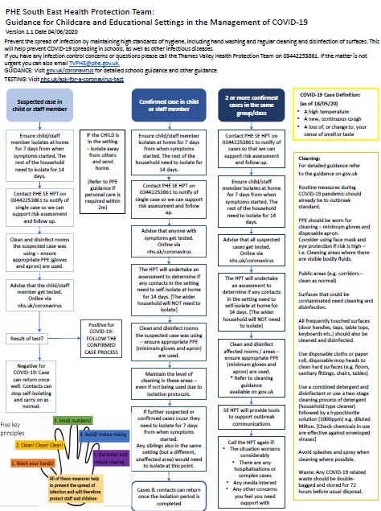
Please be aware of this new flow chart summary from PHE South East Health Protection Team:
Guidance for Childcare and Educational Settings in the Management of COVID-19. Version 1.1 Date 04/06/2020

Actions:
- Suspected Covid-19 case in child or staff member
- Confirmed Covid-19 case in child or staff member
- 2 or more confirmed cases in the same group/class

If you have any infection control concerns or questions call the Thames Valley Health Protection Team on 0344 225 3861.

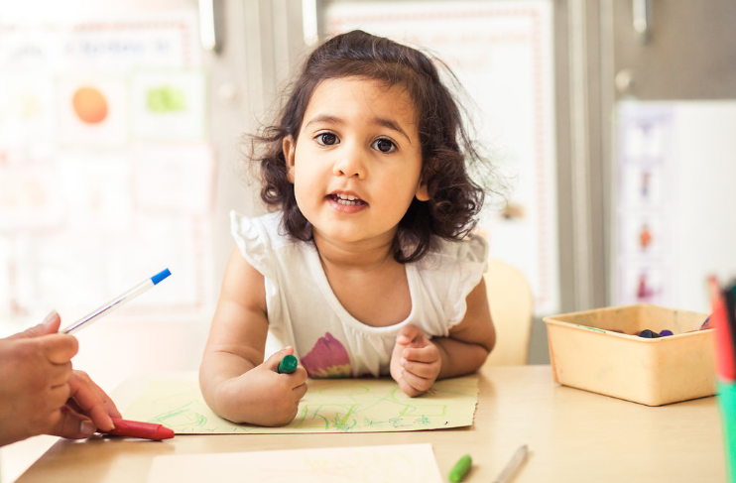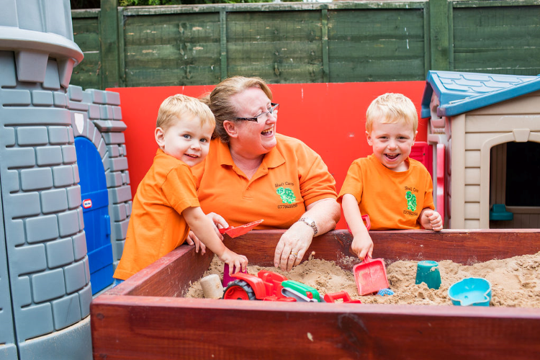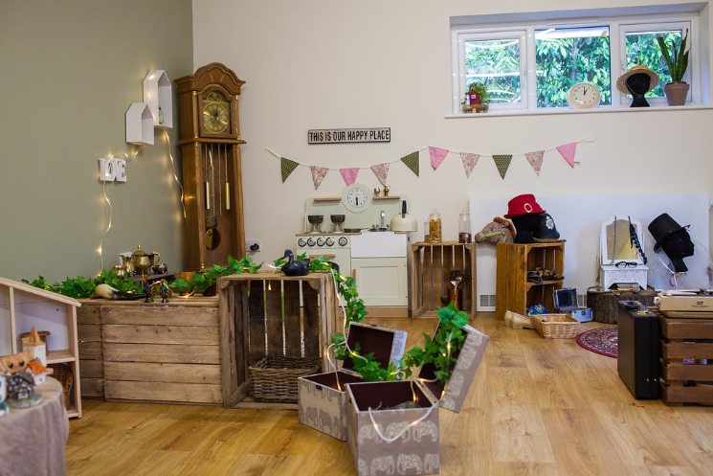

Sector Updates
The Oral Health Improvement Team
Following advice from our Infection Control Team at Oxford Health NHS Trust and Public Health England, it has been agreed that due to the Coronavirus Pandemic to suspend tooth brushing for the current time in Schools, Nurseries, Early Years Settings and Special Schools where children are in a contained area and would be tooth brushing together. This offers further protection to all those involved, both in the activity and supervision from a small risk of spray.

We have also been advised that current ‘used’ toothbrushes should be disposed of. It is advisable that all storage equipment, brush buses etc. to be thoroughly cleaned for storage and future use. New toothbrushes can be made ready (in wrapping) for use when things settle.

This is of course only a suspension for the Early Years/school settings. We would still like you to encourage your children to be brushing their teeth before they come to your settings and of course at night time before bed, and following a healthy lifestyle.

Regarding accreditation: this will not change the Accreditation Award you have at the present time. This will not affect you working towards the Silver Award or the preparation work for the Gold Award Accreditation.

When things settle and tooth brushing can be resumed in settings, we can then accredit your setting with a Gold award if your children are tooth brushing to the correct guidelines.

If you require any further training materials or would like any further information regarding our online training please contact us at Oral.Health@oxfordhealth.nhs.uk

PPE Purchasing

Further to our correspondence regarding PPE the council now has a web form for you to access rather than use the email address. You can find the web form here:

https://slough-self.achieveservice.com/service/PPE_stock_update

Study launched to monitor prevalence of coronavirus (COVID-19)
The Government has today launched a new voluntary study to assess and monitor the prevalence of coronavirus (COVID-19) among pre-school, primary and secondary school pupils and teachers.

The initial phase will collect data from up to 100 schools across England, with results available over the summer. We are working closely with the Department of Health and Social Care to identify suitable schools that may wish to be part of the initial phase of the study.
Participation from schools is on a voluntary basis, and all parents and guardians will be asked to provide informed consent prior to testing.

Further information on this study can be found here:
https://www.gov.uk/government/news/study-launched-to-monitor-prevalence-of-covid-19-in-schools

Funding available for set-up and training on digital education platforms
Funding is available to access expert technical support to get set-up on either Google’s G Suite for Education or Microsoft’s Office 365 Education.

Digital education platforms can help schools to:
• assign and assess work, providing feedback remotely
• communicate with staff, pupils and parents, using written word, voice and video
• facilitate collaboration between groups of pupils and teachers
• open up opportunities to broadcast assemblies and lessons to pupils

Schools and academy trusts can apply for funding through The Key:
https://covid19.thekeysupport.com/covid-19/deliver-remote-learning/make-tech-work-you/digital-education-platform-hub/

Government Updates

Preparing for the wider opening of schools and early years settings
Guidance on the actions for education and childcare settings to prepare for wider opening from 1 June, at the earliest, can be found here:
https://www.gov.uk/government/publications/actions-for-educational-and-childcare-settings-to-prepare-for-wider-opening-from-1-june-2020

Guidance on implementing protective measures in education and childcare settings can be found here:
https://www.gov.uk/government/publications/coronavirus-covid-19-implementing-protective-measures-in-education-and-childcare-settings

Guidance for early years providers to help them prepare to open their settings for children of all ages from 1 June can be found here:
https://www.gov.uk/government/publications/preparing-for-the-wider-opening-of-early-years-and-childcare-settings-from-1-june

Ofsted: coronavirus (COVID-19) rolling update
Ofsted guidance and information relating to coronavirus (COVID-19) for schools, early years, children's social care and further education and skills providers. Updated to note that that nannies on the voluntary part of the Childcare Register should discuss with the family they work for to see if it is appropriate to carry on working at this time. https://www.gov.uk/guidance/ofsted-coronavirus-covid-19-rolling-update?utm_source=505865a4-029c-4bcc-9c4a-e3553650c315&utm_medium=email&utm_campaign=govuk-notifications&utm_content=immediate#history

Guidance for parents and carers as schools and other education settings in England open to more children and young people can be found here:
https://www.gov.uk/government/publications/closure-of-educational-settings-information-for-parents-and-carers

LGA Early Years Reference Group - wraparound care

The current DfE line on the issue is below, and information is now with ministers for a decision. DfE colleagues are very aware of the challenges this is posing and are working hard to get something through as quickly as government processes allow.

The department acknowledges the queries being raised regarding wraparound care for children in early years and schools. The current guidance for school aged children can be found here: https://www.gov.uk/government/publications/closure-of-educational-settings-information-for-parents-and-carers/closure-of-educational-settings-information-for-parents-and-carers and the guidance for early years can be found here: https://www.gov.uk/government/publications/coronavirus-covid-19-early-years-and-childcare-closures

As education settings open to more pupils, it is crucial that we are minimising the risks to the nation’s health, and in particular the risk of a second peak that overwhelms the healthcare system. It is for this reason that we are asking schools to ensure children are kept in small consistent groups throughout the school day, and why we want to ensure children are as far as possible kept in the same consistent groups in any wraparound provision they attend. Currently the department has stated that provision can only open if it is on a school site and only for children attending the same provision / school. We are however becoming increasingly aware of some of the issues surrounding this approach, and are therefore reviewing our current position.

As soon as we have an update, we will share it with relevant stakeholders and ensure it is reflected in any COVID19 guidance.

SLOUGH EARLY YEARS AND PREVENTION SERVICE: TELEPHONE: 01753 476554 / EMAIL: earlyyears@slough.gov.uk

