# PHE South East Health Protection Team (HPT):

FLOWCHART 038C V1 18.6.2020

Call the HPT again if:

* The situation worsens

considerably

* + There are any hospitalisations or

complex cases

* Any media interest
* Any other concerns you feel you need

support with

SE HPT will provide tools to support outbreak communications

Maintain the level of cleaning in these areas – even if not being used due to isolation protocols.

Clean and disinfect affected rooms / areas – ensure appropriate PPE (minimum gloves and apron) are used.

* Refer to cleaning guidance

available on gov.uk

Guidance for Childcare and Educational Settings in the Management of COVID-19

Prevent the spread of infection by maintaining high standards of hygiene, including hand washing and regular cleaning and disinfection of surfaces. This will help prevent COVID-19 spreading in schools, as well as other infectious diseases.

If you have any infection control concerns or questions please call the Thames Valley Health Protection Team on 03442253861. If the matter is not urgent you can also email [TVPHE@phe.gov.uk.](mailto:HIOW@phe.gov.uk)

GUIDANCE: Visit gov.uk/coronavirus for detailed schools guidance and other guidance TESTING: Visit nhs.uk/ask-for-a-coronavirus-test

Contact PHE SE HPT on 03442253861 to notify of single case so we can support risk assessment and report to [healthandsafety@slough.gov.uk](mailto:healthandsafety@slough.gov.uk)

If the CHILD is in the setting

– Isolate away from others and send

home.

(Refer to PPE Flowchart 038A if personal care is required within 2m)

Ensure child/staff member isolates at home for 7 days from when symptoms started. The rest of the household need to isolate for 14 days.

Contact PHE SE HPT on 03442253861 to notify of single case so we can support risk assessment **and** email [healthandsafety@slough.gov.uk](mailto:healthandsafety@slough.gov.uk)

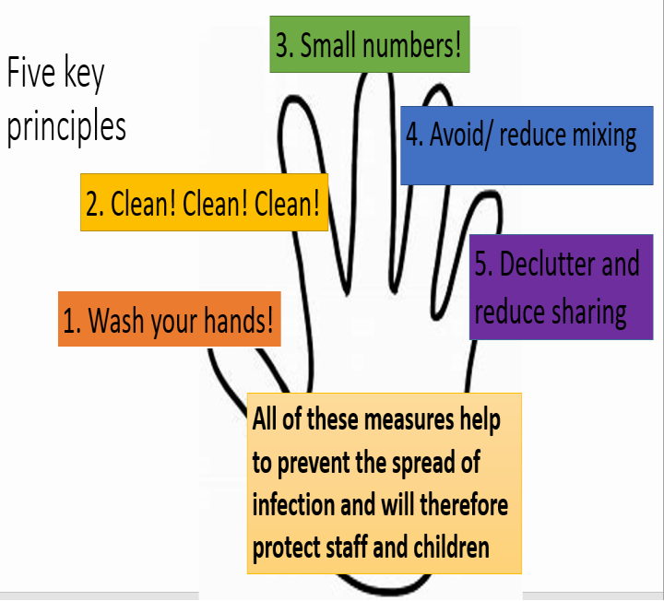

Cases & contacts can return once the isolation period is completed

If further suspected or confirmed cases occur they need to isolate for 7 days from when symptoms started.

Any siblings also in the same setting (but a different, unaffected area) would need to isolate at this point.

Negative for COVID-19: Case

can return once well. Contacts can stop self-isolating and carry on as normal.

Clean and disinfect rooms the suspected case was using

– ensure appropriate PPE (minimum gloves and apron)

are used.

Positive for COVID-19: FOLLOW THE CONFIRMED CASE PROCESS

Result of test?

Advise that the child/staff member get tested.

Online via nhs.uk/coronavirus

Clean and disinfect rooms the suspected case was using – ensure appropriate PPE (gloves and apron) are used.

**Cleaning:**

For detailed guidance refer to the guidance on gov.uk

Routine measures during COVID-19 pandemic should already be to outbreak standard.

PPE should be worn for cleaning – minimum gloves and disposable apron.

Consider using face mask and eye protection if risk is high –

i.e. Cleaning areas where there are visible bodily fluids.

Public areas (e.g. corridors –

clean as normal)

Surfaces that could be contaminated need cleaning and disinfection.

All frequently touched surfaces (door handles, taps, table tops, keyboards etc.) should also be cleaned and disinfected.

Use disposable cloths or paper roll, disposable mop heads to clean hard surfaces (e.g. floors, sanitary fittings, chairs, tables)

Use a combined detergent and disinfectant or use a two-stage cleaning process of detergent (household type cleaner) followed by a hypochlorite solution (1000ppm) e.g. diluted Milton. [Check chemicals in use are effective against enveloped viruses]

Avoid splashes and spray when cleaning where possible.

Waste: Any COVID-19 related waste should be double- bagged and stored for 72 hours before usual disposal.

Advise that all suspected cases get tested.

Online via nhs.uk/coronavirus

The HPT will undertake an assessment to determine if any contacts in the setting need to

self-isolate at home for 14 days. [The wider household will NOT need to isolate]

Contact PHE SE HPT on 03442253861 to notify of cases so that we can support risk assessment and follow up and [healthandsafety@slough.gov.uk](mailto:healthandsafety@slough.gov.uk)

Ensure child/staff member isolates at home for 7 days from when symptoms started. The rest of the household need to isolate for 14 days.

The HPT will undertake an assessment to determine if any contacts in the setting need to self-isolate at home for 14 days. [The wider household will NOT need to isolate].

Advise that anyone with symptoms get tested.

Online via nhs.uk/coronavirus

Ensure child/staff member isolates at home for 7 days from when symptoms started. The rest of the household need to isolate for 14 days.



**Suspected case in child or staff member**



**2 or more confirmed cases in the same group/class**



**Confirmed case in child or staff member**

**COVID-19 Case Definition:**

**(as of 18/05/20)**

* A high temperature
* A new, continuous cough
* A loss of, or change to, your sense of smell or taste