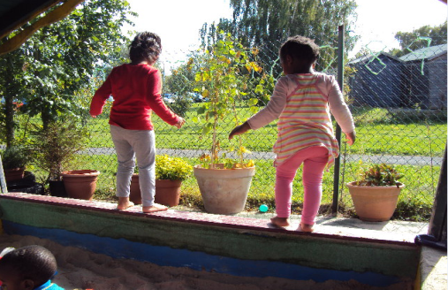 |  | Early Years and Prevention Service  - COVID-19  - 3rd June 2020
Recovery Planning for EArly Years and childcare providers |  | In This Issue: 7th July 2020
Advocates of outdoor play

The Slough Early Years sector are passionate advocates of outdoor play and recognise there is a no more important time to facilitate learning outside than today.

Outdoor learning is a wonderful opportunity for all children to experience something outside their normal routine. ‘Outdoor environments fulfil children’s basic needs for freedom, adventure, experimentation, risk-taking, and just being children.’ (Greenman,1993).

Children have spent less time outside in recent months. During the pandemic, some children have had very little time playing and learning outside. Parents may have been worried or not willing to take their children out; concerned they may become infected by the Corona virus. In a recent article by a renowned psychologist, boys have been particularly affected by the lockdown, more so than girls (Stephen Biddulph -The Times Friday April 17 2020)

Considering why we had a lockdown, being healthy is even more important. Settings and schools who work with young children in early years know how quickly bacteria and viruses can spread in these close indoor environments. We can reduce the spread of infection through lots of fresh air. ‘Outdoor play enables the infectious agents to spread out and be dissipated; it also enables children to get fresh air and exercise and be less constrained than they are in the classroom (Aronson, 2002)

Other positive reasons include:
•Natural daylight improves vitamin D production
•Daily sunlight can reduce short sightedness
•Releasing the serotonin in the brain that makes you feel good and helps with positive moods.
•Strengthening the body’s immune system.
•Helping children get a good nights sleep.
•Having a good impact on strengthening young muscle and bone.
•Improved emotional well-being, allowing children to socialise and communicate well.

The government is very clear about children being outdoors to learn and be healthy, which supports children’s emotional and physical well-being.

Settings should maximise use of private outdoor space. Childminders and early years providers may take small groups of children to outdoor public spaces, for example parks, provided that a risk assessment demonstrates that they can stay 2 metres away from other people at all times. This should be restricted to small groups and should be done in line with wider government guidelines on the number of people who can meet in outdoor public places. Providers should not take larger groups of children to public outdoor spaces at one time.

The importance of outdoor learning
The importance of outdoor learning - Advocates of outdoor play
The Slough Early Years sector are passionate advocates of outdoor play and recognise there is a no more important time to facilitate learning outside than today. Page 1
Slough Parent/Carer Information and Advice Sessions
They say a problem shared is a problem halved
In light of the current situation we have reviewed our parent drop on sessions.
Page 5

Oftsed: coronavirus (COVID-19) rolling update

Our plans for the autumn
On 17 March, all routine inspections of schools, further education, early years and social care providers were suspended. Urgent inspections where specific concerns have been raised are still going ahead. This allows us to prioritise the immediate safety of children where necessary. As far as we are able, we are continuing our important regulatory work.
We have now announced our plans for autumn. Routine inspections will remain suspended, but we are planning a programme of visits to education and social care providers.
We are in daily contact with the Department for Education (DfE) to discuss the COVID-19 outbreak and its impact across education and social care.

Inspection reports and management information
During this period, we paused publishing some reports from recent inspections. After requests from a number of schools, further education providers and early years providers to publish their reports, we wrote to all providers with unpublished inspection reports to ask whether they would like their reports to be published. We have published the reports for providers that asked for this.
We have decided to publish before the summer holidays the inspection reports that are not yet published. It is important that learners, parents and carers have access to the most recent inspection information about providers when they make decisions about their future or their children’s future. To delay publication any longer would not be in the public interest. We contacted affected providers beforehand to confirm this and are now publishing these reports.
We also continue to publish statistics and transparency information. We paused publishing some management information in April, but we will gradually re-start when additional inspection reports have been published.

Regulatory activity and urgent monitoring visits
This section applies only to:
- early years and childcare providers
- children’s social care providers that we inspect under the social care common inspection framework (SCCIF)

We have suspended all routine inspections. We continue our important regulatory work to help maintain social care (SC) provision for the most vulnerable children, and the registration of vital early years (EY) services. This includes reviewing notifications from providers and other information we receive.

We have temporarily adjusted our regulatory and inspection activity to focus on:
- provision that causes us concern
- the need to register new provision
- expansion to existing provision

We will act proportionately as an intelligent, focused and responsible regulator and inspectorate, consciously working to minimise the burdens on providers. We are focusing our work on the safeguarding and welfare of children and on identifying and addressing any major failures of leadership and management.

Although routine inspections are suspended, there may still be specific circumstances when we need to visit a children’s home or other children’s social care or childcare provider to be assured that children are not at risk of harm. We are calling these ‘urgent monitoring visits’ during this time.
You should read this guidance alongside our usual registration and compliance procedures and policies. We will follow them as far as is reasonably practicable in the circumstances.

Deciding whether regulatory action is needed
We want to ensure that decisions are made consistently and as safely as possible. Therefore, we are reviewing certain decisions through a central panel that covers both children’s social care and early years.
This applies to regional decisions about the need for any regulatory action against an early years or social care provider that may reduce capacity in the system (for example, restrictions of accommodation, refusals to register, the cancellation or suspension of any registration, and the refusal to lift a suspension)

Off-site activity
We will decide what needs to be done on or off site on a case-by-case basis, considering the lines of enquiry and the apparent level of risk.
We will carry out as much of our activity as possible off site, including when we:
- have identified a service as high risk or of concern based on information available to us
- are monitoring services that were judged inadequate
- are deciding whether to take enforcement action, such as issuing compliance or enforcement notices, suspending or cancelling a registration or restricting accommodation at a children’s home
- are checking provider’s compliance with welfare requirement notices (EY) or compliance notices (SC)
- are monitoring compliance with suspension (EY and SC) or restrictions of accommodation (SC only)
- are considering a variation request (SC only)
- are deciding whether we can lift, or should renew, suspensions (EY and SC) and restrictions of accommodation (SC only)

To carry out off-site activity, the inspector will usually contact the provider by telephone but may use email or letter.
The inspector may request that the provider shares electronically as much relevant evidence as possible to help the inspector. This evidence will vary according to the nature of the case and whether it is EY or SC, but may include:
- photographs of premises such as repairs and decoration (and/or having a tour of the building through a video call)
- safety certificates
- confirmation of building works, such as invoices
- updated policies
- updated action plans
- staffing lists to confirm that the provider has enough staff to re-open
- staff training records and/or a careful risk assessment and plan for training (including e-learning, given the current circumstances)

Urgent monitoring visits to social care providers

On-site visits to early years and childcare providers
We will only make on-site visits after we have considered evidence from off-site activity, for example if off-site activity has raised concerns and there is insufficient evidence that allows us to decide that children are safe.

Inspectors will plan the visit to ensure that they are on site for the minimum amount of time. In announced visits, they will agree in advance with the registered provider what activity they will carry out.

After any off-site activity or on-site visits
After carrying out off- or on-site activity, we will usually arrange a case review to decide what further action to take (if any). This may include a decision to go on site.

After our on-site visits or off-site activity, we may publish an outcome summary of any action we take or ask a provider to take in order to meet legal requirements at this time, if appropriate.

We will take a proportionate approach that recognises the actions a provider may need to take to provide urgent childcare for children of critical workers and vulnerable children, while keeping children safe.

Early years and childcare
All routine inspections are suspended. We have announced our plans for autumn, when we are planning a programme of visits to education providers, including early years settings.
Since 1 June, early years and childcare settings have returned to wider opening for all children, as well as vulnerable children and children of critical workers. The DfE released guidance on protective measures. It also confirmed that if childminders are not providing care for vulnerable children or children of critical workers, they can provide care for children from ‘one household’. This will help with the central government plans as more people return to work.

Letting us know if you are opening or temporarily closing
We have been working with the DfE and local authorities to find out which early years providers, including childminders, are currently open or temporarily closed. This is to help find out if there is sufficient and accessible childcare available in the coming weeks and to help support vulnerable children as best we can.

We still need further information about whether some providers are open or closed. We may contact you via email in the coming weeks to ask you about your setting and plans for the future. Please check that this email comes from an @ofsted.gov.uk address before responding as soon as you can.
If your operating circumstances do change (you open or close), notify us by sending an email to enquiries@ofsted.gov.uk with ‘Change in operating hours’ in the subject field. In the body of the email, please confirm the unique reference number for each setting and the details of the change. You can find your URN on your registration, your inspection report(s), and on your Ofsted reports page.

Registration visits
On 8 June 2020, we started to return to on-site registration visits. Individuals who have an application that is at the ‘ready for a visit’ stage will soon receive a telephone call from Ofsted to see if we can arrange a visit.

Applicants reserve the right to withdraw their application, or put their application on hold.

Fast-track application process
To support local authorities and registered early years and childcare settings, we have put in place temporary arrangements that allow us to fast-track applications and requests from existing providers only to operate provision in a different way or to set up additional premises.

Contact your local authority for further information on this.

Resigning registrations

You should tell us if you are resigning your registration. To do this, email enquiries@ofsted.gov.uk from your email address that we have on your registration and include your unique reference number (URN). You can find your URN on your registration, your inspection report(s), and on your setting’s Ofsted reports page.

First aid certificates
If your paediatric first aid certificate is due to expire, the Health and Safety Executive has announced a final deadline of 30 September 2020 for re-qualification of first aid requirements, which applies to certificates expiring on or after 16 March 2020.

The DfE has updated its guidance around early years foundation stage (EYFS) disapplications to state that providers, if asked to do so, should be able to explain why the first-aider has not been able to requalify and demonstrate what steps have taken to access the training. Employers or certificate holders must do their best to arrange requalification training at the earliest opportunity.

Regulation and inspection of early years providers as they return to providing care for all children
Since 1 June, early years and childcare settings have returned to wider opening for all children, as well as vulnerable children and children of critical workers.
At the moment, much of what we do in our role at Ofsted will stay the same, but some things will be different in order to support providers with the current context.

The early years foundation stage statutory framework requirements
The DfE has provided temporary flexibility in meeting some requirements of the early years foundation stage (EYFS) statutory framework.

This includes those around:
- ratios and qualifications of staff
- paediatric first aid certificates
- learning and development and the progress check at age 2

This temporary legislation has been passed in parliament. All other current requirements in the framework continue to apply.

The DfE expects these reduced requirements to remain in place until at least 25 September 2020. It is regularly reviewing this date.

Therefore, during this time, we will not penalise any providers if they cannot fully meet the requirements due to the current protective measures. But providers should take all reasonable steps to meet the existing learning and development requirements where possible, given the benefits to children in having a broad range of educational opportunities.

Routine inspections
Routine inspections, which report on the quality of education that children in the EYFS receive while attending an early years or childcare provider, remain suspended.

However, we continue to take action against providers and intervene when we have evidence that they are not meeting any of the other requirements that continue to apply, for example in keeping children safe and healthy. We continue to have a role in ensuring that these are met.

Information for parents of children in early years provision during this time
You can find information about Ofsted’s role in regulating childcare.

If you have concerns about your child’s early years or childcare provider, you should still try to resolve these directly with the provider in the first instance, as is the case in normal times. You should only inform us if you remain dissatisfied with the provider’s response, or if you have a serious concern about children’s safety and well-being.

During this time, your concerns may be about protective measures that the early years provider should implement. The DfE has guidance on implementing protective measures, which covers issues such as:
- social distancing
- PPE equipment for staff
- staff or children showing symptoms

As in normal circumstances, we have no power to get involved with contractual issues, such as disputes about fees and operating hours. It is up to providers how they charge for their services and the hours that children can attend for. The DfE’s frequently asked questions about funding issues may be helpful.

early years and childcare providers

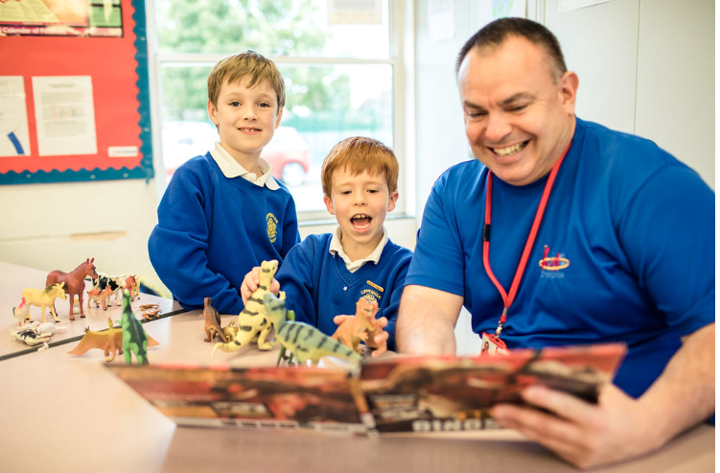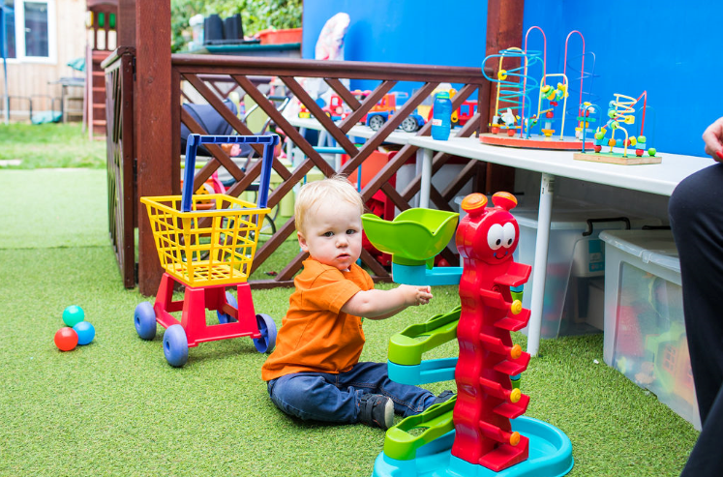

Slough Parent/Carer Information and Advice Sessions

They say a problem shared is a problem halved.
In light of the current situation we have reviewed our parent drop on sessions and would like to offer these remotely via phone calls made to you by our trained family support staff.
We can help by offering a listening ear, friendly advice, or signposting to other services in the area that may be able to help you further.

We have appointments available on the following days:
July | August
Tuesday 14 July 12.30-2.30pm  Wednesday 15 July 12.30-2.30pm  Thursday 16 July 9.30-11.30am  Tuesday 21 July 12.30-2.30pm | Tuesday 4 August 9.30-11.30am  Wednesday 5 August 9.30-11.30am  Thursday 6 August 12.30-2.30pm  Tuesday 18 August 12.30-3.30pm

If you would like to speak to someone please email your name, contact number, ages of children and a brief outline of the difficulties to Aneesa Younus at aneesa.younus@slough.gov.uk and she will book you into your preferred session date and time and someone to call you to talk through the problems you are experiencing.
Family Fund
In May the government announced that they were identifying £37.3 million of direct support in 2020 – 21 to the Family Fund for SEND children in England.
The support is partly in response to COVID 19 pandemic. Families can apply to the Family Fund for a grant for items to support their SEND child/ren such as:- washing machines, computers, educational toys and specialist equipment, there is a definitive list of what can be applied for on the Family Fund website https://www.familyfund.org.uk/Pages/Category/using-your-grant

Families can complete an application online, with a separate form for each additional child, and there is a video to support them. https://www.familyfund.org.uk/FAQs/how-do-they-apply
To make an application there is a suitability criteria, again the Family Fund have included a video to help make this information more accessible to families https://www.familyfund.org.uk/FAQs/our-disability-criteria
In summary, they are:
- A permanent resident in England, Northern Ireland, Scotland and Wales.
- Have current legal residency in the UK and have lived in the UK for 6 months, be eligible to work and apply for funds.
- A parent or carer of a disabled or seriously ill child or young person aged 17 and under who lives at home.
- Eligible for and can send evidence of one of the following: tax credits or benefits – Universal credit, Child tax credit, working tax credit, Income based jobseekers allowance, Incapacity benefit, Employment support allowance, Housing benefit, Pension credit.
- Asking for a grant related to the needs of their child, children or young person.

You can fund out more information about Family Fund here: https://www.familyfund.org.uk/
Read the government press release here: https://bit.ly/2ygnv39
CPD, Training and qualifications

Windsor Forest College
Windsor Forest College are recruiting for the following Part time course due to start in September :-

Leve1 Award in Introduction in Early Years – 11 weeks ( 1 day per week) Entry requirement E3 English

Level 2 Certificate In Supporting Teaching and Learning in Schools – 37 weeks( 1 day per week in college, 1 day in placement) Entry requirements Level 1 maths /English

Level 2 Diploma for the Early Years Practitioner – 37 weeks – ( 1 day per week in college, 1 day in placement) Entry requirements Level 1 maths /English

Higher Education courses at Windsor Forest College
We would like to introduce you to the Higher Education courses that we deliver for practitioners, teaching assistants, staff who are teaching or working with children and young people in the care and education sector.

The Foundation Degrees that we offer at our Langley campus are:

Foundation Degree in Children’s Development and Learning, through the University of Reading (suitable for anyone working with children aged between 0 – 11years).

Foundation Degree in Working with Children and Young People, through the University of West London (suitable for anyone working with children and young people aged between 0 – 25years).

These are aimed at practitioners who hold a Level 3 qualification, and who are ready for the next stage of their professional development, and the completion of the Foundation Degree can then lead to a third year ‘top-up’ to a full BA Honours Degree, either here at The Windsor Forest Colleges Group (Langley Campus), or at a University of your choice.

If you think one or more of your staff may be interested in any of these courses, could you please forward this information on to them, so that they can make enquiries with us, if they wish to further their qualifications in the children's workforce.

https://www.windsor-forest.ac.uk/

NDNA
Supporting Staff Well-being and Resilience – LVC
Strategies for nursery managers to improve the emotional intelligence and well-being of your team.
Course details
This Live Virtual Classroom training consists of 4 x 90 minute modules that will be delivered 1 module at a time. The course will be completed over a period of 2 weeks with a gap task between each module.
https://www.ndna.org.uk/NDNA/Events/Event_Display.aspx?EventKey=210720LSSW

PACEY
Are you considering a career change? Do you like working with children? Why not consider becoming a childminder?
Knowing how difficult the last few months have been, and how challenging the months ahead are going to be, we’re offering 20% off our HBCA Childminding Qualification throughout July in partnership with The Childcare Company. Don't forget, the course also comes with 3 months free PACEY membership.

Once you complete the course, you'll also be able to get a free childminders essentials pack (worth £89.99) when you sign up for your first discounted 12-month PACEY membership.
You can find out more and apply here - www.pacey.org.uk/hbca

ACEs
Introduction to Adverse Childhood Experiences - Early Trauma Online Learning
You will be able to identify adverse experiences that can impact on a child's development and their response to stress, understand the importance of healthy brain development in a child’s early years and the impacts of toxic stress, understand that experiencing adversity in childhood can have a significant impact over a person’s life course resulting in ill health, poor wellbeing and in some cases premature death. You will be able to identify a range of social and community impacts resulting from ACEs, give key examples of ‘Protective Factors’ that can help prevent ACEs and different strategies that can help build resilience. You will understand what it means to look at adverse childhood experiences through a ‘trauma informed lens’. You will understand how building resilience can help mitigate the impact of ACEs.
https://www.acesonlinelearning.com/

nsering your questions

Sand Pits: Planning guide for early years and childcare settings

Planning what children should learn and how to adapt the EYFS
The priorities at this time are helping young children to adapt to their new routines and supporting children to settle back into the setting, especially where there have been staffing changes. Continuing to support their early language and communication skills is essential. Children who have had limited opportunities for exercise should be encouraged to exert themselves physically.

Plan how children can learn in age-appropriate ways about how they can keep themselves safe, including regular handwashing and using tissues. Consider how to encourage children to learn and practise these habits through games, songs and repetition.

Consider new approaches that will need to be taken to minimise the sharing of resources between groups, for example for painting, sticking, cutting and outdoor construction activities, which should be thoroughly cleaned before and after use by different groups. Malleable resources, such as play dough, should not be shared between groups and public health advice is that, as sand pits cannot be thoroughly cleaned between uses, they should not be used at this time. Consider how resources can be used safely and in which circumstances and which items it might be more practical to remove during this time.

Plan how outdoor space, where available, can be used as much as possible. Consider how all groups of children can be given equal opportunities for outdoor learning, while ensuring outdoor equipment and toys are appropriately cleaned between being used by different groups.

https://www.gov.uk/government/publications/preparing-for-the-wider-opening-of-early-years-and-childcare-settings-from-1-june/planning-guide-for-early-years-and-childcare-settings

Water Play: Consider ‘running water’ activities, particularly outside such as water toys, sprays and individual water play such as painting with water using individual buckets and brushes or use of a small tray (one child only use) that is tipped away and disinfected between use. All resources must cleaned after individual use in line with guidance.
Use of other sensory materials should be one child use only i.e individual play dough kept in labelled bags

Sector Updates
Government Updates

Case studies on plans for schools opening to all children in autumn
United Learning has worked with a range of schools to publish some useful case studies on how they're planning to re-open in the autumn term.

These case studies draw on examples from head teachers as to how they will implement the Department’s guidance for the return to school in September.

The guidance for the full opening of schools, early years and colleges can be found here:
- Full opening of schools from the start of the autumn term
- Actions for early years and childcare providers during the coronavirus (COVID-19) outbreak
- Full opening of special schools and other specialist settings from the start of the autumn term
- What further education colleges and providers will need to do from the start of the 2020 autumn term
- What parents and carers need to know about early years providers, schools and colleges in the autumn term
- Re-opening buildings and campuses for higher education (HE)

PE and Sport Premium funding for schools
The Secretary of State for Education, Gavin Williamson, announced yesterday that schools in England will benefit from £320 million from the PE and Sport Premium during the academic year 2020-21. The PE and Sport Premium is designed to help children get an active start in life, supporting primary schools to improve the quality of their PE and sport provision so that pupils experience the benefits of regular exercise – from becoming healthier both mentally and physically, to improved behaviour and better academic achievement.
We have also confirmed that any PE and Sport Premium funding from the current academic year (2019-20) that schools were unable to use as a result of the coronavirus (COVID-19) outbreak can be brought forward to use in the next academic year, giving head teachers an opportunity to develop or add to their existing provision, or to make improvements that will benefit pupils joining the school in future years.

Covid Summer Food Fund
The Covid Summer Food Fund will enable children who are eligible for benefits-related free school meals (FSM) to be supported over the summer holiday period. All vouchers for the summer holidays must be ordered at least one week before your school’s summer term ends. The costs will be met centrally by the Department for Education.
Please read the guidance in full before ordering to ensure your orders are processed correctly.

Extension to the Breakfast Clubs programme
We confirmed on Friday that the charity coordinators of the National Breakfast Club Programme, Family Action and Magic Breakfast, will work closely with schools in disadvantaged areas so that the children most in need can continue to get a healthy breakfast in July and August.

Children from more than 1,800 schools in England who are currently part of our Breakfast Clubs programme will now be offered healthy breakfasts over the summer. The extension of the Breakfast Clubs programme will help to support families on low incomes who, as a result of the coronavirus (COVID-19) outbreak, may be finding it hard to provide healthy food for their children outside of the school term.

Changes to the law on education, health and care needs assessments and plans due to coronavirus (COVID-19)
Guidance on temporary changes to special educational needs and disability legislation during the coronavirus (COVID-19) outbreak. 6 July 2020 Guidance updated to reflect announcement on 2 July that, unless the evidence changes, we will not be issuing further national notices to modify section 42 of the Children and Families Act 2014. https://www.gov.uk/government/publications/changes-to-the-law-on-education-health-and-care-needs-assessments-and-plans-due-to-coronavirus?utm_source=ec51ee6a-d61e-43b1-a50a-f2e1442484a4&utm_medium=email&utm_campaign=govuk-notifications&utm_content=immediate#history

Pacey: NEWS: Ofsted inspections in England to fully resume from January 2021
*Updated 6 July 2020 with additional autumn term information*
Ofsted have confirmed in the latest guidance for early years settings that routine inspections for registered early years provision in England will restart from January 2021. By this time, it is expected that the EYFS will be reinstated fully. The timing of routine inspections resuming will continue to be kept under review.

While routine inspections are due to start in January 2021, Ofsted are continuing to take action against providers and intervene when there is evidence that they are not meeting any of the other requirements that continue to apply, for example in keeping children safe and healthy. Ofsted are continuing to have a role in ensuring that these are met.

As announced on the 8 June, on-site registration visits have resumed. Individuals who have an application that is at the ‘ready for a visit’ stage will receive a telephone call from Ofsted to arrange a visit.

In the autumn term, Ofsted will be gathering insight on how schools and other providers are bringing children back into formal education after such a long time away. To be able to monitor progress and regulatory standards, inspectors will commence some regulatory activity and be making visits to those who have been judged ‘inadequate’ or ‘requires improvement’ and have associated actions to fulfil as well as a wider sample. Inspectors will look at what progress leaders and managers have made to meet actions set at the last inspection and how they are improving their practice. These visits will not result in a judgement. However, Ofsted will publish a short summary to confirm what it found during the visit.
Find more support on the Coronavirus spotlight.
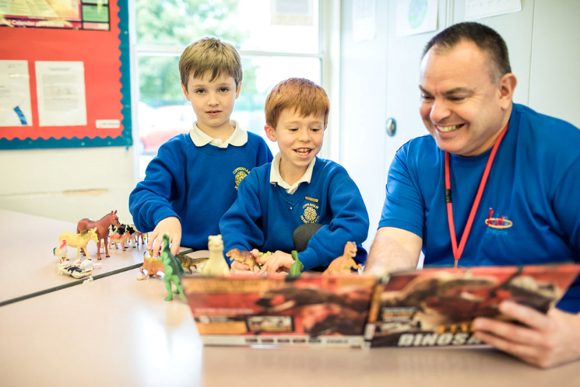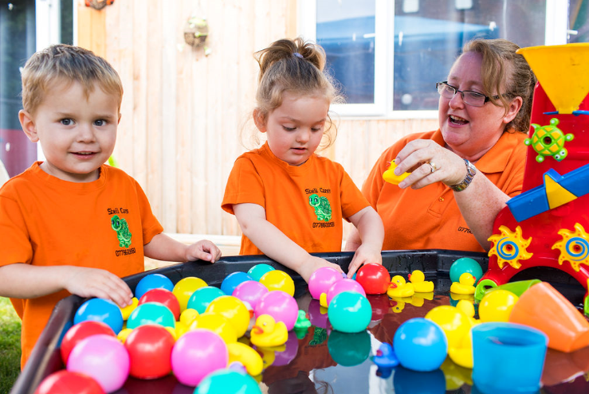
SLOUGH EARLY YEARS AND PREVENTION SERVICE: TELEPHONE: 01753 476554 / EMAIL: earlyyears@slough.gov.uk

