Early Years and Prevention Service
  - COVID-19

Recovery Planning for EArly Years and childcare providers |  | This Issue: 9th July 2020

Coronavirus (COVID-19): financial support for education, early years and children’s social care
Main changes to previous guidance
This guidance has been updated to reflect the Coronavirus Job Retention Scheme (CJRS) flexibilities that the Chancellor announced on 12 May to support employers bringing employees back to work whilst still receiving support from the scheme. The following changes or additions have also been made on 9 July 2020.
Coronavirus (COVID-19): financial support for education, early years and children’s social care
Main changes to previous guidance. Page 1 - 2

https://www.gov.uk/government/publications/coronavirus-covid-19-financial-support-for-education-early-years-and-childrens-social-care/coronavirus-covid-19-financial-support-for-education-early-years-and-childrens-social-care

Due to the variety of organisations in the education, early years and children’s social care sectors and the different types of support on offer, it may be appropriate for organisations to access a mixture of different support. However, we expect that all relevant organisations should first consider any potential options to reduce their operating cost and secure commercial loans (including CBILS, CLBILS and CCFF outlined above) before seeking to access grant paying schemes like the CJRS or seeking specific support from the Department for Education (DfE).
Early years
This section will be relevant to early years providers that are employers, and that usually have a mix of public income (largely this will be funding for the free early education entitlements, also known as ‘DSG funding’) and private income (largely this will be the fees that parents pay for childcare beyond the free entitlements).
First Aid Quality Partnership
We as the industry leaders in workplace first aid training recommend that employers consider the following aspects as part of their due diligence when choosing a first aid training provider during the CoVid19 outbreak. Page 2 - 3

Childminders are less likely to be employers, and therefore are less likely to be eligible for support via the CJRS. Childminders may find the Self Employment Income Support Scheme more relevant. Maintained nursery schools should take account of the guidance in this section. For school-based nursery provision, please refer to the ‘schools’ section below.

On 17 March 2020, the Chancellor confirmed that the government will continue to pay local authorities for free early years entitlement places for 2, 3 and 4 year olds to support providers at this time. On 18 March 2020, the government also announced a business rates holiday for many nurseries in England for the 2020 to 2021 tax year. Read the guidance.

From 1 June, early years settings have been able to open to all children. As previously, employers should only access the CJRS if necessary, and only if the conditions set out below continue to be met.

Private sector nurseries and childminders should only furlough employees, and therefore seek support through the CJRS, if they meet the following conditions:
•the employee works in an area of business where services are temporarily not required and where their salary is not covered by public funding
•the employee would otherwise be made redundant or laid off
•the employee is not involved in delivering provision that has already been funded (free entitlement funding)
•the employee is not required to deliver provision for an attending child
•the grant from the CJRS would not duplicate other public grants received, and would not lead to financial reserves being created

If it is difficult to distinguish whether staff are funded through free entitlement or private income for the purposes of meeting the first three conditions as listed above, then an early years provider can access the CJRS to cover up to the proportion of its salary bill which could be considered to have been paid for from that provider’s private income. This would typically be income received from ‘parent-paid’ hours that have not yet returned as a result of coronavirus (COVID-19),and excludes all income from the government’s free entitlements (or ‘DSG income’) for all age groups. In line with the conditions of the scheme listed above, providers should use the month of February 2020 to represent their usual income, in calculating the proportion of its salary bill eligible to be covered by the scheme, taking into account parent-paid income that has returned. Providers should adjust these proportions in subsequent furloughing applications if their income from the government’s free entitlements changes.

Investment in traineeships and apprenticeships for young people announced

Chancellor Rishi Sunak has announced that businesses will receive a cash payment for every apprentice they hire, with a payment of £2,000 per apprentice under the age of 25, and a payment of £1,500 for apprentices aged 25 and over. These payments are in addition to, where appropriate, the existing £1,000 payment made to employers who employ a 16 to 18 year old apprentice or an apprentice aged under 24 with an Education, Health and Care Plan.
Businesses offering new traineeships in England will also receive a £1,000 bonus per new trainee, with triple the number of places available.

Over £100 million is also to be invested in providing more places on level 2 and 3 courses to help 18 to 19 year olds leaving school or college to find work.

early years and childcare providers

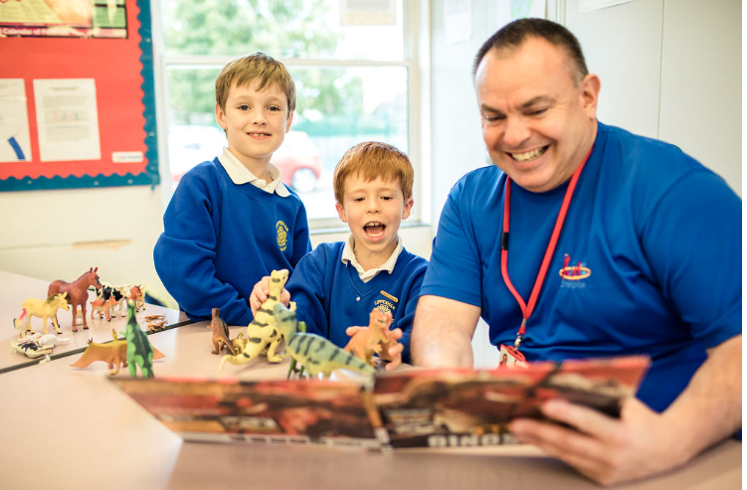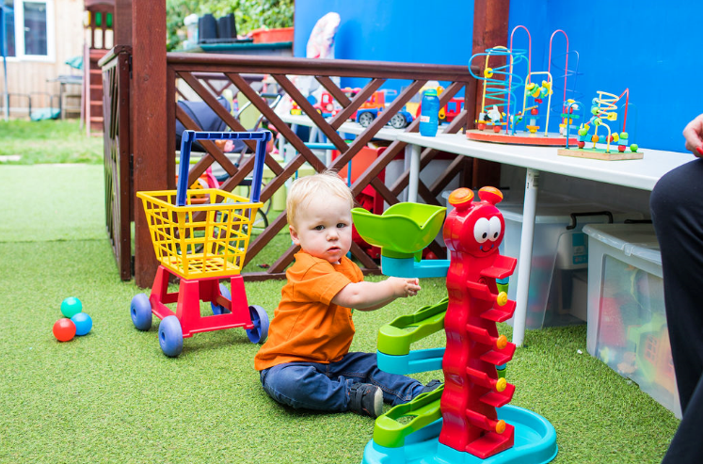

DfE webinar for Local Authority Lead Officers 9th July 20

Leaders across the EY service attended a webinar with DfE and the below notes were taken:
Key points from the DfE webinar

- The temporary modifications to the EYFS will finish on 25th September and there are currently no plans to change this, however it is reviewed on a monthly basis (this could include extending the first aid cut off date)
- DfE are proceeding with securing early adopter schools for September and will share with LA’s if they have any schools in their area who have signed up
- DfE are planning to cross reference the main tow guidance documents for early years (Actions for EY & Planning guide) to produce one piece of guidance, being published soon
- From 20th July settings are not required to have ‘bubbles’ but should consider how they can minimise contact between groups of children where appropriate
- Parents and carers should be encouraged to limit the number of settings their child attends, where possible
- DfE Data collection task is likely to continue until the end of September but this will be reviewed in September
- Routine Ofsted inspections to start in Jan 2021 and regulatory work for settings with inadequate or RI with actions to commence in the autumn term
- Holiday clubs should be run with groups of 15 children and 1 staff and groups should not be mixed, they should be operating outdoors where possible and social distancing where possible
- From 20th July Holiday clubs can operate with children from different schools
- DfE are looking to procure a contract of support for the LA and hoping to have things in place in late autumn. This is likely to be focused on take up (2 year olds, SEND) and business support for providers. There will be a universal offer (guidance and best practice support) and a targeted offer.

Funding points (Emily Arch, DfE Head of EY funding)
- DfE are talking to ministers about their proposed arrangements for autumn term funding and will publish guidance before the end of term
- Funding updates for summer will be based on January census 2020 (as usual)
- Autumn term 2020 funding is usually based on January 2021 census and this is being discussed with minister and further guidance will be publish before the end of term
- There will be no exceptional costs/funding for the EY sector (like schools got)
- MNS should be accessing the job retention scheme, something which schools can not access
- With regards to sustainability the government has offered various schemes for the sector to access such as the job retention scheme, business loans, business grants, business rates relief. DfE plan to issue further guidance on the job retention scheme specific to the EY sector relating to the current offer and the continuation until October.
- There will be a government wide spending review during the late summer and early autumn and during this they will look at the overall funding levels for EY. We will find out in the autumn what our funding will be for 2021-22
- MNS funding discussions were put on hold due to COVID but this is still a high priority on the DfE’s agenda and they are now moving back to ‘their day jobs’. Ministers recognise the importance of MNS and are continuing to ask DfE to review the long term plans for this sector. More to follow

Lots of other questions in the chat box and the DfE will produce a Q&A sheet following the webinar
- When will development matters be rewritten and published
- Should out of school settings who are on the EY register follow the ‘actions for EY’ guidance or the holiday guidance?
- Can holiday clubs offer off site activities and if so will there be a restriction on numbers in groups?
- Will parents be able to join a new provision from 1st September if they are in their grace period for 30 hours?
- Will schools be allowed to defer start dates for reception children and offer part time starts?
- Staggered September starts are starting to cause issues and parents are going to struggle with additional childcare costs. Children attending school on a rota basis is also causing issues for working parents

Delivering first aid training during the CoVid19 breakout – advice to employers
In addition to the requirements laid down by the HSE in ‘Selecting a first-aid training provider A guide for employers’ – GEIS3, we as the industry leaders in workplace first aid training recommend that employers consider the following aspects as part of their due diligence when choosing a first aid training provider during the CoVid19 outbreak.
- A training provider should risk assess their training delivery and mitigate all risks of possible spread of CoVid19.
- A training provider should design lessons to ensure that a distance of 2m is maintained between students and between the students and trainers unless close contact is absolutely necessary for teaching or assessment purposes. Sensible adaptions to training and assessment activities should be introduced to achieve this.
- A training provider should provide appropriate handwashing facilities and / or alcohol hand sanitiser as students enter and exit the training room and throughout their time in the classroom.
- Where close contact is absolutely necessary and it is teaching and assessment related to a situation where a first aider would be expected to wear PPE, PPE must be used.
- A training provider should have in place a process to discourage those with symptoms of a cold or flu attending training and preventing those who attend with either a fever or cough from entering the classroom. They should also have in place a process to manage instances of people who develop symptoms of CoVid19 during the delivery of any training
- All equipment that is used by students should be thoroughly cleaned before use by an individual student.
- The first aid taught should include protocols that ensure the safe performance of first aid during the current CoVid19 outbreak backed up by a body of medical opinion and the Resuscitation Council (UK). This must still include the teaching of rescue breaths.

New Content
Early Years Foundation Stage Forum
This month we have something interactive for you! We have created a short survey relating to your experiences over the last few months and looking to the future. Responses are anonymous and we will use them to inform our article themes and to support our public relations and marketing as well as to inform the way we develop Tapestry and the Foundation Stage Forum. We would love to hear your views. To take part in the survey please follow this link.

New on the FSF this month we have an article by Julian Grenier, Reflecting on the EYFS Curriculum. Julian is headteacher of Sheringham Nursery School and Children's Centre, which is also a Research School where practice and research meet and evolve together. He is currently working with the Department for Education on the update to Development Matters. We also have a piece by early years consultant Leslie Patterson, The 3Rs Re-imagined. Leslie shares her 3Rs, Resilience, Relationships and CReativity. Coming up in our Primary section, look out for Jack's celebration of Year 6 as they say goodbye to an unconventional final year at primary school.

Take a moment to have a quick read of our Coffee Breaks with your cuppa. There are thoughts on the back to front transitions into new year groups, settings and schools in September in All packed and ready to go?, and we take a closer look at the new educational programmes in the revised EYFS.
The education team have an array of new podcasts for you. We have been joined by Alistair Bryce Clegg to explore play and transition as children return to nursery and school; Helen Moylett to discuss inequality, children's voices and policy change; and Learning Coach and SLT member Aimee Durning and Head Teacher Dr James Biddulph share their reflections from the University of Cambridge Primary School. You can listen to our podcasts on Apple Podcasts or Spotify as well as other platforms, and remember to subscribe so you know when a new one is available.
Tapestry has added the revised Early Learning Goals as an additional Framework ('ELG 2020') for those users who are planning to be early adopters. A manager on your account can turn them on from the browser version by going to the Control Panel, Settings, then Assessments. Enabling 'ELG 2020' won't remove the current ELGs from the EYFS framework or snapshot screens. We are waiting to see what the new Development Matters will look like. For those of you getting ready to receive new children, you now have the ability to add children as 'enrolling'. These additional children don't contribute to the number of active children on your package and you can't use all the functions of Tapestry with them. You can read more about it in this tutorial. Finally for this month, you can now access accident forms outside the Care Diary. Find out about this option here.
https://eyfs.info/

Ofsted replaces Ofsted Online website
We have closed the Ofsted Online site today as replacement web pages are now fully operational.
As part of the continuing improvements and updates we’re making to Ofsted’s online systems, we’ve moved our application forms for new services and guidance over to GOV.UK closing the outdated Ofsted Online site.
Our new pages provide access to all our childcare and early years forms and our social care forms.
You can use them to:
- register with us
- tell us about changes
- report a serious incident or accident
- pay an Ofsted invoice

GOV.UK is a much easier-to-use site and this change provides a number of improvements to the service:
- the information is easier to view on your phone and the site can be used on any browser
- guidance for each form now appears on the page, rather than on a separate site
- the application forms have been updated to a step-by-step process.
- a more secure method of payment has been introduced for independent schools, childcare and social care providers to pay their Ofsted invoices

We tested the new forms and guidance with a wide range of users and listened to their feedback, which has been very positive. To help us continue to improve, please tell us what you think of the new service through links at the end of each form.
Note: As Ofsted Online is no longer available, any browser bookmarks or references to the old site will need to be updated with the new GOV.UK links.
https://www.gov.uk/government/news/ofsted-replaces-ofsted-online-website?utm_source=8c7ec354-a06e-401d-8986-da77630f36c0&utm_medium=email&utm_campaign=govuk-notifications&utm_content=immediate

Ofsted: coronavirus (COVID-19) rolling update
Ofsted guidance and information relating to coronavirus (COVID-19) for schools, early years, children's social care and further education and skills providers. Updated information for early years professionals on paediatric first aid certificates. https://www.gov.uk/guidance/ofsted-coronavirus-covid-19-rolling-update?utm_source=4dd8a07c-7c6e-46fd-b521-4398456d743c&utm_medium=email&utm_campaign=govuk-notifications&utm_content=immediate#history

Sector Updates
Government Updates

Behaviour and discipline in schools
How school leaders and staff can develop a school behaviour policy, including checklists to support full school opening following the coronavirus (COVID-19) outbreak.
Published 16 July 2013
Last updated 9 July 2020 — see all updates Added 'Checklist for school leaders to support full opening: behaviour and attendance'.
https://www.gov.uk/government/publications/behaviour-and-discipline-in-schools?utm_source=41b495de-d732-4442-a2d1-6011f9d41d94&utm_medium=email&utm_campaign=govuk-notifications&utm_content=immediate#history

Updated guidance for further education colleges and providers
We have updated our guidance on what further education colleges and providers will need to do from the start of the 2020 autumn term and confirmed that they can now make arrangements for learners aged 19+ to return to onsite delivery from 13 July, where this can be safely accommodated.
You should prioritise post-19 learners for return onsite as soon as is practical in the following priority order:
- Learners who have had their assessments delayed and were due to complete level 2 or 3 programmes between March and July 2020
- Apprentices
- Learners participating in level 1 and below learning
- Community education provision
You should assess how many learners can safely attend while observing the summer term protective measures requirements.

Plans for all children and young people to return to full-time education at the start of the autumn term
The guidance for the full opening of schools, early years and colleges at the start of the autumn can be found here:
- Full opening of schools from the start of the autumn term
- Actions for early years and childcare providers during the coronavirus (COVID-19) outbreak
- Full opening of special schools and other specialist settings from the start of the autumn term
- What further education colleges and providers will need to do from the start of the 2020 autumn term
- What parents and carers need to know about early years providers, schools and colleges in the autumn term
- Re-opening buildings and campuses for higher education (HE)

Covid Summer Food Fund
The Covid Summer Food Fund will enable children who are eligible for benefits-related free school meals (FSM) to be supported over the summer holiday period. All vouchers for the summer holidays must be ordered at least one week before your school’s summer term ends. The costs will be met centrally by the Department for Education.
Please read the guidance in full before ordering to ensure your orders are processed correctly.

Commercial guidance for sourcing PPE: DfE
The note attached signposts a number of organisations that have developed resilient supply chains throughout the Coronavirus (COVID-19) outbreak which we want to share with you for information. The note has been approved by DfE’s Commercial Director.
This information will be included in the next update of the guidance on Safe working in education, childcare and children’s social care settings, including the use of personal protective equipment, which is due to be published soon.

Education plans from September 2020
Guidance for education providers about Ofsted’s phased return to inspection. Included a new section - 'Information for local areas on special educational needs and disabilities arrangements'. https://www.gov.uk/guidance/education-plans-from-september-2020?utm_source=3273c4a8-6ef8-4e10-972c-bebba1abbdf4&utm_medium=email&utm_campaign=govuk-notifications&utm_content=immediate#history

Local lockdowns: guidance for education and childcare settings
What schools, colleges, nurseries, childminders, early years and other educational settings need to do if there's a local lockdown during the coronavirus (COVID-19) outbreak. This update confirms the circumstances in which holiday, after school clubs, and other out of school settings, can operate in Leicester, and the affected surrounding areas, during the lockdown period. https://www.gov.uk/government/publications/local-lockdowns-guidance-for-education-and-childcare-settings?utm_source=7b0066a5-86bc-4497-a073-e899bec62b38&utm_medium=email&utm_campaign=govuk-notifications&utm_content=immediate#history

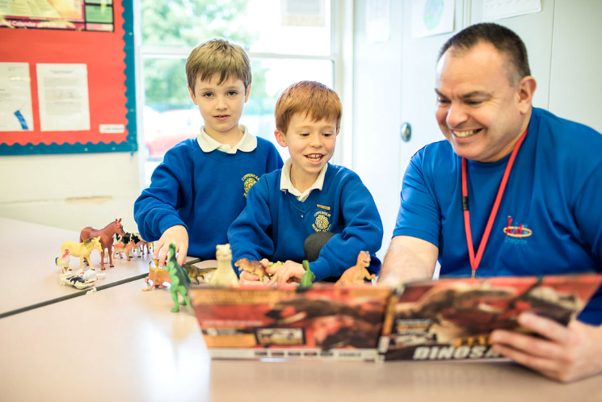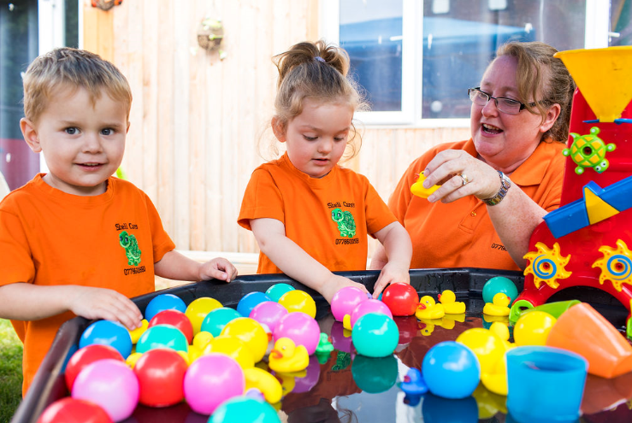
SLOUGH EARLY YEARS AND PREVENTION SERVICE: TELEPHONE: 01753 476554 / EMAIL: earlyyears@slough.gov.uk

