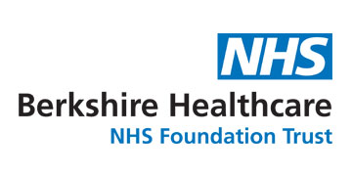
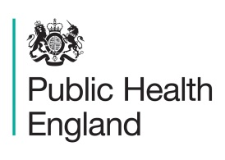

Flu immunisation uptake for XXX School and winter prepardeness 2020/21
Over the last four years, schools have provided fantastic support to the delivery of the flu vaccination programme for primary school aged children in specified year groups by hosting vaccination sessions for their children. Vaccination provides both individual protection to children who receive the vaccine and prevents the spread of flu to their family and local community, and especially to the more vulnerable members of the community.
The vaccination programme has been very successful with evidence that there has been less illness in the community with fewer GP consultations, hospital admissions, and emergency department attendances. (See appendix 1 for more information).
In the light of coronavirus, the flu vaccination season for 2020/21 is more important than ever. The NHS is planning on doubling the number of people that get vaccinated for the flu to help “protect the NHS and save lives” through reducing pressures on GP’s and hospitals when they may be dealing with an increased number of coronavirus cases.
Flu immunisation rates at primary schools have been increasing nationally and in Berkshire last year (2019/20), XX% of pupils were vaccinated. However, the uptake in Slough remains lower at XX%. We want to work with you to increase this rate in the coming winter.

What was your immunisation uptake for 2019/20?

XXX School Average uptake- XX% - XX highest in Slough (Up from XX%)

Why does the flu vaccination help XXX School?

- Helps protect children against flu which in turn may reduce pupil and staff absenteeism rates
- Promotes a healthy working environment in your school, including amongst parents and family
- The engagement in public health programmes, including vaccination, is recognised by OFSTED as being important and will help with requirement for schools to evidence they are meeting criteria pertaining to personal, social, health and economic education (PSHE)
- Provides an opportunity to integrate learning about the benefits of vaccination into the school curriculum including history and science

- Immunising more children reduces the chances of flu spreading in the community to more vulnerable residents, protecting all of us from flu
- It will help the school focus on sickness and absence from other illness or viruses

What are we asking from you for the 2020/21 flu season?

We would like to continue working with you to expand the flu vaccination programme within your school. Berkshire Health Care NHS Foundation Trust (BHFT) has a team of dedicated nurses who are funded to deliver the school based immunisation programme. They will be in contact with you in the coming weeks to arrange dates for the new academic year to carry out the vaccination process. We encourage schools to work as closely as possible with the nurses from BHFT to ensure that as many children as possible are offered the flu vaccination this year.

The flu nasal spray (Fluenz Tetra) remains the most effective vaccine to protect children and the wider community against flu. However, in order to prevent localised outbreaks this winter, an alternative vaccine in the form of an injection may be offered to those children whose parents refuse the live attenuated influenza vaccine (LAIV) due to the porcine gelatine content.
We are also ensuring that the 2020/21 immunisation programme is closely integrated with your “Active Movement” programme and their “Active Recovery” work. There will be a range of materials sent to your school which link Flu vaccinations and Active Movement, along with a bespoke homework that we would like all children to complete.

Staff/Teacher/Parent offer

We are running a bespoke immunisation and infection control training course for teachers and support staff on the 22nd September and the 21st October. Further details are enclosed.

We are also holding a similar, shorter, session for parents and carers on the 29th September. Please help us promote this session by sharing to your parents/carer groups. Further details are enclosed.
The flu vaccination itself is being expanded this year and will include:
- Adults 65 and over
- people with certain medical conditions
- pregnant women
- people living with someone who's at high risk from coronavirus (on the NHS shielded patient list)
- children aged 2 and 3 on 31 August 2020
- children in primary school
- children in year 7 (secondary school)
- frontline health or social care workers
- (Later in the year, the flu vaccine may be given to people aged 50 to 64. More information will be available later in the autumn)
Please promote the vaccine to your workforce. If you have staff that don’t fall into the above criteria for a free vaccine then please consider supporting them with accessing a vaccine at their local pharmacist. The average cost is around £8-10 at most local pharmacists.
If you need help in promoting the importance of the flu vaccination to pupils/parents/staff, need any advice or guidance, or simply have any questions then please do not hesitate to contact me directly.

For more information on the annual flu programme for primary schools please visit the following page: www.gov.uk/government/collections/annual-flu-programme or see this leaflet for more details on the school programme for next year.
Kind Regards
Timothy Howells
Senior programme officer - Public Health
Slough Borough Council
timothy.howells@slough.gov.uk / 01753 875144

Appendix 1 – Infographic on primary school vaccination success project from the 2014/2015 flu season

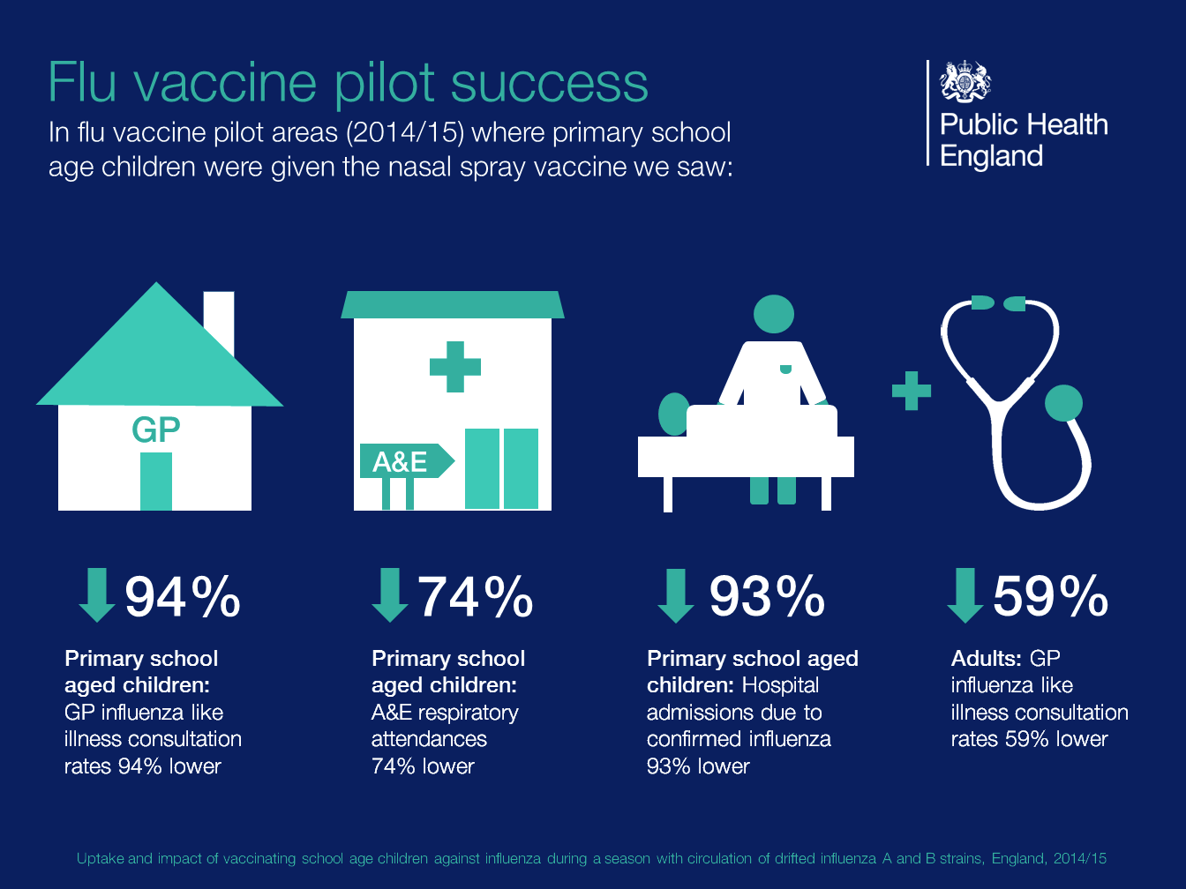

Oxford Vaccine Group. Vaccine Knowledge Project Vaccine ingredients page, gelatine section. Available at: http://vk.ovg.ox.ac.uk/vaccine-ingredients#gelatine
Public Health England. The children’s flu vaccination programme, the nasal flu vaccine Fluenz and porcine gelatine, your questions answered. Available at: https://assets.publishing.service.gov.uk/government/uploads/system/uploads/attachment_data/file/386842/2902998_PHE_FluPorcine_QAforParents_FINAL_CT.pdf

