# PHE South East Health Protection Team (HPT):

FLOWCHART 038C V3 268.2020

Call the HPT again if:

* The situation worsens

considerably

* + There are any hospitalisations or

complex cases

* Any media interest
* Any other concerns you feel you need

support with

SE HPT will provide tools to support outbreak communications

Maintain the level of cleaning in these areas – even if not being used due to isolation protocols.

Clean and disinfect affected rooms / areas – ensure appropriate PPE (minimum gloves and apron) are used.

* Refer to cleaning guidance

available on gov.uk

Guidance for Childcare and Educational Settings in the Management of COVID-19

Prevent the spread of infection by maintaining high standards of hygiene, including hand washing and regular cleaning and disinfection of surfaces. This will help prevent COVID-19 spreading in schools, as well as other infectious diseases.

If you have any infection control concerns or questions please call the Thames Valley Health Protection Team on 03442253861 (08449670083 out of hours). If the matter is not urgent you can also email [TVPHE@phe.gov.uk.](mailto:HIOW@phe.gov.uk)

**COVID-19 Case Definition:**

**(as of 18/05/20)**

* A high temperature
* A new, continuous cough
* A loss of, or change to, your sense of smell or taste

GUIDANCE: Visit gov.uk/coronavirus for detailed schools guidance and other guidance TESTING: Visit nhs.uk/ask-for-a-coronavirus-test

**School Closure**

If you think you may need o close the school contact PHE SE HPT on 03442253861 first to discuss from public health perspective.

**Cleaning:**

Refer to gov.uk (Cleaning in non healthcare settings outside the home) for detailed guidance. Routine enhanced cleaning should already be in place.

The minimum PPE for cleaning an area after a suspected or confirmed case of COVID19 has left the setting possible is disposable gloves and a disposable apron. N.B if risk assessment indicates a higher level of virus may be present e.g where someone unwell has spent the night such a boarding school dormitory, then additional PPE may be necessary – speak to your HPT for advice.

Public areas e.g. corridors –

clean as normal. All frequently touched surfaces (door hanles, taps, table tops, keyboards etc) should be disinfected and cleaned

Use disposable cloths or paper roll, disposable mop heads to clean hard surfaces (e.g. floors, sanitary fittings, chairs, tables)

Use disposable cloths/paper roll, disposable mop heads to clean hard surfaces.

Use a combined detergent and disinfectant or use a two-stage cleaning process of detergent (household type cleaner) followed by a hypochlorite solution (1000ppm) e.g. diluted Milton. [Check chemicals in use are effective against enveloped viruses]

Waste: Any COVID-19 related waste should be double- bagged and stored for 72 hours before usual disposal.

Contact PHE SE HPT on 03442253861 to notify of single case so we can support risk assessment **and** email [healthandsafety@slough.gov.uk](mailto:healthandsafety@slough.gov.uk) You do not need to send other children/staff home at this point. Await testing results for the suspected case

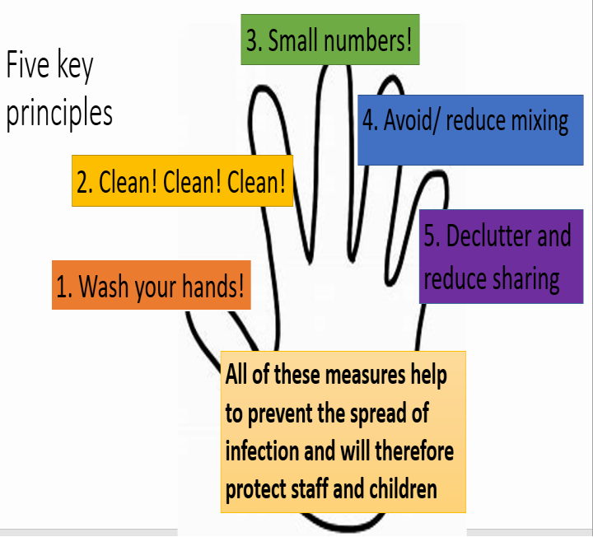

Cases & contacts can return once the isolation period is completed

If further suspected or confirmed cases occur they need to isolate for 10 days from when symptoms started.

Any siblings also in the same setting (but a different, unaffected area) would need to isolate at this point.

Negative for COVID-19: Case

can return once well. Contacts can stop self-isolating and carry on as normal.

Clean and disinfect rooms the suspected case was using

– ensure appropriate PPE (minimum gloves and apron)

are used.

Positive for COVID-19: FOLLOW THE CONFIRMED CASE PROCESS

Contact PHE SE HPT on 03442253861 to notify of single case so we can support risk assessment and follow up

Report to [healthandsafety@slough.gov.uk](mailto:healthandsafety@slough.gov.uk)

If the CHILD is in the setting

– Isolate away from others and send

home.

(Refer to PPE Flowchart 038A if personal care is required within 2m)

Ensure child/staff member isolates at home for 10 days from when symptoms started. The rest of the household need to isolate for 14 days.

Advise that the child/staff member get tested.

Online via nhs.uk/coronavirus

Clean and disinfect rooms the suspected case was using – ensure appropriate PPE (gloves and apron) are used.

Advise that all suspected cases get tested.

Online via nhs.uk/coronavirus

The HPT will undertake an assessment to determine if any contacts in the setting need to

self-isolate at home for 14 days. [The wider household will NOT need to isolate]

Contact PHE SE HPT on 03442253861 to notify of cases so that we can support risk assessment and follow up.

Notify [healthandsafety@slough.gov.uk](mailto:healthandsafety@slough.gov.uk)

Ensure child/staff member isolates at home for 10 days from when symptoms started. The rest of the household need to isolate for 14 days.

The HPT will undertake an assessment to determine if any contacts in the setting need to self-isolate at home for 14 days. [The wider household will NOT need to isolate].

Advise that anyone with symptoms get tested.

Online via nhs.uk/coronavirus

Ensure child/staff member isolates at home for 10 days from when symptoms started. The rest of the household need to isolate for 14 days.



**Suspected case in child or staff member**



**2 or more confirmed cases in the same group/class**



**Confirmed case in child or staff member**