Children and Families, Early Years Division

Weekly News Bulletin: 4th November 2020

## **New national restrictions to come into force on Thursday 5 November**

On Saturday 31 October, the Prime Minister announced [new national restrictions](https://www.gov.uk/guidance/new-national-restrictions-from-5-november?utm_source=2%20November%202020%20C19&utm_medium=Daily%20Email%20C19&utm_campaign=DfE%20C19) that will come into force on Thursday 5 November for 4 weeks until Wednesday 2 December.

We will continue to prioritise the wellbeing and long-term futures of our children and young people and will not be closing early years settings, schools, colleges or universities. It remains very important for children and young people to attend, to support their wellbeing and education and help working parents and guardians. Senior clinicians still advise that school is the best place for children to be, and so they should continue to go to school.

Until Thursday 5 November, the relevant [Local COVID Alert Level](https://www.gov.uk/guidance/local-covid-alert-levels-what-you-need-to-know?utm_source=2%20November%202020%20C19&utm_medium=Daily%20Email%20C19&utm_campaign=DfE%20C19) measures will continue to apply in the area where you live. From Thursday, the national restrictions replace the local restrictions in your area.

**Department for Education coronavirus (COVID-19) helpline – opening hours**

The Department for Education coronavirus (COVID-19) helpline is available to answer questions about coronavirus (COVID-19) relating to education settings and children’s social care.

Please listen carefully to all of the available options before selecting the most appropriate option for your nursery, school, college or university.

Please select option 1 or 2 if you require specific advice on the action to take to respond to a positive case of coronavirus (COVID-19) in your setting. This option will take you through to a dedicated team of NHS Business Services Authority advisors who will work through a risk assessment with you to identify close contacts and will inform you what action is needed based on the latest public health advice.

Please select option 3 or 4 for any other questions about coronavirus (COVID-19) relating to education settings and children’s social care.

Phone: 0800 046 8687  
Opening hours: Monday to Friday from 8am to 6pm  
Saturday and Sunday from 10am to 6pm

## **Department for Education guidance**

Our guidance to support education providers, local authorities and parents during the coronavirus (COVID-19) outbreak can be accessed using the links below:

|  |
| --- |
| * [Guidance for early years and childcare providers](https://www.gov.uk/government/collections/early-years-and-childcare-coronavirus-covid-19?utm_source=2%20November%202020%20C19&utm_medium=Daily%20Email%20C19&utm_campaign=DfE%20C19) * [Guidance for schools](https://www.gov.uk/government/collections/guidance-for-schools-coronavirus-covid-19?utm_source=2%20November%202020%20C19&utm_medium=Daily%20Email%20C19&utm_campaign=DfE%20C19) * [Guidance for further and higher education providers](https://www.gov.uk/government/collections/further-and-higher-education-coronavirus-covid-19?utm_source=2%20November%202020%20C19&utm_medium=Daily%20Email%20C19&utm_campaign=DfE%20C19) * [Guidance for local authority children’s services](https://www.gov.uk/government/collections/local-authority-childrens-services-coronavirus-covid-19?utm_source=2%20November%202020%20C19&utm_medium=Daily%20Email%20C19&utm_campaign=DfE%20C19) * [Guidance for holiday or after-school clubs and other out-of-school settings](https://www.gov.uk/government/publications/protective-measures-for-holiday-or-after-school-clubs-and-other-out-of-school-settings-for-children-during-the-coronavirus-covid-19-outbreak?utm_source=2%20November%202020%20C19&utm_medium=Daily%20Email%20C19&utm_campaign=DfE%20C19) |

**Advertising vacancies**

Does your setting currently have vacant places for early years children?

If you would like the Early Years Service to promote your vacancies on our [early years facebook page](https://www.facebook.com/sloughearlyyears/) or the Slough Borough Council [facebook](https://www.facebook.com/sloughcouncil/) and [twitter](https://twitter.com/SloughCouncil?ref_src=twsrc%5Egoogle%7Ctwcamp%5Eserp%7Ctwgr%5Eauthor) pages please email [earlyyears@slough.gov.uk](mailto:earlyyears@slough.gov.uk) and we will include your details in future posts about vacancies.

Alternatively please call Raj Braich on 07395 258 096

**What parents and carers need to know about early years providers, schools and colleges during the coronavirus (COVID-19) outbreak**

We have updated the guidance on [what parents and carers need to know about early years providers, schools and colleges during the coronavirus (COVID-19) outbreak](https://www.gov.uk/government/publications/what-parents-and-carers-need-to-know-about-early-years-providers-schools-and-colleges-during-the-coronavirus-covid-19-outbreak?utm_source=30%20October%202020%20C19&utm_medium=Daily%20Email%20C19&utm_campaign=DfE%20C19) to include the latest information on self-isolation and shielding, who needs to get a test for coronavirus (COVID-19), face coverings, assessment and exams.

**Calling all Slough parents, and carers with young children!**

We’d really like you to take part in our latest music video, to encourage children to look after their teeth! We’d like to motivate young children to brush their teeth, eat healthy snacks and visit the dentist – remember YOU are a great role model!

To get involved, simply grab your phone and record a short clip of you and your child brushing your teeth! If you’d just like your child to be in the shot, please encourage and support your child brushing their teeth in the video clip, as all talking and noise will be muted in the final video.

Here are some ideas of other shots you might want to try:

-           child brushing their teeth, then spitting and not rinsing

-           turning the tap on, brushing teeth at night time

-           putting pea sized amount of toothpaste on the child’s toothbrush

-           children smiling and holding their toothbrush.

If you have any other ideas for more unique shots, please don’t hesitate to take these and send them to us!

Please email your video clip(s) to [sloughoralhealthvid@yahoo.com](mailto:sloughoralhealthvid@yahoo.com) by 20 November or contact [Daniya.Kayani@slough.gov.uk](mailto:Daniya.Kayani@slough.gov.uk) for more information.

We cannot confirm that all shot(s) will be used in the final video, but by submitting these to us, you are confirming your permission for us to use all/any of the material you have shared.

This initiative is to encourage as many of Slough’s families  to take part, so please spread the word to your families and encourage them to ‘Get brushing’….obviously, not all submissions can be used, but anything that gets families to focus on tooth brushing can’t be a bad thing.

It is also a great opportunity to broach the subject of oral health with families, especially those that you know have difficulties in this area.

If any centre feels comfortable to video a group of children engaging in supervised tooth brushing, feel free to film this and submit it. The Comms team are working on a ‘catchy’ song that will be played over the final video…. so no need to talk throughout the making of your clip.

**Slough - Local Welfare Provision**

With the government’s announcement regarding no free school vouchers for the holidays, if you know of a family in Slough struggling on a low income, please refer them to the Local Welfare Provision.

All applications need to be completed online via the following link

<https://lwa.financialassessments.co.uk/LocalWelfareAssistance/Home/Redirector/Index/?id=63796d90-05ab-42cb-9303-41e5eaae76aa&mod=OA>

For an applicant that is unable to access the internet/or may have vulnerabilities, they can call My Council 01753 475111 where we will book an appointment for the application form to be completed on their behalf. *\*However please note this service is only for those who really need the assistance as stated above.*

A member of the LWP team will then contact the applicant and advise the verification proofs required to assess the application. We are still working on the same timescales of 24 hours for Emergency Assistance and 10 days for Non Emergency, providing we have the verification proofs required to assess the claim.



**Bookstart Treasure Packs for 3-4 year olds (information for early years settings only)**

Bookstart, the national bookgifting programme from BookTrust, offers **FREE** book packs for every child and guidance materials for parents and carers. The packs help families develop a daily reading habit at home and give every child a flying start in life.

They can be ordered by early years settings for collection from your local library through Slough Libraries’ click and collect service. Please email [clickandcollect@slough.gov.uk](mailto:clickandcollect@slough.gov.uk), or contact your local library directly, stating the number of 3-4 year olds in your nursery, the library you would like to collect from and preferred day/time, together with a phone number. Library staff will then contact you to arrange an appointment to collect the packs.

If you have library membership, you can order library books to loan via the click and collect service too. Tell us the type of books you like and we’ll make a selection for you.

[online catalogue https://slough.spydus.co.uk/](https://slough.spydus.co.uk/)

If you are working with children with additional needs in your setting, please contact the Slough Bookstart Coordinator, Alison Beer, to find out more about accessible packs. Telephone 07710855868 or email [alison.beer@slough.gov.uk](mailto:alison.beer@slough.gov.uk). The Bookstart Coordinator can also advise home educators about the packs and how to collect them.

**Bookstart Baby Packs (information for the public)**

The Bookstart baby pack is a free pack of books and resources, designed to support and encourage families to read with their child as early as possible.

All babies up to 12 months are eligible for the pack. If you have yet to register the birth, you will receive a pack from the registrar.

For babies born March-September, that are already registered, but did not get a pack, it can be collected from their local Slough Library via a click and collect service.

Email **clickandcollect@slough.gov.uk** , stating you would like a Bookstart Baby pack, letting us know your preferred pick up day/time, which library you would like to collect from and a contact number. A member of library staff will be in touch to arrange an appointment to pick up your pack.

**Ofsted: coronavirus (COVID-19) rolling update**

Ofsted guidance and information relating to coronavirus (COVID-19) for schools, early years, children's social care and further education and skills providers.

3 November 2020

Added new details of how we will carry out our work during the national restrictions starting on 5 November.

<https://www.gov.uk/guidance/ofsted-coronavirus-covid-19-rolling-update#history>

**Childcare Choices Communications Toolkit**

HM Government have developed a range of communications tools to help you promote 30 hours and Tax-Free childcare. Here you can find useful email templates, leaflets, posters and social media content.

<https://www.childcarechoices.gov.uk/providers/communications-toolkit/>

**Wellbeing Workshops**

Please find below the details of 2 wellbeing workshops that public health and Slough Borough Council are running with the CVS as part of the #OneSlough work as we go into lockdown 2.

These are available for public, private or voluntary sector.

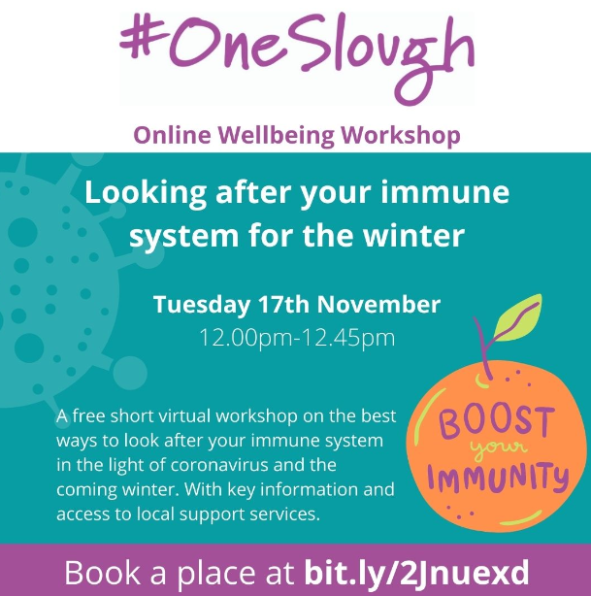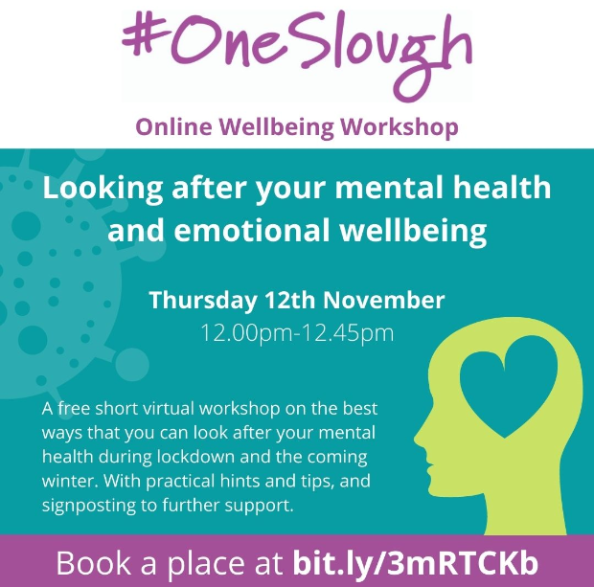

**Training and Continuous Professional Development**

**MULTI-AGENCY TRAINING OFFER 2020-21 is under review (Level 2 Safeguarding)**

Covid 19 has presented many challenges for our workforce and has taught us a lot about Virtual working together!

We are currently revising all our training and developing virtual modules. We have committed to virtual training September through to March 2021 unless it is safe to have face to face training.

<https://www.sloughsafeguardingpartnership.org.uk/scsp/scsp/training/multi-agency-training-offer-2020-21-refreshed-in-light-of-covid-19>

**Safeguarding basics and COVID-19**

Below is a link to a video which has been developed to cover the basics of safeguarding during COVID-19.  It covers safeguarding for both children and adults at home and also includes domestic abuse and exploitation.

It takes less than 10 minutes to view and may be particularly useful as a resource for:-

* redeployed staff
* staff or volunteers  working in different ways within the safeguarding arena during this period
* volunteers who do not read English very well as there is no requirement to read the slides.

The messages are simple - “There is no excuse for abuse during Lockdown” and “Help is available -It is business as usual for safeguarding services”

Link to Slough Safeguarding basics <https://youtu.be/RDc4mBGbRmA>

**Safeguarding Level 3**

*It is always recommended that Designated Safeguarding Leads complete a localised Safeguarding course to ensure they have up to date information about local policy’s and procedures. Due to COVID 19 the Slough Safeguarding Partnership are currently unable to offer face to face training but will endeavour to review other options such as online training in the future. In the meantime there are a number of other organisations who offer Level 3 Safeguarding training online which you could access, however we strongly recommend that you ensure you are aware and up to date with Slough’s Safeguarding procedures* [*https://berks.proceduresonline.com/slough/index.html*](https://berks.proceduresonline.com/slough/index.html)

**Please note these courses are not recommendations and we are not endorsing the training. This list is not exhaustive**

**Level 3 Safeguarding Children: Paediatric First Aid Training Online**

This online safeguarding training level 3 course programme is aimed at all childminders, nursery staff, but also school teachers & support staff working with children & infants who could potentially assess and evaluating the needs of a child, infant or young person, who may be potentially at risk of harm.

<https://www.onlinepaediatricfirstaid.co.uk/product/level-3-online-safeguarding-children-course-childminders-nursery-staff/>

**Designated Safeguarding Lead (Level 3): The National Nursery Training**

As part of the National Nursery Training Designated Safeguarding Lead course you will learn:

* Understand the safeguarding structure and have an understanding of the law, policy and recommended guidance to uphold the highest safeguarding standards
* Understand the roles and responsibilities of the Designated Safeguarding Lead
* Be able to identify signs of possible abuse
* Understand the process to follow when a safeguarding issue is identified
* Understand the correct procedure for dealing with disclosures.
* Understand the varying levels of need of individuals and processes to follow.
* Understand the correct procedure for recording information and following due process beyond referral to external agencies.

<https://nationalnurserytraining.com/product/designated-safeguarding-lead-level-3/>

**Designated Safeguarding Lead online Course: EYFS Resources**

The Designated Safeguarding Lead course covers the following:

◦the definition of safeguarding and child protection,

◦recap on signs and symptoms of abuse

◦how to report concerns

◦how to respond to allegations of abuse

◦recording information correctly

◦roles and responsibilities of people and agencies

◦creating a child protection policy

◦the role of a Designated Safeguarding Lead (DSL)

<https://www.eyfsresources.co.uk/training/early-years-safeguarding-courses/designated-safeguarding-lead-online-course>

**NSPCC Safeguarding Training**

<https://learning.nspcc.org.uk/training>

**Prevent**

Prevent should be seen as part of the existing safeguarding framework;

While it remains rare for children and young people to become involved in terrorist activity, young people from an early age can be exposed to terrorist & extremist influences or prejudiced views. As with other forms of safeguarding strategies, early intervention is always preferable.

Slough Borough Council working with other local partners, families and communities, play a key role in ensuring young people and their communities are safe from the threat of terrorism.

Prevent training, aims of session.

• Understand Prevents aims

• Think about who may be vulnerable to Extremism and Radicalisation – all forms

• See why some people are able to influence and manipulate others to commit crimes

• Recognise when a vulnerable individual may be in need of help

• And be clear on what help and support looks like in this area, and who you should turn to if you have concerns

• Look at the threats, risks and vulnerabilities

9th December 2020 @ 10am – 12pm

12th January 2021 @ 10am – 12pm

9th February 2021 @ 10am – 12pm

9th March 2021 @ 10am – 12pm

To book a free space please email [Philip.Dobson@slough.gov.uk](mailto:Philip.Dobson@slough.gov.uk)

Alternative evening session will run on 23rd February 2021 @ 6.30pm – 8pm bookings via the Link <https://thelink.slough.gov.uk/events/early-years-prevent-training-1>

**Strong Home Learning Experience to support children’s learning and development**

**National Literacy Trust – Words for life /New digital platforms for families and teachers**

The virtual school library will help primary schools give children who have been most adversely affected by COVID-19 access to books all year round. The words for life website supports with the home learning environment for children <https://wordsforlife.org.uk/?mc_cid=ea64f10f58&mc_eid=dfacb06fa7>

The websites are packed with free books, fun activities and exclusive author content.

For more information look [here](https://literacytrust.org.uk/news/to-celebrate-international-literacy-day-hrh-the-duchess-of-cornwall-opened-ivydales-new-school-library-and-launched-our-virtual-school-library-for-all-uk-schools/?mc_cid=ea64f10f58&mc_eid=dfacb06fa7)

**For Happy Healthy Early Years** - Support from trusted NHS professionals <https://healthforunder5s.co.uk/>

**Simple, fun activities for kids, from newborn to five** <https://hungrylittleminds.campaign.gov.uk/>

**Talk to your baby**

[www.talktoyourbaby.org](http://www.talktoyourbaby.org)

**Building a happy baby - a guide for parents**

[www.unicef.org.uk/babyfriendly](http://www.unicef.org.uk/babyfriendly)

**Education Endowment Foundation**

NEW: Supporting reading at home - we have made some of our resources available in Polish, Punjabi, Urdu, Bengali, and Lithuanian. <https://educationendowmentfoundation.org.uk/covid-19-resources/support-resources-to-share-with-parents/>

**Improving the Home Learning Environment** guide by the Department of Education and National Literacy Trust <https://assets.publishing.service.gov.uk/government/uploads/system/uploads/attachment_data/file/756020/Improving_the_home_learning_environment.pdf>

**The Toddler Meal Planner is a must have in every kitchen!**

Created in collaboration with parents to solve a real need, it makes it easy for parents to get the balance right, helping to take the guesswork out of toddler meals and set up healthy habits for life at a critical time in children’s development. You can find the meal planner [here](https://infantandtoddlerforum.org/blog/new-resource-inspired-by-parents-for-parents-the-toddler-meal-planner-is-a-must-have-in-every-kitchen/?utm_source=Email&utm_medium=Email&utm_campaign=August%20email)