Wearing PPE whilst working around the Borough
- Those who work only outside (not visits to households/businesses) should only wear the mask when travelling on public transport as you should maintain 2m distance whilst carrying out your tasks, unless the risk assessments identifies a risk.

- Those who have been provided masks to wear during visits (to households/businesses) should wear the mask: when using public transport and throughout the visit. Visiting officers wearing PPE should still maintain the 2m distance as much as they can.
Putting on PPE
Before putting on the PPE, perform hand hygiene. Use hand sanitiser or soap and water.
Make sure you are hydrated and are not wearing any jewellery, bracelets, watches or stoned rings.
The order of putting on PPE is:
- Surgical Face Mask
- Gloves

Sessional use
Surgical masks can be used a single sessional use e.g. you do not have to change your mask in between visits. Gloves should be changed after every visit.
Masks should be changed if you want to take a break or the mask becomes heavily soiled (from perspiration)/ is uncomfortable. The duration of one sessional use will vary from person to person and the intensity of the work activity.
Taking off PPE
The order of taking off PPE is:
- Gloves: Remove gloves, grasp the outside of the cuff of the glove and peel off, holding the glove in the gloved hand, insert the finger underneath and peel off second glove.
- Wash hands / use alcohol hand sanitiser
- Remove surgical face mask
- Wash hands / use alcohol hand sanitiser.
Waste disposal: PPE can be disposed of normally when you are coming into contact with non-symptomatic persons. If symptomatic, the waste should be double bagged and left for 72 hours before it is placed in normal waste collection.
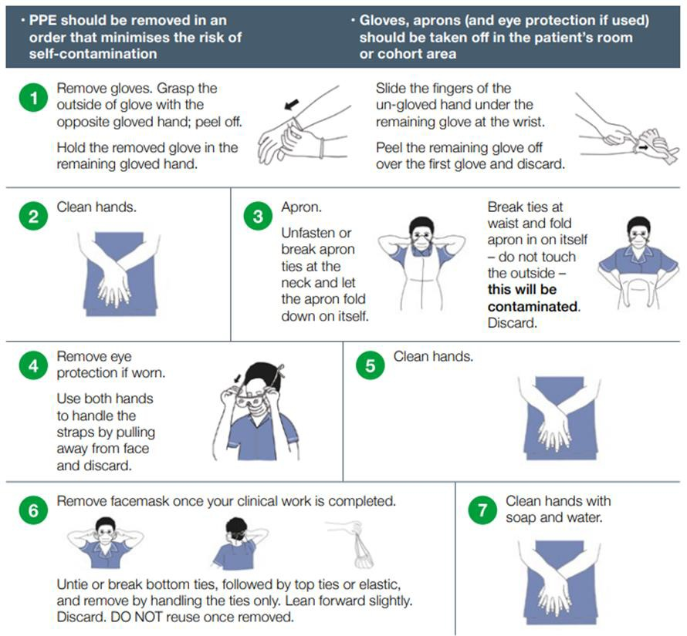
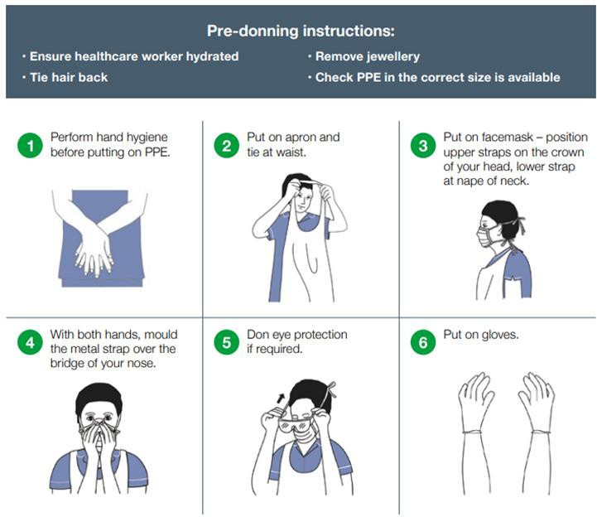
TAKING OFF PPE
PUTTING ON PPE

Source – Public Health England:
- • Putting on
- • Taking off

