FORM 038O COVID
Issue 3
Date: 03.03.2021
Implementing COVID Testing in schools.
Coronavirus Health and Safety Checklist
This checklist has been developed in conjunction with government guidelines for testing in schools.
https://www.gov.uk/guidance/asymptomatic-testing-in-schools-and-colleges?utm_medium=email&utm_campaign=govuk-notifications&utm_source=e4f98685-3c9d-4f66-be89-500f9ccef42c&utm_content=immediate
https://assets.publishing.service.gov.uk/government/uploads/system/uploads/attachment_data/file/950515/Schools_Colleges_Testing_Handbook_revised_04012021.pdf
And
Department of Health and Social Care COVID-19 National Testing Programme Clinical Standard Operating Procedure for Mass Testing with Lateral Flow Antigen Testing Devices in Schools and Colleges’ handbook (31/12/2020)
For links to further guidance and support materials please contact the DfE coronavirus helpline on Telephone 0800 046 8687

Communication | where complete
Letters have been sent to parents, pupils and staff advising of the procedure and the purpose of the testing

Consent forms from parents been received

Templates can be found here:-
https://www.gov.uk/guidance/asymptomatic-testing-in-schools-and-colleges

Website has been updated with details of testing

Staff have been communicated on arrangements

The Privacy notice has been sent to the person giving consent

Arrangement have been implemented on how to communicate positive results

Remote Education
Remote learning has been organised whilst testing is being undertaken. Note: There is a requirement to provide at least 4 hours of remote education per day

Free school meals have been set up for eligible pupils that are engaging in remote education

Advanced preparation for testing
A clinical compliance checklist is in place.

The ATS Risk log has been completed. See page 50 Department of Health and Social Care COVID-19 National Testing Programme Clinical Standard Operating Procedure for Mass Testing with Lateral Flow Antigen Testing Devices in Schools and Colleges’ handbook (31/12/2020)

A testing programme has been prepared

An incident management system and escalation protocols in place

A test register has been set up

A system to register each test for test and trace purposes has been set up

A system to manage and track equipment and supplies required for the set-up and day to day running of a test site, including site supplies besides test kits and PPE, has been determined

A booking system for testing is in place.

A quality management plan is in place.

Those who will conduct cleaning if an individual is sick during testing have been identified.

Infection Prevention and Control (IPC) procedures are in place and operatives have been provided with IPC advice. More guidance can be found here:- https://www.gov.uk/government/publications/wuhan-novel-coronavirus-infection-prevention-and-control

Testing Environment
A room has been allocated to conduct the testing. See Appendix 3 for the suggested room layout from the NHS and refer to section 6.3 page 16 Department of Health and Social Care COVID-19 National Testing Programme Clinical Standard Operating Procedure for Mass Testing with Lateral Flow Antigen Testing Devices in Schools and Colleges’ handbook (31/12/2020) for details of the testing site set up.

Ensure the following is considered:-
- There is sufficient space for appropriate social distancing
- The room is easy to clean floor and surfaces
- The flooring is resistant, and non-absorbent
- Regular cleaning of the room is in place and added to your cleaning schedule. Note: cleaners should not be present when testing is conducted so regular breaks in testing is required for cleaning.
- Individuals have been identified who will clean the testing area between tests
- The room has good ventilation
- The ambient temperature is 15-30 C
- A one-way flow is in place from entry to exit as much as possible
- There is clear access to PPE donning and doffing area
- There is ready access to hand hygiene (soap and water/appropriate alcohol-based hand rub)
- Privacy is provided for participants who self-administer a test
- Health and safety, disability access, and fire safety regulations that govern deployment sites have been met
- All surfaces are de-cluttered with no personal or non-essential equipment
- There is enough room for storage
- There is appropriate testing site waste management arrangements
- Courier and waste collection have easy access
- Where attendees will queue have been identified. This may include a waiting room if required. Ensure social distancing is maintained.
- Safeguarding measures are in place
- Appropriate signage in displayed, including:
  - Hand washing requirements
  - Respiratory hygiene - ‘Catch it, bin it, kill it’
  - Personal Protective Equipment (PPE) (Donning and Doffing)
  - Social distancing: All workers should always remain 2 metres apart where possible, in accordance with government guidance
  - Equipment distancing and cleaning
  - Effective segregation and disposal of waste
- Test instruction posters are displayed
- IPC standards guidance are displayed on site

Personnel conducting the test
Those administering the tests have been identified. Note- the government recommends that this includes 1 to 2 members of staff with others being either volunteers (for example governors) or agency staff brought in for this purpose.

Those administering the tests have had a DBS check

Those who will administer the test if the staff/pupil is unable to, have been identified

Those administering the tests have received training on how to conduct this safely. Training should include handling and analysis of samples, infection prevention and control. See section 5.2 page 15 of Department of Health and Social Care COVID-19 National Testing Programme Clinical Standard Operating Procedure for Mass Testing with Lateral Flow Antigen Testing Devices in Schools and Colleges’ handbook (31/12/2020).

Your staff training has included PPE and IPC standards, including those approved by the NHSE/I IPC Cell

You have allocated roles and responsibilities. See section 5.1 page 13 of Department of Health and Social Care COVID-19 National Testing Programme Clinical Standard Operating Procedure for Mass Testing with Lateral Flow Antigen Testing Devices in Schools and Colleges’ handbook (31/12/2020).

The correct PPE is provided to those that are testing. See Appendix 4

Arrival
Attendees have been advised of where they are to report to for their test

staff and pupils are organised by appointments to prevent queues and congregating

An area has been allocated for parents to wait whilst their child is being tested

An area has been allocated where staff and pupils wait to receive their test results

Staff / Parents / and children over the age of 11 have been advised that face coverings should be worn

Preparing the testing area
Doors and windows are open to ensure good ventilation

The room is set up to maintain social distancing

Handwashing facilities or hand sanitiser is available for use in the room

The following are in place: - a mirror, timer, permanent markers, hand sanitiser, tissues, and clinical waste bins in the testing area

A computer has been set up in the room

A person has been organised to conduct the administration

The administrator has conducted a DSE Assessment

Test kits including the swabs, extraction materials, LFD devices, clean cup to prop up the extraction tube or a plastic takeaway carton and punch holes in to keep the test tubes upright, and barcodes have been prepared

Test instructions / leaflet are available

Testing preparation
Devices prepared to use for registering tests and results

Barcodes prepared for each test

Test instructions to prepare, collect and record sample results followed

System’s are in place to record the barcode number on each LFD device against the time each sample was placed onto the LFD device. See the On-Off sheet in appendix 4

Staff informed that if an LFD is positive, the staff or pupil needs to take a confirmatory PCR test.

Report any problems relating to test kits and delivery issues using the rapid testing contact form

PPE
PPE (IIR face masks and nitrile gloves) is provided for use

Those administering tests have been informed / trained in how to don and remove PPE correctly

COSHH
The safety data sheet for the chemicals used in the test has been sourced

A COSHH risk assessment is in place or the test
Cleaning required
- Testing area: Cleaners should not be present when testing is conducted so regular breaks in testing is required for cleaning.
- As a minimum frequently touched surfaces must be cleaned twice a day, and one of these should be at the beginning or the end of the working day.
- All surfaces that the ‘Subject’ has come into contact with must be cleaned and disinfected, including all potentially contaminated and frequently touched areas such as handles, light switches, telephones, and the surfaces that the subject may have had contact in between each individual that is tested
- Disposable cloths or paper roll and disposable mop heads, are to be used to clean all hard surfaces, floors, chairs, door handles and sanitary fittings – think one site, one wipe, in one direction and place in the offensive waste bin (tiger bag)
- Any cloth and mop heads used for cleaning must be disposed of and should be placed into the offensive (tiger bag) waste bin provided
- Surfaces will require to be cleaned at the end of the session before the next session starts i.e. in between test group batches of Subjects
- Public areas where a symptomatic subject has passed through and spent minimal time, but which are not visibly contaminated with body fluids can be cleaned thoroughly as normal.
- Cleaning of equipment
  - All digital equipment should be regularly wiped between batches of tests and at the beginning and end of each session.
  - Cleanable keyboard, mouse (could be medical keyboard/mouse to silicon covers down to plastic covers, or plastic sleeves) that will tolerate being cleaned with chlorine releasing agents 1000ppm are recommended.
  - If a cover is used silicone option is preferable as it is more user friendly and will last longer than the plastic versions.
  - The cleaning wipe used should meet the requirement sent out in cleaning policy section and be effective against enveloped viruses.
  - An equipment cleaning regime should be in place and clearly communicated, The keyboard and mouse should be cleaned at the start of the day, after each batch of cartridge have been reviewed and uploaded and at the end of the day (and if they become contaminated with any form of spillage.
  - A replacement schedule should be in place to replace damaged covers and the equipment should not be used if the cover is torn/worn.
  - Any trays that are used for e.g. to move LFDs for recording after reading and marking of results should be made from a material that will tolerate being cleaned with chlorine releasing agents at 1000ppm, are straight sides, and smooth.

Schools must follow the cleaning guidelines outlined on page 36 Department of Health and Social Care COVID-19 National Testing Programme Clinical Standard Operating Procedure for Mass Testing with Lateral Flow Antigen Testing Devices in Schools and Colleges’ handbook (31/12/2020).

Cleaning staff must follow the PPE guidance as listed in Department of Health and Social Care COVID-19 National Testing Programme Clinical Standard Operating Procedure for Mass Testing with Lateral Flow Antigen Testing Devices in Schools and Colleges’ handbook (31/12/2020).
Storage of Tests
Arrangements have been made to store tests – both unused and used.

The storage of tests have been arranged to ensure used and unused tests are separated

Please note: The test cartridge and extraction solution should be stored at ambient temperature (2-30 degrees Centigrade). The reagents and devices must be at room temperature (15-30 degrees centigrade) when used for testing.
Waste Disposal
Waste disposal arrangements are in place
Consider
- General waste
- Packaging
- Swabs
- Cartridges and Devices
- PPE

See Appendix 1 and 2 for methods of disposal

Separate waste containers are in place to segregate the waste
Waste categories are:
- Domestic / recycling (all packaging) - Black bag
- Chemical (swabs/cartridges/tissues) - Unmarked Yellow or Clear bag
- Offensive (PPE, cloths, mop heads) - Tiger bag

You will need:-
- Extra wheelie bins for waste storage
- Extra bin bags, as required (tiger , yellow/clear, black)
- Waste collected more regularly (frequency to be agreed with individual school)
Waste containers are clearly labelled

For further details see:
https://www.gov.uk/government/publications/coronavirus-covid-19-lateral-flow-tests-waste-codes/waste-codes-for-mass-testing-with-lateral-flow-antigen-testing-devices
Insurance
Your insurance company have been informed that testing will commence

Any insurance company requirements are in place before testing start
Guidance for testing SEND pupils
Specialist settings are encouraged to:
- offer all staff home test kits to be taken on a twice weekly basis
- upon wider reopening from 8 March 2021, where it is appropriate to do so offer pupils and students aged 11 and above (including those who have been attending during the lockdown period, including vulnerable children and the children of critical workers) 3 supervised tests 3 to 5 days apart on-site before moving to home testing
- work with pupils and students of secondary school age who are in attendance and their families to agree the most appropriate way for them to access twice weekly testing from 8 March 2021

In circumstances where a pupil or student would not be able to be tested through an Asymptomatic Test Sites (School) but who could be tested at home by (or with support from) a suitably competent adult. Settings can provide home testing kits to them from the outset (without the pupil being tested at an ATS (School) first), where this is appropriate for the pupil or student.

It is recognised that home testing may not be appropriate for some pupils and students. In these instances, on-site testing should be offered if that is a viable alternative. If a pupil or student is unable to tolerate a swab-based test at all, no testing should take place.

Specialist settings have the flexibility to be able to work with pupils/students and their families to agree the most appropriate way of them participating in twice-weekly testing. Guidance will be available via this link - https://www.gov.uk/government/publications/guidance-for-full-opening-special-schools-and-other-specialist-settings/mass-asymptomatic-testing-in-specialist-settings

Where you do not have enough staff to carry out assisted swabbing on pupils who cannot self-swab, additional workforce capacity may be available from Medacs.

There are a number of options that settings and families have if a pupil or student is unable to self-swab. These are detailed in the section and can be summarised as:
- having a parent, carer or suitably trained member of staff assist with swabbing on-site
- having a parent or carer assist with swabbing at home
- whether at home or on-site, doing a nasal only or throat only swab if a combined nasal and throat swab is not possible

Areas staff may wish to consider
These questions are based on feedback from the sector.
- How can staff help ensure that the child or young person knows what is involved and the reasons for it? What methods of communication work best for them?
- How can parents help their child know what testing will involve and what advice can they provide to the setting as to what might work best?
- Would it be helpful by exception for a parent, with appropriate measures in place to manage infection risk, to accompany the pupil or student as they self-swab when taking the test, or to assist their swabbing during the test? For more information, see What if a pupil or student can’t self-swab
- Would it be helpful to have someone on the staff who has a good relationship with the child or young person present during the testing?
- Would it be helpful for the child or young person to be familiarised with the site to be used for testing and how it will be set up?
- How can the site being used for testing be made as calm an environment as possible?
- Will it help to offer the child or young person a relaxing activity after testing or refreshments to help make it as positive an experience as possible?
- If the child or young person stims to relieve their anxiety, then will it help to allow them to have their stimming toy with them throughout the test?
- If the child or young person would be more comfortable with testing being done at home, would that be the better approach from the outset?
Resources for parents will be made available to help them support their children testing at home.

Appendix 1 Waste codes for mass testing with lateral flow antigen testing devices
Item | Waste categorisation | European waste catalogue code (EWCs) | Likely management route | HTM 07.01 packaging
General waste | Domestic/recycling | 20 03 01 | Materials Recycling Facility > Energy From Waste plant > Landfill
All packaging | Packaging | 15 01 01, 15 01 02, 15 01 05, 15 01 06 | Materials Recycling Facility > Energy From Waste plant > Landfill | Use existing municipal route
Swabs | Chemical | 18 01 04 +18 01 07 | Energy From Waste plant > Clinical Waste Incinerator | Unmarked yellow neutral container > white / clear > last resort tiger - Do not use hazardous waste packaging
Cartridges/Devices | Chemical | 18 01 04 + 18 01 07 | Energy From Waste plant > Clinical Waste Incinerator | Unmarked yellow neutral container > white / clear > last resort tiger - Do not use hazardous waste packaging
PPE | Offensive | 18 01 04 | Energy From Waste plant or last resort Landfill | Yellow bag with black stripe = Tiger bag

https://www.gov.uk/government/publications/coronavirus-covid-19-lateral-flow-tests-waste-codes/waste-codes-for-mass-testing-with-lateral-flow-antigen-testing-devices
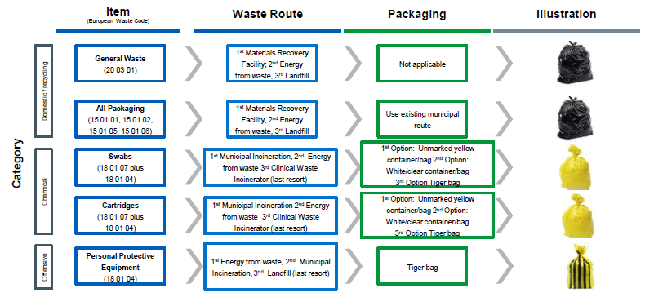
Appendix 2 Packaging and disposal of waste

Appendix 3
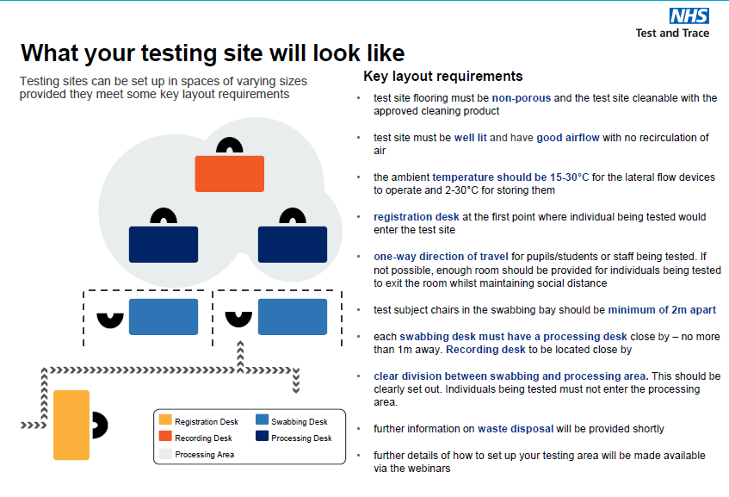
Appendix 4 PPE by roles
Role | Disposable gloves | Disposable plastic apron | Fluid-resistant (Type IIR) surgical mask (FRSM) | Eye protection
Processing Operative2 | ✓  | ✓  | ✓  | ✓ 
Indicates single or sessional use | Replace after each test (single)  | Replace after each session  | Replace after each session  | Replace after each session 
Cleaning Staff3 | ✓  | ✓  | ✓  | ✓ 
Test Assistant4 | × | × | ✓  | ×
Covid Coordinator / Team Leader | × | × | ✓  | ×
Registration Assistant | × | × | ✓  | ×
Results Recorder | If contact with LFD | × | ✓   | ×
Supplies Coordinator | × | × | ✓  | ×
Queue Coordinator | × | × | ✓  | ×
Indicates single or sessional use | Replace after each session | Replace after each session | Replace after each session | Replace after each session

Notes:
1) Anything not identified as “single use” is for “sessional” use (a session ends when a worker leaves the care setting, fresh PPE is used at the start of each session) i.e. at break or end of shift. PPE is sessional however should be changed if protective properties are compromised or contaminated from secretions.
2) Processing Operatives should wear apron/visor and mask sessionally and change gloves between samples. PPE for rest of the team is sessional.
3) Cleaners need to change gloves and apron if cleaning a spillage
4) In this SOP the Test Assistant is not administering the swab and is only supervising, therefore Test Assistants do not need to wear apron, gloves and visor, but they need immediate access to gloves if intervening
5) If results recorders handle LFD cartridges, they should wear gloves on sessional basis.
6) PPE should be changed if protective properties are compromised or if contaminated, or if suspected to be contaminated.

Appendix 4
On-Off sheet
Sheet to record your lateral flow test. The on time is however many minutes past the hour and the off time is 30 minutes after.
ON | 0.00 | 0.05 | 0.10 | 0.15 | 0.20 | 0.25 | 0.30 | 0.35 | 0.40 | 0.45 | 0.50 | 0.55 | ON
OFF | 0.30 | 0.35 | 0.40 | 0.45 | 0.50 | 0.55 | 0.00 | 0.05 | 0.10 | 0.15 | 0.20 | 0.25 | OFF
Document Control
Version | Date Change | Changed by | Items
1 | January 2021 | G.Watson | First version
2 | 1st Feb 2021 | G.Watson | Added details of DfE coronavirus helpline for more guidance and support materials.  Added rapid testing contact form
3 | 3rd March 2021 | G.Watson | Included section for testing SEND pupils

