Appendices for
COVID-19 Resource Pack for
Educational Settings

Version 11.00
June 2021

Appendices Table of Contents
Appendices Table of Contents 1
Appendix A. Checklist of information to gather before calling the DfE Helpline about a case/cases 2
Appendix B Testing flow chart and actions for educational setting 3
Appendix C. Template letters General for parents following confirmed PCR positive case/s 4
Appendix D: Template letter for parents/guardian of close contacts of COVID-19 (PCR positive) 7
Appendix E: Template letter for parents/guardian of close contacts of COVID-19 (LFD positive) 11
Appendix F. Escalation criteria to HPT 14
Appendix G Email template for contacting your local HPT for advice/support with COVID-19 15
Appendix G. Early years and Primary School Guideline Flowchart 18
Appendix H. Secondary School Guideline Flowchart 19

Dealing with positive cases
If positive test is LFD – for close contact use letter in appendix E
For rest of educational setting no letter required
If positive test is PCR – for close contacts use letter in appendix D
For rest of educational setting use letter in appendix C

Appendix A. Checklist of information to gather before calling the DfE Helpline about a case/cases

Information required when phoning DfE Helpline about a case/s
Your name, position and contact details (phone and email)
Name of education setting, address and postcode
Details of which year groups attend the setting
Local Authority
Local Health Protection Team
Date of onset of symptoms (or test date if asymptomatic)
Dates in educational setting while infectious
Year group/course of pupil who has tested positive OR role of staff member who has tested positive
List of potential contacts in the setting (please see section 5 for contact definitions and description of who is likely to meet these in an educational setting).
Please be aware that the entire pupil ‘journey’ or school day during the infectious period (2 days before date of symptom onset to 10 days after) should be considered – including school transport, breakfast or afterschool clubs, classes attended, break and lunchtime arrangements, etc.

Appendix B Testing flow chart and actions for educational setting
Infectious period: Two days before the onset of symptoms to ten days after the onset of symptoms. If asymptomatic, two days before date first positive test was taken to ten days afterwards
Isolation period:
Cases
- Symptomatic: Your isolation period includes the day your symptoms started and the next 10 full days. E.g. if your symptoms started at any time on the 15th of the month, your isolation period ends at 23:59 hrs on the 25th of the month.
- Asymptomatic: In the absence of symptoms, the isolation would start from the date of the positive COVID-19 test* was taken and continue for ten full days after this. E.g. if positive test was taken any time on the 15th of the month, your isolation period ends at 23:59 hrs on the 25th of the month.
Contacts
- Household contacts: Ten full days from first onset of symptoms in the household. Onset of symptoms is day 0. See this illustrative guide
- Non household contacts: Ten full days from last date of exposure. Eg if your exposure date is 15th of the month, you should isolate for ten full days after this to 23:59 hrs on the 25th of the month
*For self-administered LFD tests (i.e. tests taken at home rather than at school or other assisted testing site) the legal duty to self-isolate is from PCR test date which may result in cases isolating longer than ten days if the date of the positive PCR test was taken was after the LFD positive test. It is recommended that people get a PCR test as soon as possible after a LFD test ideally on the same day where possible.
If an asymptomatic close contact tests negative (by LFD or PCR test) during their isolation period they must still complete 10 days isolation from last exposure date before returning to school

NEGATIVE
No action if not tested previously.
If previously LFD positive can stand down contact tracing as long as case does not have symptoms and PCR negative test taken within 2 days of LFD test; otherwise case and contacts must continue to isolate
Continue with COVID secure measures
PCR test
POSITIVE
Contact trace if not already done so (see section 6 in education pack)
Send letter D to close contacts advising isolation and to get a PCR test
Send letter C to rest of setting/year group
If meets escalation criteria (appendix G) or there are other concerns contact HPT

POSITIVE
Case should isolate with household and get a PCR test ASAP and inform school of the result.
Action for school:
Contact trace (see section 6 in education pack)
Send letter appendix E to close contacts advising isolation

LFD test
NEGATIVE
No action for school. Continue with COVID secure measures
Student / member of staff

Appendix C. Template letters General for parents following confirmed PCR positive case/s

Dear Parents/guardians,
We are writing to inform you there has been a confirmed case/ have been confirmed cases of COVID-19 within the nursery/school/college.
We know that you may find this concerning, but we are continuing to monitor the situation and are working closely with Public Health England. This letter is to inform you of the current situation and provide advice on how to support your child. Please be reassured that for most people, coronavirus (COVID-19) will be a mild illness.

A small number of children, who have had contact with the individual testing positive for COVID-19, have been asked to stay home for 10 days.

The school remains open and your child should continue to attend as normal if they remain well. All students and staff, regardless of year group, should remain vigilant regarding COVID-19. All parents are advised to continue with the routine twice weekly asymptomatic LFD COVID-19 testing of those ages 11 and above in the household.

What to do if your child develops symptoms of COVID 19
If your child develops symptoms of COVID-19 they need stay at home and self-isolate immediately and get a test through https://www.nhs.uk/ask-for-a-coronavirus-test or by calling 119. Your household needs to isolate too. This includes anyone in your ‘Support Bubble’.
If your child tests positive, your child and household need to continue isolating for at least 10 days from the date when their symptoms appeared (or date of their positive test if they do not have symptoms). Add your child’s details to NHS Test and Trace and inform the school/educational setting so that other close contacts can be identified and advised to isolate.
The isolation period includes the day their symptoms started and the next 10 full days. This means that if, for example, symptoms started at any time on the 15th of the month, the isolation period ends at 23:59 hrs on the 25th. In the absence of symptoms, the isolation would start from the date of the test was taken and continue for ten days after this. If the person does not have symptoms when testing positive but goes on to develop symptoms, the isolation is extended for ten days after the onset of symptoms as explained here (in the “if you tested positive” section). If other household members become unwell they need to extend their isolation period.

If your child has COVID-19 symptoms and does not get tested they will need to isolate with the household and support bubble for at least 10 days from the onset of symptoms.
Household members should not go to work, school or public areas and exercise should be taken within the home. If you require help with buying groceries, other shopping or picking up medication, or walking a dog, you should ask friends or family. Alternatively, you can order your shopping online and medication by phone or online. Household members staying at home for 10 days, will greatly reduce the overall amount of infection the household could pass on to others in the community
If you are able to move any vulnerable individuals (such as the elderly and those with underlying health conditions) out of your home, to stay with friends or family for the duration of the home isolation period.
Please see the link to the PHE ‘Stay at Home’ Guidance:
https://www.gov.uk/government/publications/COVID-19-stay-at-home-guidance/stay-at-home-guidance-for-households-with-possible-coronavirus-COVID-19-infection
What to do if your child / family member tests LFD positive
If someone in your household receives a positive LFD test, you should get a PCR COVID-19 test as soon as possible. The person testing positive should isolate with their household following the stay at home guidance. If your child tests positive with an LFD or PCR test you must inform the school so they can start contact tracing.
Symptoms
The most common symptoms of coronavirus (COVID-19) are recent onset of:
- A new continuous cough
- A high temperature
- A loss of, or change in, your normal sense of taste or smell (anosmia)
For most people, coronavirus (COVID-19) will be a mild illness.
If your child does develop symptoms, you can seek advice from the nhs.uk website at https://www.nhs.uk/conditions/coronavirus-covid-19/check-if-you-havecoronavirussymptoms/. If you are concerned about your child’s symptoms, or they are worsening you can seek advice from NHS 111 at https://111.nhs.uk/ or by phoning 111.
How to stop COVID-19 spreading
There are things you can do to help reduce the risk of you and anyone you live with getting ill with COVID-19:
- Wash your hands with soap and water often – do this for at least 20 seconds.
- Use hand sanitiser gel if soap and water are not available.
- Wash your hands as soon as you get home.
- Cover your mouth and nose with a tissue or your sleeve (not your hands) when you cough or sneeze.
- Put used tissues in the bin immediately and wash your hands afterwards.
- Participate in twice weekly LFD testing following national guidelines (recommended for 11 years and over).

Further Information
Further information is available at https://www.nhs.uk/conditions/coronavirus-covid-19/
Further information on rapid lateral flow tests are available at: https://www.gov.uk/order-coronavirus-rapid-lateral-flow-tests
Guidance in different languages: https://www.gov.uk/government/publications/COVID-19-stay-at-home-guidance

Yours sincerely
Headteacher/Manager

Appendix D: Template letter for parents/guardian of close contacts of COVID-19 (PCR positive)

Advice for child/student to Self-Isolate for 10 Days and get a PCR test
Date: DD/MM/YYYY

Dear Parent/Guardian,

We have been informed of a PCR positive case/cases of COVID-19 within the nursery/school/college.

We have followed the national guidance and have identified that your child (name) has been in close contact with the affected person. Please take the following actions:
- Your child should stay at home and self-isolate until ADD DATE (10 days after contact) following national guidance: https://www.gov.uk/government/publications/guidance-for-contacts-of-people-with-possible-or-confirmed-coronavirus-COVID-19-infection-who-do-not-live-with-the-person. We are asking you to do this to reduce the spread of COVID-19 to others in the community. If your child is well and has not tested positive at the end of the 10-day period of self-isolation, then they can return to their usual activities.
- Other members of your household can continue normal activities provided your child does not develop symptoms within the 10-day self-isolation period or test positive.
- As an extra precaution Public Health England (PHE) is now advising close contacts to get a COVID-19 PCR test (ideally 5 days after exposure or day five of isolation). If your child has had a positive PCR test within the last 90 days, you do not need to get another test unless they have new symptoms. Please read the attached document with more information about this.
- If your child tests positive they need to isolate with their household following national guidance COVID-19: guidance for households with possible coronavirus infection - GOV.UK (www.gov.uk). If they test negative, they must still complete ten days isolation.
- All members of the household aged 11 and over should continue to do their regular LFD test twice a week (every 3 to 4 days).
- Anyone with symptoms should get a PCR test as soon as possible and isolate with their household. https://www.nhs.uk/ask-for-a-coronavirus-test
- Please also inform the school/college/nursery of any positive result.

Many thanks for your help in reducing the transmission of COVID-19.

Yours sincerely
The Headteacher / The Manager
Enc. Information sheet for close contacts of PCR positive cases
Information sheet for close contacts of PCR positive cases

Booking a test for a close contact who has no symptoms

To book a test, please visit www.gov.uk/get-coronavirus-test. You will be asked to identify whether they have COVID-19 symptoms. If you have no symptoms, you should select ‘No’ for this answer and proceed through the questions until they get to the question: Why are you asking for a test?
- Please select the box that says: I’ve been told to get a test by my local council, health protection team or healthcare professional  - And then the option that states: My local council or health protection team has asked me to get a test, even though I do not have symptoms  - You can then proceed to book the test. | 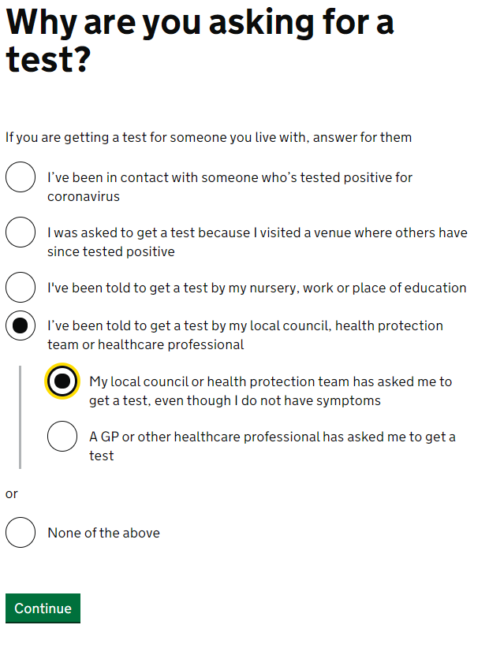

If your child has had a positive PCR test in the last 90 days, you do not need to book another one unless they have new symptoms. If your child has had a recent test using a Lateral Flow Device (LFD), we would ask that they still take a PCR test using the process above. The website will provide information of how to take the test and and you will be informed directly of a positive or negative result.

If you agree for your child to be tested and they receive a positive result:
- They must self-isolate, along with your household, and follow the national guidance: COVID-19: guidance for households with possible coronavirus infection - GOV.UK (www.gov.uk).
- Please inform the school of any positive result and also complete NHS Test and Trace so that contacts receive appropriate advice to avoid onward transmission.
- If your child tests negative, they should still continue with their ten-day isolation as a close contact as they may be incubating the disease.
What to do if your child develops symptoms of COVID 19
If your child develops symptoms of COVID-19 they need stay at home and self-isolate immediately and get a test through https://www.nhs.uk/ask-for-a-coronavirus-test or by calling 119. Your household needs to isolate too. This includes anyone in your ‘Support Bubble’.
If your child tests positive, your child and household need to continue isolating for at least 10 days from the date when their symptoms appeared (or date of their positive test if they do not have symptoms). Add your child’s details to NHS Test and Trace and inform the school/educational setting so that other close contacts can be identified and advised to isolate.
The isolation period includes the day their symptoms started and the next 10 full days. This means that if, for example, symptoms started at any time on the 15th of the month, the isolation period ends at 23:59 hrs on the 25th. In the absence of symptoms, the isolation would start from the date of the test was taken and continue for ten days after this. If the person does not have symptoms when testing positive but goes on to develop symptoms, the isolation is extended for ten days after the onset of symptoms as explained here (in the “if you tested positive” section). If other household members become unwell they need to extend their isolation period.
If your child does not get tested they will need to isolate with the household and support bubble for at least 10 days from the onset of symptoms.
Household members should not go to work, school or public areas and exercise should be taken within the home. If you require help with buying groceries, other shopping or picking up medication, or walking a dog, you should ask friends or family. Alternatively, you can order your shopping online and medication by phone or online. Household members staying at home for 10 days, will greatly reduce the overall amount of infection the household could pass on to others in the community
If you are able to move any vulnerable individuals (such as the elderly and those with underlying health conditions) out of your home, to stay with friends or family for the duration of the home isolation period.

Symptoms of COVID 19

The most common symptoms of coronavirus (COVID-19) are recent onset of:
- A new continuous cough and/or
- A high temperature and/or
- A loss of, or change in, normal sense of taste or smell (anosmia)

For most people, coronavirus (COVID-19) will be a mild illness.

If your child does develop symptoms, you can seek advice from NHS 111 at https://www.nhs.uk/conditions/coronavirus-COVID-19/check-if-you-have-coronavirus-symptoms/ or by phoning 111.

How to stop COVID-19 spreading

There are things you can do to help reduce the risk of you and anyone you live with getting ill with COVID-19:
- Wash your hands with soap and water often – do this for at least 20 seconds.
- Use hand sanitiser gel if soap and water are not available.
- Wash your hands as soon as you get home.
- Cover your mouth and nose with a tissue or your sleeve (not your hands) when you cough or sneeze.
- Put used tissues in the bin immediately and wash your hands afterwards.
- Participate in twice weekly LFD testing following national guidelines (recommended for 11 years and over.
Further Information

Further information is available at
https://www.nhs.uk/conditions/coronavirus-COVID-19/

Further information on rapid lateral flow tests are available at: https://www.gov.uk/order-coronavirus-rapid-lateral-flow-tests

Guidance in different languages: COVID-19: guidance for households with possible coronavirus infection - GOV.UK (www.gov.uk)

Appendix E: Template letter for parents/guardian of close contacts of COVID-19 (LFD positive)

Advice for Child/student to Self-Isolate for 10 Days
Date: DD/MM/YYYY

Dear Parent/Guardian,

We have been informed of a positive case of COVID-19 within the nursery/school/college from a lateral flow device (LFD) and further testing is underway.

- Following national guidance for educational settings, children should stay at home and self-isolate until ADD DATE (10 days after contact): https://www.gov.uk/government/publications/guidance-for-contacts-of-people-with-possible-or-confirmed-coronavirus-covid-19-infection-who-do-not-live-with-the-person. We are asking you to do this to reduce the spread of COVID-19 to others in the community. If your child is well and has not tested positive at the end of the 10 days period of self-isolation, then they can return to usual activities.
- Other members of your household can continue normal activities, provided your child does not develop symptoms within the 10 day self-isolation period or tests positive.
- All members of the household aged 11 and over should continue to do their regular LFD test twice a week (every 3 to 4 days).
- Anyone with symptoms should get a PCR test as soon as possible and isolate with the household. https://www.nhs.uk/ask-for-a-coronavirus-test
- Please also inform the school/college/nursery of any positive result.

We will inform you if there are any changes to this situation or if we would request you/your child take any further measures.

Many thanks for your assistance with this.

Yours sincerely
The Headteacher / The Manager

Enc. Factsheet on COVID-19 for education settings

Factsheet on COVID-19 for educational settings

What to do if your child develops symptoms of COVID 19

If your child develops symptoms of COVID-19 they need stay at home and self-isolate immediately and get a test through https://www.nhs.uk/ask-for-a-coronavirus-test or by calling 119. Your household needs to isolate too. This includes anyone in your ‘Support Bubble’.
If your child tests positive, your child and household need to continue isolating for at least 10 days from the date when their symptoms appeared (or date of their positive test if they do not have symptoms). Add your child’s details to NHS Test and Trace and inform the school/educational setting so that other close contacts can be identified and advised to isolate.
The isolation period includes the day their symptoms started and the next 10 full days. This means that if, for example, symptoms started at any time on the 15th of the month, the isolation period ends at 23:59 hrs on the 25th. In the absence of symptoms, the isolation would start from the date of the test was taken and continue for ten days after this. If the person does not have symptoms when testing positive but goes on to develop symptoms, the isolation is extended for ten days after the onset of symptoms as explained here (in the “if you tested positive” section). If other household members become unwell they need to extend their isolation period.
If your child does not get tested they will need to isolate with the household and support bubble for at least 10 days from the onset of symptoms.
Household members should not go to work, school or public areas and exercise should be taken within the home. If you require help with buying groceries, other shopping or picking up medication, or walking a dog, you should ask friends or family. Alternatively, you can order your shopping online and medication by phone or online. Household members staying at home for 10 days, will greatly reduce the overall amount of infection the household could pass on to others in the community
If you are able to move any vulnerable individuals (such as the elderly and those with underlying health conditions) out of your home, to stay with friends or family for the duration of the home isolation period.

Symptoms of COVID 19

The most common symptoms of coronavirus (COVID-19) are recent onset of:
- A new continuous cough and/or
- A high temperature and/or
- A loss of, or change in, normal sense of taste or smell (anosmia)

For most people, coronavirus (COVID-19) will be a mild illness.

If your child does develop symptoms, you can seek advice from NHS 111 at https://www.nhs.uk/conditions/coronavirus-COVID-19/check-if-you-have-coronavirus-symptoms/ or by phoning 111.

How to stop COVID-19 spreading

There are things you can do to help reduce the risk of you and anyone you live with getting ill with COVID-19:

- Wash your hands with soap and water often – do this for at least 20 seconds
- Use hand sanitiser gel if soap and water are not available
- Wash your hands as soon as you get home
- Cover your mouth and nose with a tissue or your sleeve (not your hands) when you cough or sneeze
- Put used tissues in the bin immediately and wash your hands afterwards
- Participate in twice weekly LFD testing following national guidelines (recommended for 11 years and over).

Further Information

Further information is available at
https://www.nhs.uk/conditions/coronavirus-COVID-19/

Further information on rapid lateral flow tests are available at: https://www.gov.uk/order-coronavirus-rapid-lateral-flow-tests

Guidance in different languages:
https://www.gov.uk/government/publications/COVID-19-stay-at-home-guidance

Appendix F. Escalation criteria to HPT

 | Primary Schools and Early Years Settings:
• | 10% (or more) of a bubble is affected within 14 days – (for example, if there are 3 or more confirmed cases of COVID-19 in a bubble of 30 people) and we have not spoken to you in the past 14 days.
• | 10% (or more) of staff are affected within 14 days – (for example, if there are 6 or more confirmed cases of COVID-19 in a staff of 60) and we have not spoken to you in the past 14 days.
• | 3 (or more) bubbles within your school/setting contain at least one confirmed case and we have not spoken to you in the past 14 days.
• | If your school is a boarding school and you have 2 or more cases in staff/pupils who are boarders and we have not spoken to you in the past 14 days.
• | There have been any admissions to hospital or deaths in your students or staff members due to COVID-19.
• | If your school is for children and young people with special educational needs and disability (SEND).
• | If your school is experiencing interest from the media.
 | Secondary Schools:
• | 5 or more students are affected in a single school year within 14 days i.e. 5 or more confirmed cases and we have not spoken to you in the past 14 days.
• | 10% (or more) of staff are affected within 14 days – (for example, if there are 6 or more confirmed cases of COVID-19 in a staff of 60) and we have not spoken to you in the past 14 days.
• | 3 (or more) bubbles within your school contain at least one confirmed case and we have not spoken to you in the past 14 days.
• | If your school is a boarding school and you have 2 or more cases in staff/pupils who are boarders and we have not spoken to you in the past 14 days.
• | There have been any admissions to hospital or deaths in your students or staff members due to COVID-19.
• | If your school is for children and young people with special educational needs and disability (SEND).
• | If your school is experiencing interest from the media.

Appendix G Email template for contacting your local HPT for advice/support with COVID-19
You can often receive a quicker response from your local HPT by emailing them, with the completed form in this Appendix, to the following addresses:
Thames Valley HPT ICC.TVPHEC@phe.gov.uk
Hampshire & Isle of Wight HPT ICC.HIOW@phe.gov.uk
Surrey & Sussex HPT ICC.SurreySussex@phe.gov.uk
Kent HPT ICC.Kent@phe.gov.uk
Please include as much of this information as possible to inform our risk assessment and advice to you.
You are welcome to add any further details but please do not include any information that could potentially be used to identify individuals, including name, date of birth, or address. Any such information must be sent securely or provided over the phone. Fields marked with a star* are always required

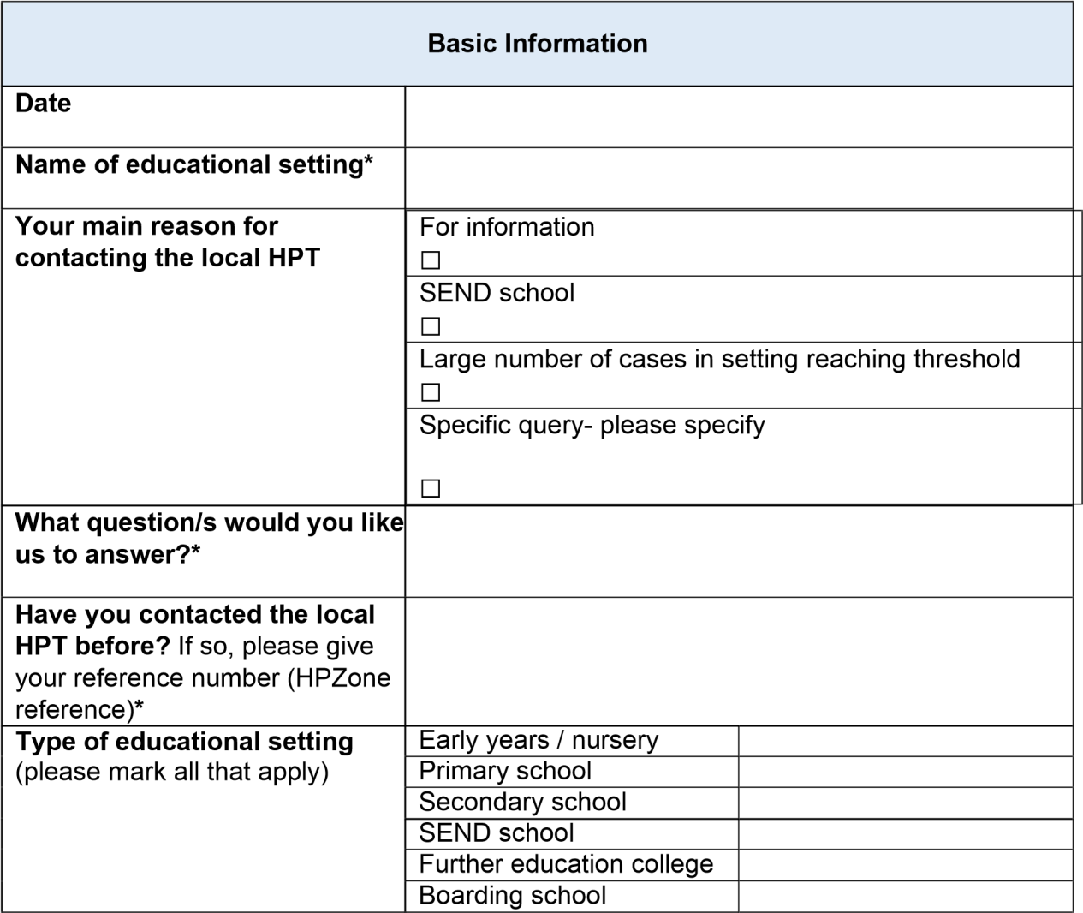

Address

Post code*
Total number of staff in school
Total number of students in School
Contact details
Main contact person* - name
Main contact person – role
Contact telephone number* (if including a mobile number please let us know what times are ok to call, as we work past the end of the school day)
Email address for our reply*
Other point of contact and
contact details

Situation information
Total number of students with a positive test result in the previous 14 days
For boarding schools only: Please specify case numbers for boarding and/or day pupils | No. of cases in boarding pupils | No. of cases in in day pupils
Which years/classes are these students in? Please let us know how many confirmed Cases in each.
How many households are affected? (Are there any Siblings amongst the confirmed cases)
Total number of staff with a positive test result in the previous 14 days
Staff and children identified as close contacts and advised to self-isolate
Early years settings- How many individual children or bubbles have been excluded? For each bubble, please give the approx.
number of students and staff excluded
Primary schools – how many bubbles have been excluded? For each bubble, please give the number of students with a Positive test
Secondary schools – how many students have been excluded as contacts? Please give this by year if several years are affected
 | Hospital admissions
Have any students or staff been admitted to hospital?
Have there been any admissions to intensive care or deaths?
 | Actions taken
Have you had any support already from DfE
helpline/local public health- please specify
Please tell us what actions you have already taken

Appendix G. Early years and Primary School Guideline Flowchart
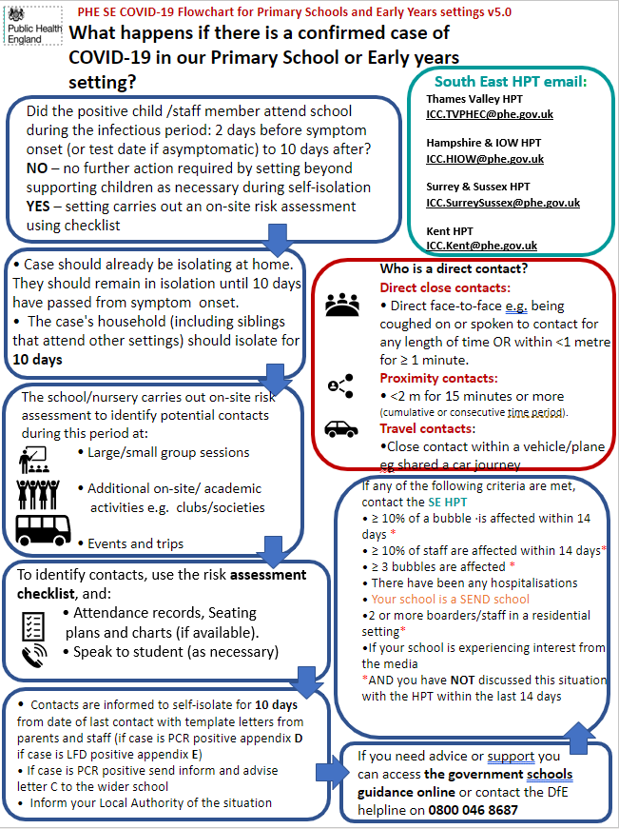
For full guidance please refer to PHE SE educational settings pack, Schools coronavirus operational guidance and Early Years guidance.

Appendix H. Secondary School Guideline Flowchart
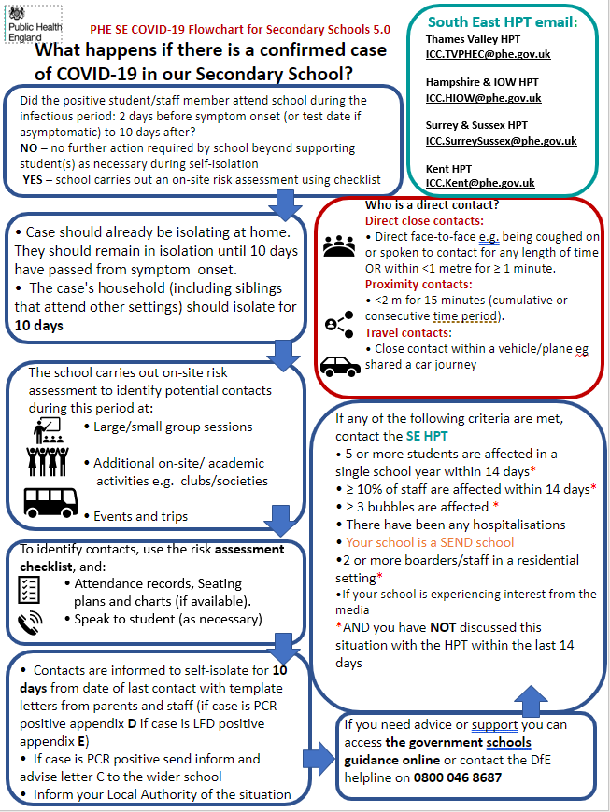

For full guidance please refer to PHE SE educational settings pack and Schools coronavirus operational guidance

