Children and Families, Early Years Division
Weekly News Bulletin: 09 June 2021

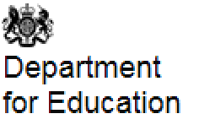

Reported coronavirus (COVID-19) notifications by registered early years and childcare settings

This data is published fortnightly. It gives the number of registered early years and childcare providers reporting one or more confirmed cases of coronavirus (COVID-19) by week.
Updated 01 June 2021

Numbers recorded in May have continued to be recorded at a level lower than April this year.

Attendance in education and early years settings during the coronavirus outbreak

A summary of attendance in education settings up to 28 May 2021 and early years settings up to 28 May 2021.
Updated 08 June 2021

Early years settings

The early years local authority survey has moved to fortnightly. We estimate 922,000 children are currently attending early years childcare settings on Thursday 27 May 2021 – about 57% of the number of children who usually attend childcare in term time.
Due to many children attending EY settings on a part-time basis, we would not expect all children to be in attendance on the day of the data collection. On a typical day in the Summer term we expect attendance to be 1,154,000, due to different and part-time patterns of childcare during the week.
We estimate that the 922,000 children currently attending early years settings is approximately 80% of the usual daily level.

Changes to childminder testing process

Following feedback on the registration and uploading process since March, the Department of Health and Social Care (DHSC) and NHS Test and Trace have been working to identify ways to make it easier for childminders to identify their profession when recording results on the NHS Covid-19 test results portal.

The changes are due to come into effect from 2 June and are designed to allow us to monitor more clearly the effectiveness of our testing programme and identify any areas or groups within the early years childcare system that are not engaging in testing, so we can identify potential barriers.

Instructions on how childminders can access testing kits remains unchanged and can be found on the gov.uk webpage: https://www.gov.uk/government/publications/asymptomatic-testing-early-years-staff-in-different-settings/rapid-asymptomatic-coronavirus-covid-19-testing-in-early-years-settings#childminders-and-wraparound-childcare-providers

This means that childminders will need to follow the process detailed in the attached document for each completed asymptomatic LFD rapid test.

If you have any questions about this change, please contact the Department for Education Coronavirus Helpdesk. Information on how to contact them can be found here:
https://www.gov.uk/contact-dfe

COVID-19 test kit delivery schedules for schools and colleges
Delivery schedules for the week commencing Monday 7 June are now available on the document sharing platforms. Please check the published delivery schedule prior to contacting the helpline in relation to expected timescales for receipt of deliveries. Please wait for 48 hours after a scheduled delivery date before contacting the helpline.

The delivery schedule for primary schools and maintained nurseries is available on the primary schools document sharing platform.

Corona virus testing in schools and colleges: grant funding
Updated 02 June 2021

These conditions of grant funding cover the roll-out of rapid mass testing from 4 January until 23 July 2021.

The document sets out the:
- scope
- eligibility
- allocations and payments approach
- terms of the funding

For testing conducted in the period 2 April to 23 July 2021, payments to colleges, non-maintained special schools, local authorities, and to academies will be made at the end of August 2021.

COVID-19 testing in education settings reporting data available through the ‘View Your Education Data’ portal

COVID-19 testing reporting data for your setting can now be accessed on the ‘View Your Education Data’ (VYED) portal'. To view your data, you will need to log into the portal using either your IDAMs or DfE sign in.
You will be able to view the reported numbers of positive, negative and void test results registered by your setting. The data consists of registered results for pupils and staff, for tests conducted either on site via Asymptomatic Testing Site (ATS) or at home if these have been registered to the setting. You can access the user guide and FAQs for more information.
The data can be used to check your understanding of your testing position, and benchmark against national data.

It relies on staff and students accurately registering test results therefore discrepancies between the data and actual testing levels is likely to occur.

The data does not include results from PCR tests, community or surge testing; therefore, this should be factored in when interpreting participation rates.

This data can support your existing efforts in encouraging staff and students to report and participate in testing. Public Health England provides a range of materials that settings can use, with additional downloadable products for areas where variants of concern have been identified.

Maintaining momentum of the rapid testing programme is key to helping break the links of transmission and helping to ensure education settings remain open to all students and staff.

Department for Education COVID-19 helpline

The Department for Education COVID-19 helpline and the PHE Advice Service (option 1) is available to answer any questions you have about COVID-19 relating to education settings and children’s social care.

Phone: 0800 046 8687

Opening hours:
Monday to Friday from 8am to 6pm
Saturday and Sunday from 10am to 6pm

Please listen carefully to all of the available options before selecting the most appropriate option for your nursery, school, college or university.

Use the links below to check the latest guidance from the Department of Education
- Guidance for early years and childcare providers
- Guidance for schools
- Guidance for special schools and other specialist settings

Survey of Childcare and Early Years Providers 2021

Survey of Childcare and Early Years Providers 2021 is a legitimate request that has been issued on behalf of the Department for Education. The independent research contractor (NatCen) has been commissioned to carry out the survey fieldwork. This research is very important to the Department and providers’ participation would be extremely valuable but is entirely voluntary.

When contacting school-based and group-based providers they aim to limit calls to business hours unless an appointment outside of those times has been agreed. If interviewers do call at a time that is not convenient for your providers, they are happy to call back at a time that suits respondents.

DWP Lists

Due to a technical issue the DWP lists are expected to be circulated w/c 7 June.

If you have any queries please do not hesitate to contact earlyyears.entitlements@education.gov.uk

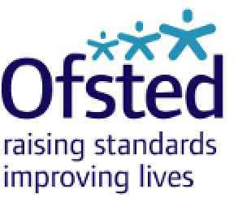

Amanda Spielman to continue as Ofsted Chief Inspector

The Education Secretary has today confirmed the reappointment of Amanda Spielman as Chief Inspector of Education, Children’s Services and Skills (HMCI) for a new term of two years.

The new term will commence on 1 January 2022, at the point the Chief Inspector’s initial five-year term concludes and will run until 31 December 2023

Ofsted: corona virus rolling update
Ofsted guidance and information relating to coronavirus (COVID-19) for schools, early years, children’s social care and further education and skills providers
Updated: 3 June 2021

Change made:
Updated the guidance on paediatric first aid certificates.

Early years and childcare

First aid certificates
If your paediatric first aid (PFA) certificate expired on or after 1 October 2020, the DfE previously advised that this would be valid until 31 March 2021. The extended deadline for requalification has now passed and providers must have a valid PFA certificate in place.

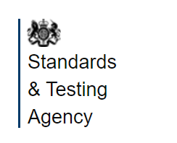

For the attention of all Heads, Assessment Leads and Reception Leads in maintained schools, Academies and Free Schools

Below is information from an official communication from the Standards and Testing Agency on 8 June 2021 Information: reception baseline assessment materials

The Reception Baseline Assessment (RBA) will be statutory in schools from September 2021.
Schools will shortly receive their assessment resource pack. This will include important information about how they can get ready for the assessment in the lead up to the summer holidays.
If your school does not receive this delivery by the end of June, you should contact the RBA helpline on 0330 088 4171 or email receptionbaseline@nfer.ac.uk.

Reminder: reception baseline assessment confirmation form

To help schools prepare for the RBA, headteachers were sent an email with a link to a short online form. This form captures key information about their school and gives headteachers the opportunity to nominate an RBA lead to oversee the day-to-day running of the assessment.
Headteachers should complete the confirmation form by Friday 18 June. If your school has not received a link, please contact the RBA helpline on 0330 088 4171 or email receptionbaseline@nfer.ac.uk.

Self-Employment Income Support Scheme fifth grant

A fifth grant covering May 2021 to September 2021 will be open to claims from late July 2021.
The grant is taxable and will be paid out in a single instalment.
Guidance for claiming the grant will be available by the end of June 2021
Self-Employment Income Support Scheme fifth grant - GOV.UK (www.gov.uk)

PACEY: The fifth SEISS grant will be paid in a single instalment and is calculated differently to previous grants. This time the amount you will receive is calculated based on how much your turnover has been reduced in the year April 2020 to April 2021. This is available to those living in the UK who are self-employed or a member of a partnership and covers May to September 2021. If you’re eligible based on your tax returns, HMRC will contact you in mid July 2021 to give you a date that you can make your claim from.
Safeguarding

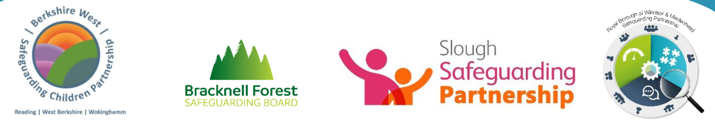

Pan Berkshire online child protection procedures updates April 2021 newsletter:

The procedures can be found at: https://proceduresonline.com/berks/

Health and wellbeing

Guidance for mental health and wellbeing in schools and colleges
Department of Education
02.06.21

The whole school or college approach, published by Public Health England (PHE), defines the behaviours that go with good mental health and wellbeing practice. Find out what help you can get to develop a whole school approach to mental health and wellbeing.

Public Health and Slough

Please read the additional information sent with this week’s newsletter about access to coronavirus testing in Slough
- Access to asymptomatic testing in Slough
- Slough testing sites
- Mobile testing sites in Slough

Useful information:

- Home - HWS Slough (healthandwellbeingslough.co.uk)

- Coronavirus (COVID-19): guidance and support - GOV.UK (www.gov.uk)

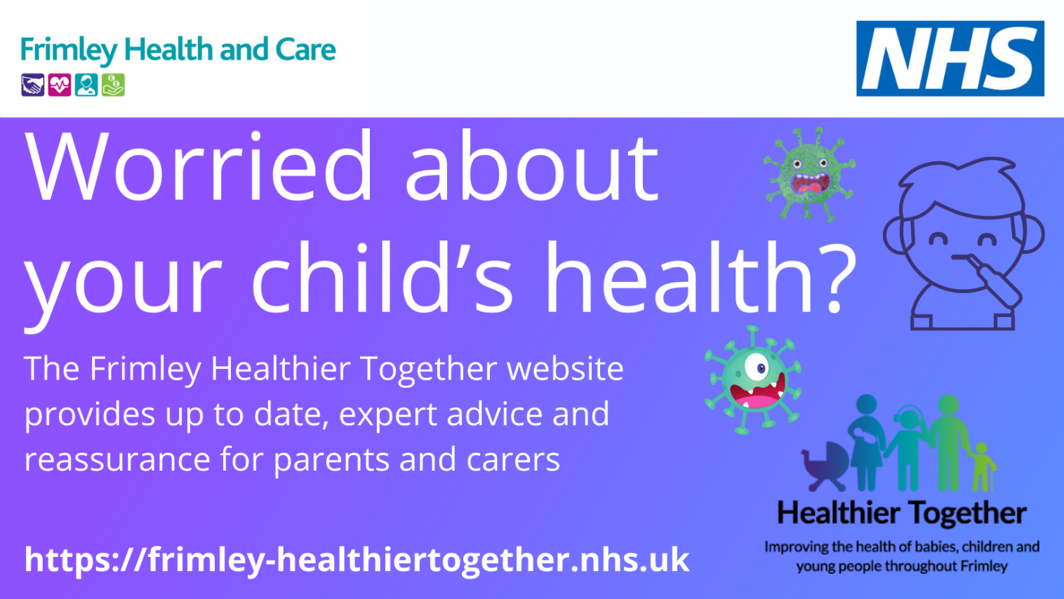

The Frimley Healthier Together website launch

It can be extremely stressful when a child is unwell. The Healthier Together website provides information to help recognise what might be wrong, where to seek help if required, what you should do to keep your child comfortable and how long your child's symptoms may last.
https://frimley-healthiertogether.nhs.uk/

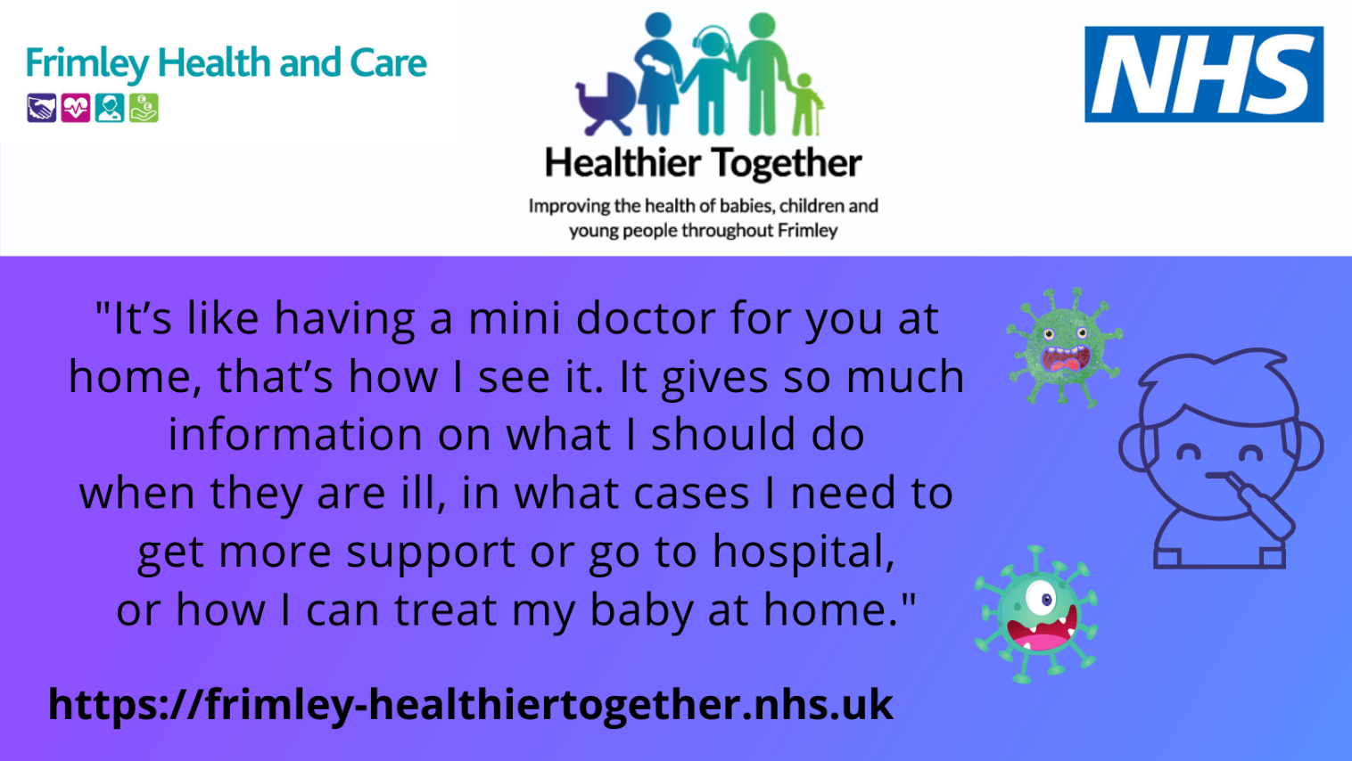
SEND and Inclusion

Summer born children unfairly labelled as having special needs

Summer-born children are being unfairly labelled by primary schools as having Special Educational Needs or Disabilities (SEND), according to new research from London School of Economics funded by the British Academy.

Updates for parents:

What parents and carers need to know about early years providers, schools and colleges during COVID-19
Last updated 12 May 2021

Making the news and events:

National Carers Week – 7-14 June

Carers Week is an annual campaign to raise awareness of caring, highlight the challenges unpaid carers face and recognise the contribution they make to families and communities throughout the UK. It also helps people who don't think of themselves as having caring responsibilities to identify as carers and access much-needed support.

The theme for this year is ‘Making Carers visible and valued’.

Partners have come together through the Slough Carers Partnership, which comprises of representatives from SBC, the CCG, Slough Children First, community and voluntary sector and carers to develop a local programme of activities for the week. It includes everything from coffee mornings and singing sessions, to virtual royal palace tours, cooking sessions and mindfulness and happiness workshops. For more information of events:

Carers week events - 7 to 13 June | Slough For You (sloughfamilyservices.org.uk)

Carers Week Events- 7-13 June 2021 – Slough Carers Support

Childhood Day 11 June 2021 NSPCC

Arts Experiences for Young Children
Barnardos and National Childhood Network
Lots of lovely creative play activities including malleables, drawing and painting, music and dance.

