Mobile Working

Policy Schedule

Policy owner and lead | ODHR: Health and Safety
Consultation | Trade unions | September 2021
 | CCF | September 2021
 | CMT | N/A
Equality Impact Assessment | Not Applicable
Approving body | H&S Board
Date of approval | July 2021
Date of implementation | September 2021
Version number | Version 1
Related documents | Codes of Practice: 009
Review interval | Annual

Contents Page Number

- Introduction 3

- Training 3

- Work Equipment 4

- Key Health and Safety Points 4

- Hierarchy of risk control for mobile working 5

Risk Assessment Template Form 6

Guidance – How to reduce the risk of injury 10

References 11

Documents (applicable to this guide):
COP 009 DSE

- Introduction

  - The aim of this document is to identify the principal risks to the health and safety of employees and contractors arising from mobile working.

  - For the purposes of this guide and legislation, the term mobile working means the use of mobile devices including laptops, tablets, phablets and smartphones

  - Work ‘whilst traveling’ is work that is carried out when actually using transport in transit rather than working between journeys in a café, community hub office etc.

  - The legislation requires an assessment of the risks to staff from the use of mobile equipment. The risk assessments must be specific to the particular equipment utilised by individuals and teams.

  - There are specific legal requirements, duties and responsibilities contained within the Health and Safety (Display Screen Equipment) Regulations 1992 as amended by the Health and Safety (Miscellaneous Amendments) Regulations 2002. The DSE Regulations are fit for purpose and are applicable to mobile working: They require organisations to
- Identify who the users are: Know and understand which staff are using mobile technology: Regulation 1.
- Assess the risks. Identify and understand how those staff are using that equipment: Regulation 2.
- Provide a suitable workstation. and provide equipment to allow staff to set up a suitable workstation and adopt good posture wherever they are: Regulation 3..
- Ensure staff have a good work routine and understand the need for breaks and allow them to take those breaks: Regulation 4.
- Provide eye-sight testing and corrective appliances if required: Regulation 5.
- Training about how to use (mobile) technology safely. Regulation 6.
- Provide Information about the risks and how to mitigate them. This should include advice on setting up mobile workspaces: Regulation 7

1.6 This COP should be read in conjunction with COP 009 Display Screen Equipment.

- Training

  - All staff must be provided with sufficient instruction, training or supervision to be able to carry out their work safely.

  - A key element of training is musculoskeletal risk management to make sure that a) people understand the risks they are exposed to, and b) what they should do about them.

  - Managers and supervisors should have sufficient experience or training to be able to identify the hazards and to be able to put in place measures to reduce the chances of injury.

  - Any employee who is required to use mobile devices must be trained in its safe use. Training records should be kept and maintained.

- Work equipment

  - The term ‘mobile devices’ applies to laptops, tablets, phablets and smartphones.

  - All mobile devices must be suitable for the purpose and maintained and repaired or renewed when damaged.

- Key Health and Safety Points

  - Managers and supervisors must ensure that:

- An assessment is carried out for all devices which are used by their team
- All employees or contractors work in accordance with the adopted safe working practices and procedures.
- Employees are provided with sufficient levels of information, instruction, training and/or supervision
- All accidents, incidents near misses and problems are reported and recorded as soon as possible.
- All work equipment is maintained to a safe condition
- All necessary documentation is maintained.
- All line managers should keep regular contact with all employees

  - Employees must ensure that:

- They support and engage in the completion a mobile working assessment
- Whenever there is a substantial change to the work that they undertake a further assessment must be undertaken.
- Attend the required training courses
- They advise their manager of any ill-effects being experienced whilst using devices.
- They advise their manager if they are have concerns for their health
- They adhere to the adopted safe working practices and procedures
- All accidents, incidents or near misses are reported to their manager or supervisor as soon as possible.
- They use devices in the correct manner and report any defects to their manager or supervisor.
- They do not endanger themselves or others.

- Hierarchy of risk control for mobile working

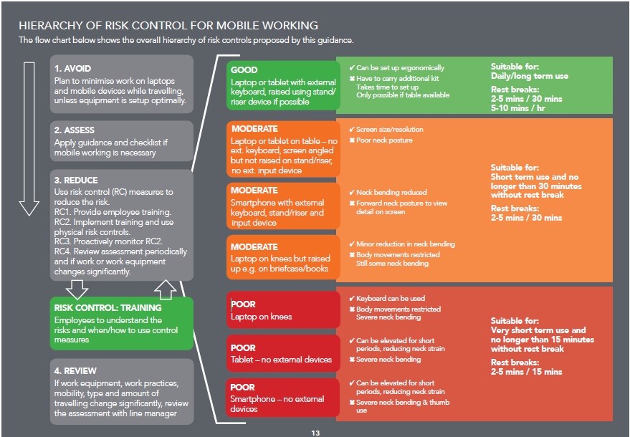
Source: Mobile Working Risk Management System - Guidance on managing the musculoskeletal risks from mobile working Chartered Institute of Ergonomics and Human Factors
Risk Assessment Title:
Directorate: |  |  |  |  |  | Service/Location: |  |  | Task:
Hazard |  |  | Before Controls |  |  | Existing Controls | After Controls |  |  | Further Action Required | By Whom and When
Activity/Equipment/  Process | Possible Injury/Harm | To Whom | Likelihood | Severity | Risk Rating
 |  |  |  |  |  |  | Likelihood | Severity | Risk Rating
Transporting your equipment | Manual handling | Employee |  |  |  | Maximum bag weight should be 10-15% of bodyweight.  This equates to ;-  Male 8.4kg – 12.5kg  Female 7kg – 10.5kg  Use a rucksack to transport items around as it spreads weight evenly throughout the body  Avoid heavy rucksacks  Ensure the length of the rucksack suits the user  Use a trolley if weight is over 10-15% of bodyweight or if employee has back issues  Take unnecessary items out of the bag before use
Type of work conducted e.g. emails, internet, document writing, spreadsheets, presentations, etc. | RSI, backache, shoulder pain, wrist and joint pain | Employee |  |  |  | Record the work conducted over a typical week to assess exposure and intensity of use  Consider working on a hard copy  Consider the weight and security of a hard copy  Avoid high intensity work where you are in a fixed position for longer periods If you need to work on the go then choose low intensity work or eliminate it altogether
Mobile working on laptops | RSI, backache, shoulder pain, wrist and joint pain | Employee |  |  |  | Avoid using a laptop directly on a table or desk:  Where possible use a laptop stand keyboard and mouse.  Provision of portable keyboards, mice etc  Consider the table height and seating:  Eyes should be level with the top of the screen  Elbows are the same height as the external keyboard  Legs should be supported and feet on a footrest or the floor.
Working on a laptop on your knees | RSI, backache, shoulder pain, wrist and joint pain | Employee |  |  |  | Avoid working with the laptop on your knees  Minimise the time spent working on the laptop  If the work is unavoidable raise the laptop with a portable laptop stand and keyboard  Make sure the laptop is stable and the vents are not obstructed  Take regular breaks (2-5 minutes every 15 minutes)  Undertake regular arm and hand exercises
Screen brightness | Eyestrain | Employee |  |  |  | Adjust screen brightness  Avoid working with the sunlight directly on the screen  Keep the screen clean
Tablets and smartphones | RSI, backache, shoulder pain, wrist and joint pain | Employee |  |  |  | Avoid long text entry  Use written notes and voice memos  Use dictation and voice control facilities  Use voice texting
Using a tablet as a laptop | RSI, backache, shoulder pain, wrist and joint pain | Employee |  |  |  | Use an external keyboard, case/stand and a stylus  Set up as ergonomically as possible  Standing up a tablet may help but there may still be poor neck posture  Use a tablet riser to raise the screen  Use a stylus to vary wrist posture
Sustained work on a smartphone | RSI, backache, shoulder pain, wrist and joint pain | Employee |  |  |  | Link to an external keyboard, raise the screen and use voice command or dictation  Take more frequent breaks  Avoid using a single thumb style typing  Place your little finger at the side not the base  Hold your phone up to your face not bending neck downwards  Rest your arms  Speak don’t type  Use handles or grips if holding your smartphone for long periods is not avoidable  Use screen filters to reduce glare and eyestrain  Use blue light filters or filter aps  Take regular breaks and adjust to match working conditions  Consider using rest break aps
Travel planning | Manual handling  RSI, backache, shoulder pain, wrist and joint pain | Employee |  |  |  | Book a table if working on a train or arrive early to secure a table seat  Plan ahead where you intend to work and avoid working with your laptop on your lap  Avoid working in your car  If you can’t then move away from the driver’s seat  If unavoidable then consider using a vehicle desk or go to a café instead  Avoid working on laptops on trains for sustained periods
Working in other company offices | Manual handling  RSI, backache, shoulder pain, wrist and joint pain | Employee |  |  |  | Check what facilities are available  Book a desk wherever possible  If working at the location for long periods then set up a laptop riser, portable keyboard and mouse.  Consider sending equipment to the destination if you do not have a car  Use an adjustable ergonomic chair.
Working in a hotel room | RSI, backache, shoulder pain, wrist and joint pain | Employee |  |  |  | Set up equipment ergonomically  Use business centres or travel hubs if these allow you to work more ergonomically
Employee wellbeing | Stress, anxiety, isolation | Employee |  |  |  | Managers to arrange regular contact with employees  Hold regular team meetings (via BlueJeans/ Microsoft Teams)  Managers to agree working hours to consider any caring responsibilities of employee  Managers should control and prioritise workloads ensuring they vary the tasks, and prioritise work streams  Set boundaries between working and non-working  hours – allow workers to disengage from work when  they are required to.  Encourage workers to discuss wellbeing/mental  ill-health concerns  Signpost to support options e.g. EAP, occupational health, etc  Establish monitoring and reporting systems
Insert additional concerns

Name of Assessor: Date:
Position: Review Date:
Managers Signature Date:

Guidance - How to reduce the risks of injury

Transporting your equipment
Tips for safe rucksack use
- Shoulder strap separation should not be too wide or narrow: the straps shouldn’t pinch your neck, or slope off the outsides of your shoulders.
- Length – check that the back or length of the rucksack is not too long (bouncing off your bottom) or short (hanging against your upper back only).
- Make sure that shoulder straps are adjustable and wide enough to not put uncomfortable pressure on your shoulders. Ideally straps should be cushioned although wider straps can adequately compensate for a lack of cushioning if you are carrying a light load.
- Avoid rucksacks that are already relatively heavy before you put anything in them.
- Compartments are important for business rucksacks, they will save time and reduce scope for equipment damage. You don’t want to spend valuable time bent over searching for things in the bottom of your bag.
- Rucksack straps should be adjusted so that your bag fit snugly against your back and doesn’t hang away at the top.
- Heavier items should be placed at the bottom and closer to your back.
Tips for safe single strap bag use:
- Only use a single strap bags for lighter loads.
- Use a bag with a wide strap and ideally a cushioning section which can be moved along the strap.
- Wear the strap across your body rather than on one side – this helps to reduce the asymmetric loading on spine and reduces poor shoulder posture.
- Alternate the bag frequently between shoulders.
- Keep the strap short to avoid the bag dangling and swaying when you walk.
- Avoid carrying your bag in your hands whenever possible.
When to use a wheeled bag
- Aim to use a wheeled bag if your load is over 10 to 15% of bodyweight .
- There are combination bags which allow you to alternate– between wearing as a rucksack and wheeling them – to suit different travel environments and situations.
- Remember – don’t be tempted to put too much into a wheeled bag – at some point you will probably still have to carry it i.e. steps and stairs.

Avoid unnecessary tasks that mean you are not in an optimal working positions. Consider using the time for thinking and planning instead.

Plan ahead to optimise how and where you work and match the tasks to your situation.
Trains
- Book a table seat wherever possible
- Book aisle seats to allow more elbow and arm movement

Cars
- Avoid working in your car for long periods
- If on the road then see if there is a café nearby where you can use a table
- If working in a car is unavoidable then do not sit at the drivers seat and use a lap desk
- Use transport hubs where possible

Visiting other offices
- Book a desk wherever possible
- Check what facilities are available
- Take a laptop riser, keyboard and mouse if facilities are not available
- Send equipment ahead if you are not driving
- Use an ergonomic adjustable seat

Control
- Take control of where and how you work
- Select your working environment proactively
- Consider thinking, discussing and planning versus typing
- Take control to prevent eyestrain - Control your screen brightness and report any heachaches and muscular aches to your manager immediately
- Ensure you have an eye test on a regular basis

Rest
- Take more frequent breaks when you are working in non-optimal arrangements
- Use rest break software
- Take micro pauses
- Take physical rest – put bags down if you can
- Rest, wellbeing and state of mind. Do you want to arrive at your destination refreshed and full of ideas or tired and uncomfortable from working in sub-optimal conditions?
- Be realistic about the work that can be achieved whilst travelling
- Look after your eyes
  - Avoid sunlight on your screen
  - Adjust your screen brightness
  - Ensure you clean your screen
  - Use anti-glare screen filters
  - Use blue light filters or filter aps
  - Apply the 20-20-20 rule – 20 minutes focusing on the screen then look away for 20 seconds at something 20 feet away
  - Rotate your device and zoom to increase character sizes

Technology – use it to maximum effect
- Use dictation and voice control
- Use hotkeys and keyboard shortcuts
- Try using Bluetooth pens instead of typing

References
- Work with display screen equipment: Health and Safety (Display Screen Equipment) Regulations 1992 as amended by the Health and Safety (Miscellaneous Amendments) Regulations 2002
- CIEH Mobile working guidance
- IOSH COVID-19 advice Managing remote workers

