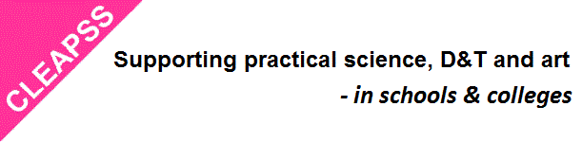

|  |  |  |
| --- | --- | --- |
| |  |  | | --- | --- | | |  | | --- | | **Prep your department for the Winter Holidays** | | |

|  |  |  |  |  |  |  |  |  |
| --- | --- | --- | --- | --- | --- | --- | --- | --- |
| |  |  |  |  |  |  |  |  | | --- | --- | --- | --- | --- | --- | --- | --- | | |  |  |  |  |  |  |  | | --- | --- | --- | --- | --- | --- | --- | | Before leaving your science department for the school holidays we advise that you go through the following check list in addition to the end of the day *‘aide memoire*’ from  [D](https://cleapss.us11.list-manage.com/track/click?u=a4601cd9dd7567ba7d1c8e848&id=64b3409ea6&e=7fe1b5f2d7)[L248b Running a Prep Room](https://cleapss.us11.list-manage.com/track/click?u=a4601cd9dd7567ba7d1c8e848&id=895f3b62cf&e=7fe1b5f2d7)  **End of Term Check List:**  Have animals and plants received adequate attention? Is electrical equipment turned off unless intended to be left on?   * **Make sure that plugs for the Fridges & Freezers have labels on them clearly indicating that they should not be switched off.** * **Check with facilities manager that power to the department will not be turned off over the holidays**   Are all gas taps turned off? Are all water taps turned off? If appropriate, are mains gas, electric &/or water turned off?  Are laboratory benches, floors and sinks free of broken glass? Are laboratory benches, floors and sinks free of spilled chemicals? Has completed practical equipment been removed from laboratories?  Are chemicals stored safely and correctly? Are gas cylinders stored securely in their normal place?  Are valuable and desirable items stored securely? In the prep room, are windows shut? Are cupboards that are the responsibility of technicians locked? Have teachers been reminded that they are responsible for the security of their own laboratories?  Have you taken appropriate Hot or Cold Weather Precautions for your chemical store?   |  |  |  | | --- | --- | --- | | |  |  | | --- | --- | | |  | | --- | | **Returning after the holidays - check your chemicals** | | | | |  |  | | --- | --- | | |  | | --- | | When you come back to school after the holidays, keep safe while you check that chemicals in the store are ok.  There may have been a spill or leak so keep safe by reading [GL246](http://science.cleapss.org.uk/Resource-Info/GL246-Checking-bottles-in-the-chemical-store.aspx) before going in, and check  [GL247](http://science.cleapss.org.uk/Resource-Info/GL247-The-shelf-life-of-chemicals.aspx) and [GL252](http://science.cleapss.org.uk/Resource-Info/GL252-Advice-on-purchasing-and-storing-concentrated-nitric-acid-65-70.aspx) for further details and advice on what to look for.    Be particularly careful if the weather has been hot or you are unsure that the store is ventilated well.  If you need any help or advice contact the CLEAPSS Helpline <https://science.cleapss.org.uk/helpline/> | | | | | |