Free RE network meeting

SACRE RE Adviser David Rees is inviting you to a special virtual launch event run by Kate Christopher
on Thursday 27th January at 4pm

Please let David Rees know if you are coming and a link will be sent to you separately
david@reesuk.onmicrosoft.com
Featuring a new KS2 & 3 resource and the opportunity to hear Kate Christopher from RE Online. Kate has written classroom resources for KS1-5 with RE Today previously
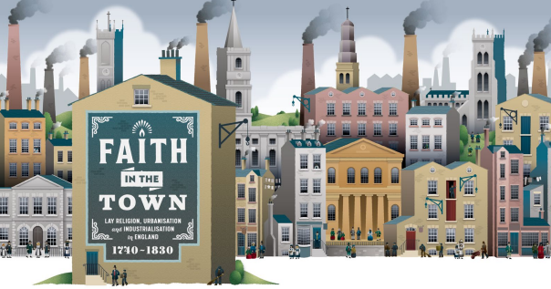

Faith in the Town
Find out about teaching resources bringing together History and RE, focusing on Christian faith in the Industrial Revolution.

There is growing interest in the potential of disciplinary studies in RE, such as History, Theology or Philosophy. This can be understood as looking through different lenses, such as a historical lens, to gain a rich understanding of the subject matter.

Ever wondered what History would actually look like in RE? How could it support understanding of religion and belief?
RE Adviser Kate Christopher has created practical teaching resources for KS2- 3 using current historical research into Christian faith during the Industrial Revolution.
Find out how pupils in RE can think like historians and explore faith, meaning and hope as life changed forever in the Industrial Revolution.

The teaching resources contain instructions for teachers, practical, classroom-ready resources for pupils and supportive notes for teachers’ enhanced understanding of this period.

This is the first example of historical thinking in RE, come along and see what you think!

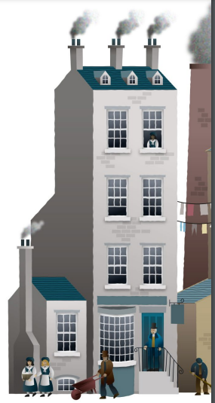

Please let David Rees know if you are coming and a link will be sent to you separately

