Cash Handling
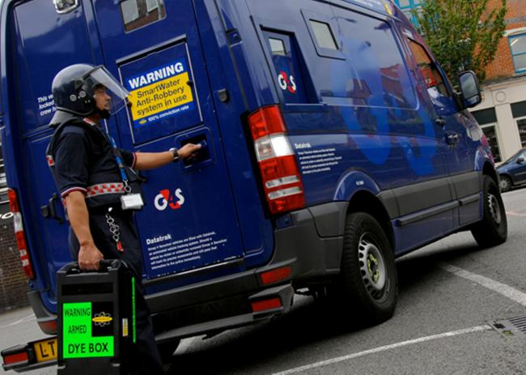
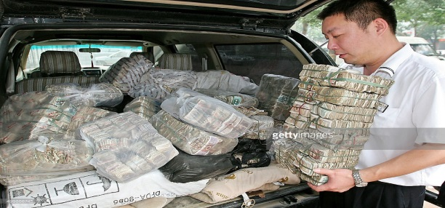
Policy Schedule | Details
Policy owner and lead | S(OD): HR: Health and Safety
Consultation | Trade unions: March 2019  CCF: April 2019  CMT: April 2019
Equality Impact Assessment | Not applicable
Approving body | H&S Board
Date of approval | July 2019
Date of implementation | October 2019
Version number | Version 2
Related documents | Codes of Practice: 001, 009, 010, 014, 020, 024, 027
Review interval | Biannual (2 Yearly)

Contents
Section | Page number
- Introduction | 3
- Training | 3
- Work Equipment | 3
- Key Health and Safety Points | 4
- Additional Information | 4

Introduction
  - The aim of this document is to identify the principal risks to the health and safety of employees, contractors and the members of the public arising from cash handling operations and specify the general precautions that must be taken to eliminate or reduce these risks.
  - For the purposes of this guide the term ‘cash handling’ refers to taking or paying out money, transporting money, emptying machines and banking money.
  - Generic risk assessments and methods of work may be appropriate for low risk activities. However, with the potential risk of violence, it is expected that most cash handling operations will have specific risk assessments.
  - There are specific legal requirements, duties and responsibilities contained within the Management of Health and Safety at Work Regulations 1999.

Training
  - All staff must be provided with sufficient instruction, training (Level 1 minimum) or supervision to be able to carry out their work safely.
  - Managers and supervisors should have sufficient experience or training to be able to identify the hazards involved in the cash handling operations and to be able to put in place measures to reduce the chances of injury.
  - Any employee who is required to carry out risk assessments for cash handling operations should as a minimum have attended the Level 2 training modules.
  - Any employee who is required to use work equipment must be trained in its safe use. Training records should be kept and maintained.

Work Equipment
  - The term ‘work equipment’ applies to any tool, machine, appliance, vehicle or lifting equipment.
  - All work equipment must be suitable for the purpose and maintained and repaired or renewed when damaged.
  - Where the safety of work equipment is dependent on proactive inspection and maintenance, a programme should be established for a competent person to carry out the necessary works (e.g. portable appliance testing and lifting equipment inspections).
  - Maintenance and inspection records should be kept

Key Health and Safety Points
  - Management and supervisors must ensure that:
    - All employees or contractors work in accordance with the adopted safe working practices and procedures.
    - Employees are provided with sufficient levels of information, instruction, training and/or supervision.
    - All accidents, incidents, near misses and problems are reported and recorded as soon as possible.
    - All work equipment and personal protective equipment is maintained to a safe condition.
    - Employees wear any Personal Protective Equipment that has been provided.
    - All hazards are eliminated or minimised to reduce the risk of injury.
    - All necessary documentation is maintained.
  - Employees must ensure that:
    - They adhere to the adopted safe working practices and procedures.
    - All accidents, incidents or near misses are reported to their manager or supervisor as soon as possible
    - They immediately bring to the attention of their manager or supervisor any uncontrolled hazards.
    - They use work equipment in the correct manner and report any defects to their manager or supervisor.
    - They wear any Personal Protective Equipment that has been provided for their safety and report any defects to their manager or supervisor
    - They do not endanger themselves or others.

Additional Information
  - Reference Documentation
    - Management of Health and Safety at Work Regulations 1999
    - HS (G) 133 Preventing violence to retail staff
    - Slough Borough Council guidelines on use of mobile phones
    - Code of Practice COP 015 - Personal Safety & Lone Working
    - Code of Practice COP 001 – Accident/Incident Reporting
    - FORM 004A - CASH HANDLING Risk Assessments

Document Control
Issue | Date | Changed by | Updates
1 | 1/05/11 | Vicki Swift H&S Advisor | First Published
2 | 13/12/22 | Georgina Watson Interim H&S Professional | Reviewed content – no changes. Made Accessible. Extracted form into it’s own document.

