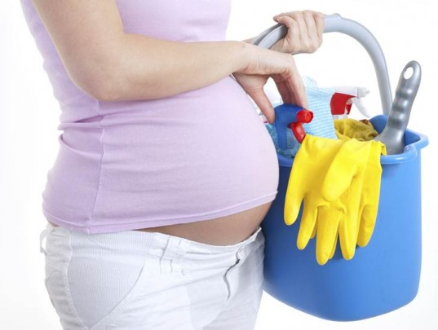
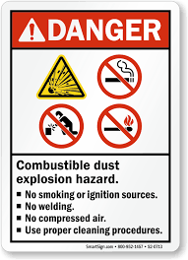
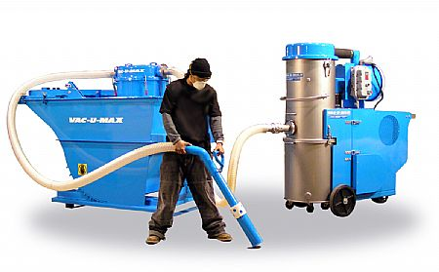
Cleaning

Policy Schedule | Details
Policy owner and lead | S(OD): HR: Health and Safety
Consultation | Trade unions: March 2019  CCF: April 2019  CMT: April 2019
Equality Impact Assessment | Not Applicable
Approving body | H&S Board
Date of approval | July 2019
Date of implementation | October 2019
Version number | Version 1
Related documents | Codes Of Practice: 005, 008, 014, 019, 020, 021, 024, 025, 027, 028, 029
Review interval | Biannual (2 Yearly)

Contents
Section | Page number
- Introduction | 3
- Training | 3
- Work Equipment | 3
- Key Health and Safety Points | 3-4
- Additional Information | 4

Introduction
  - The aim of this document is to identify the principal risks to the health and safety of employees, contractors and the members of the public arising from cleaning operations and specify the general precautions that must be taken to eliminate or reduce these risks.
  - For the purposes of this guide the term ‘cleaning’ refers cleaning of offices, housing blocks, leisure centres, theatres, school buildings and public toilets
  - Generic risk assessments and methods of work can be used for routine tasks. However, specific risk assessments should be prepared for high-risk activities (e.g. use of industrial strength cleaning chemicals or picking up sharps).
  - There are specific legal requirements, duties and responsibilities contained within the Management of Health and Safety at Work Regulations 1999 and the Control of Substances Hazardous to Health Regulations 2002.

Training
  - All staff must be provided with sufficient instruction, training (Level 1 minimum) or supervision to be able to carry out their work safely.
  - Managers and supervisors should have sufficient experience or training to be able to identify the hazards involved in the project and to be able to put in place measures to reduce the chances of injury.
  - Any employee who is required to carry out risk assessments for cleaning operations should as a minimum have attended the Level 2 training modules.
  - Any employee who is required to use work equipment must be trained in its safe use. Training records should be kept and maintained.

Work Equipment
  - The term ‘work equipment’ applies to any tool, machine, appliance, ladders, vehicle, lifting equipment, mop and buckets etc.
  - All work equipment must be suitable for the purpose and maintained and repaired or renewed when damaged.
  - Where the safety of work equipment is dependent on proactive inspection and maintenance, a programme should be established for a competent person to carry out the necessary works (e.g. portable appliance testing and lifting equipment inspections).
  - Maintenance and inspection records should be kept.

Key Health and Safety Points
  - Managers and supervisors must ensure that:
    - All employees or contractors work in accordance with the adopted safe working practices and procedures.
    - Employees are provided with sufficient levels of information, instruction, training and/or supervision.
    - All accidents, incidents, near misses and problems are reported and recorded as soon as possible.
    - All work equipment and personal protective equipment is maintained to a safe condition.
    - Employees wear any Personal Protective Equipment that has been provided.
    - Members of the public are kept well clear of any hazardous operation/area.
    - All hazards are eliminated or minimised to reduce the risk of injury.
    - Welfare facilities are provided for the employees.
    - All necessary documentation is maintained.
  - Employees must ensure that:
    - They adhere to the adopted safe working practices and procedures.
    - All accidents, incidents or near misses are reported to their manager or supervisor as soon as possible.
    - They immediately bring to the attention of their manager or supervisor any uncontrolled hazards.
    - They use work equipment in the correct manner and report any defects to their manager or supervisor.
    - They wear any Personal Protective Equipment that has been provided for their safety and report any defects to their manager or supervisor
    - They do not endanger themselves or others.

Additional Information
  - Reference Documentation
    - Health & Safety Executive: Cleaning.

Document Control
Issue | Date | Changed by | Updates
1 | 1/5/11 | V Swift H&S Advisor | First Published
2 | 14/12/22 | Georgina Watson Interim H&S Professional | Reviewed document. Made accessible. Separated risk assessment into new form

