Confined Spaces
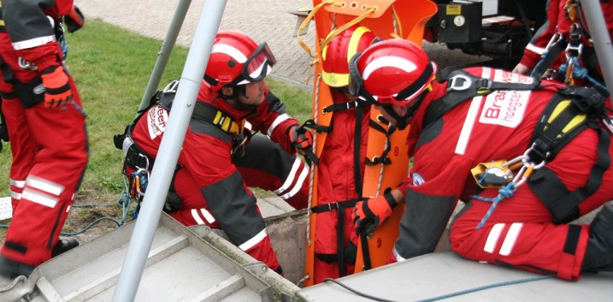
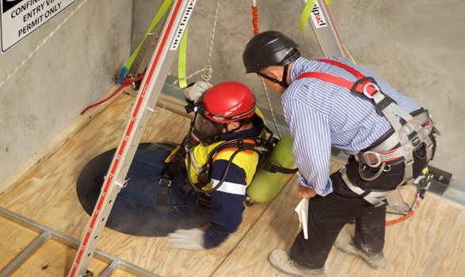
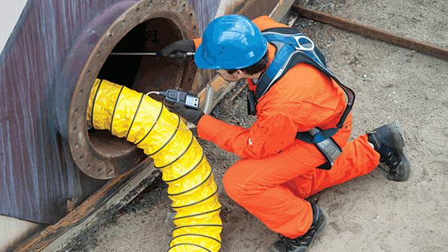
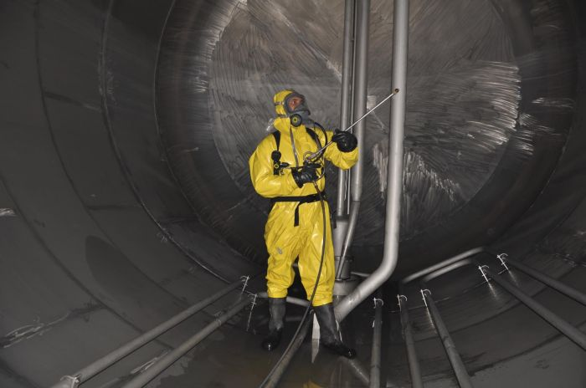
Policy Schedule | Details
Policy owner and lead | S(OD): HR: Health and Safety
Consultation | Trade unions: March 2019  CCF: April 2019  CMT: April 2019
Equality Impact Assessment | Not Applicable
Approving body | H&S Board
Date of approval | 30/07/2020
Date of implementation | 30/07/2020
Version number | Version 2
Related documents | Codes of Practice: 001, 003, 007, 008, 010, 011, 012, 013, 016, 019, 020; 021, 024, 025, 027, 032
Review interval | Biannual (2 Yearly)

Contents
Section | Page number
- Introduction | 3
- Training | 3
- Work Equipment | 3
- Key Health and Safety Points | 3-4
- Safe System of Work | 4-6
- Permit to Work | 6
- Additional Information | 6-7

Introduction
  - The aim of this document is to identify the principal risks to the health and safety of employees, contractors and the members of the public arising from working in confined spaces and specify the general precautions that must be taken to eliminate or reduce these risks.
  - For the purposes of this guide the term ‘a confined space’ refers to any place that is substantially closed and there is a reasonably foreseeable risk of serious injury within the space or nearby.
  - Whenever work is carried out in a confined space specific risk assessments and documented methods of work must be in place. Generic risk assessments and methods of work are not usually appropriate.
  - Activities in a confined space require a ‘Permit To Work’ procedure.
  - There are specific legal requirements, duties and responsibilities contained within the Confined Spaces Regulations 1997.

Training
  - All staff must be provided with sufficient instruction, training (Level 1 minimum) or supervision to be able to carry out their work safely. (Specialist training will be required for tasks that involve working in confined spaces.)
  - Managers, supervisors and Clerks of Works should have sufficient experience or training to be able to identify the hazards involved in the project and to be able to put in place measures to reduce the chances of injury.
  - Any employee who is required to carry out risk assessments for work in confined spaces should as a minimum have attended the Level 2 training modules.
  - Any employee who is required to use work equipment must be trained in its safe use. Training records should be kept and maintained.
  - An example toolbox talk and an attendance record is provided in:
    - INFO 007B Confined Spaces Toolbox Talk Content
    - FORM 032A Toolbox Talk attendance record

Work Equipment
  - The term ‘work equipment’ applies to any tool, machine, appliance, access equipment (e.g. ladders and scaffolding), vehicle or lifting equipment.
  - All work equipment must be suitable for the purpose and maintained and repaired or renewed when damaged.
  - Where the safety of work equipment is dependent on proactive inspection and maintenance, a programme should be established for a competent person to carry out the necessary works (e.g. pressure system and lifting equipment testing.
  - Maintenance and inspection records should be kept.

Key Health and Safety Points
  - Managers, supervisors and Clerks of Works must ensure that:
    - No work in a confined space is allowed without an agreed Permit To Work with an accompanying method statement and risk assessment.
    - All employees or contractors work in accordance with the adopted safe working practices and procedures.
    - Employees are provided with sufficient levels of information, instruction, training and/or supervision including provision of a buddy system during the confined space work.
    - All accidents, incidents, near misses and problems are reported and recorded as soon as possible.
    - All work equipment and personal protective equipment is maintained to a safe condition.
    - Employees wear any Personal Protective Equipment that has been provided.
    - Members of the public are kept well clear of any hazardous operation/area.
    - All hazards are eliminated or minimised to reduce the risk of injury.
    - Welfare facilities are provided for the employees.
    - All necessary documentation is maintained.
  - Employees must ensure that:
    - They adhere to the adopted safe working practices and procedures.
    - All accidents, incidents or near misses are reported to their manager or supervisor as soon as possible.
    - They immediately bring to the attention of their manager or supervisor any uncontrolled hazards.
    - They use work equipment in the correct manner and report any defects to their manager or supervisor.
    - They wear any Personal Protective Equipment or Rescue Equipment that has been provided for their safety and report any defects to their manager or supervisor
    - They do not endanger themselves or others.
    - They understand all the precautions that are to be taken.
    - They are medically fit to undertake the work.

Safe Systems of Work
  - Avoid entering confined spaces.
  - If entry into a confined space cannot be avoided, make sure a safe system of work is in place for the work to be carried out.
  - Use the results from your risk assessment to help identify the precautions that need to be taken to reduce the risk of injury. This will depend on the nature of the confined space, the associated risk and the work involved.
  - The following elements are some of the measures to be considered to eliminate, reduce, control or monitor the hazards:

    - Identify potential sources of contamination from surrounding areas.
    - Check the size of the entrance i.e. is it big enough to allow workers wearing all the necessary equipment to climb in and out easily, and to provide suitable access and means to exit in an emergency.
    - Identify risks of ground water entering the confined space.
    - Identify whether the work activity will produce hazardous conditions within the confined space.
    - Test the atmosphere in the confined space before entry for oxygen level, flammable gas and any toxic gas that has been identified by the risk assessment.
    - Ventilate the confined space throughout the operation.
    - Isolate the space.
    - Where practical, before work begins remove any sludge, liquids etc that may release harmful gases of vapours.
    - Before work begins, ensure gas, power etc is turned off and ventilate area for at least 15 minutes.
    - Extract at source, any fumes generated by the work in the confined space.
    - Continual monitoring of the atmosphere while personnel are in the confined space
    - Competent person remains outside the confined space while work is being carried out.
    - Personnel undertaking the work within the confined space have the relevant training, knowledge and physical ability to carry out the work.
    - Personnel inside the confined space have appropriate personal protective equipment and are wearing harnesses for rescue purposes.
    - Safety lines and winching equipment available for rescue purposes.
    - Self-contained emergency escape breathing apparatus carried by personnel in the confined space for use if monitoring equipment indicates a problem or a worker collapses.
    - Electrical equipment to be suitable for use in flammable atmospheres (intrinsically safe)
    - Rescue procedures must be defined, practised and understood by those involved.
    - All equipment must be regularly maintained and inspected by a competent person and a suitable record kept.
    - Consideration of any special tools or lighting which may be required.
    - A permit-to-work procedure is in place.
    - All personnel involved must be trained in the use of monitoring equipment i.e. gas monitor, safety harness, alarm etc, breathing apparatus, rescue procedures.
    - Means of communication should be in place and tested prior to work being undertaken. Any special instructions or precautions should be clearly recorded and communicated.
    - Means of raising the alarm should be tested prior to work being carried out.
    - Provision of first aiders in a rescue situation.
    - Consideration of shut down of nearby plant before attempting emergency rescue.
    - Consideration of notifying local emergency services in the event of an emergency i.e. fire brigade.
    - Ensure personnel are issued with a Weil’s Disease (Leptospirosis) card if carrying out any sewer related work. This can be shown to their doctor should they fall ill during or shortly after such work.
An example of a procedure is available in INFO 007A Typical Safe Work Procedures for entering a sewer example.

Permit to Work
  - A permit to work is a formal written system used to control certain types of work that are potentially hazardous. The document should specify the work to be done and the precautions to be taken.
  - The permit to work must include:
    - A title.
    - A reference number and any cross reference to other related permits to work.
    - Job Location.
    - Identification of any plant that is being worked on.
    - Description of the work to be done and its limitations.
    - Details of the hazards – including residual hazards and those that are introduced by the work.
    - Details of the precautions that are to be taken. The person(s) who carry out the precautions should sign to confirm that the precautions have been carried out. i.e. barriers, warning signs, covers etc.
    - Details of the protective equipment that is to be used.
    - Authorisation of the permit including the date and time duration of the permit.
    - Signature confirming the understanding of the tasks, hazards involved and the precautions required. Also confirming that the information has been passed to the workers and that the precautions have been taken.
    - Where the work requires an extension of time or a change of shift – a signature is required to confirm that the precautions are still in place and any new workers have been made fully aware of the hazards/precautions.
    - Signature confirming that the work has been completed and, where necessary, the plant is ready for testing and commissioning.
    - Cancellation of the permit – signature confirming that the work/plant has been tested and found to be satisfactory.
  - A template is available in FORM 007A Permit to Work template.

Additional Information
  - External Reference Documentation
    - Confined Spaces Regulations 1997
    - Control of Substances Hazardous to Health Regulations 2002
    - Control of Substances Hazardous to Health (Amendment) Regulations 2004
    - Health & Safety Executive website: Confined Spaces
    - Corporate Code of Practice 002 –Construction, Design & Maintenance
    - INDG258 Confined Spaces A Brief guide to working safely
    - Provision and Use of Work Equipment Regulations (PUWER) 1998
    - Workplace (Health and Safety and Welfare) Regulations 1992
    - Management of Health and Safety at Work Regulations (MHSWR) 1999
    - Personal Protective Equipment Regulations 2002
    - Personal Protective Equipment at Work Regulations 1992 (as amended)
    - Lifting Operations and Lifting Equipment Regulations (LOLER) 1998
    - Health and Safety (Safety Signs and Signals) Regulations
  - SBC Reference Documentation
    - INFO 007A Typical Safe Work Procedures for entering a sewer example
    - INFO 007B Confined Spaces Toolbox Talk Content
    - FORM 007A Permit to Work Template
    - FORM 007B Confined Space Risk Assessment Example
    - FORM 032A Toolbox Talk attendance record

Document Control
Issue | Date | Changed by | Updates
3 | 16.12.2022 | Georgina Watson Interim H&S Professional | Made accessible. Extracted appendices into forms and info sheets. Reviewed content.

