Autumn 2022. Assessment and moderation newsletter

Jamie Debbie

Welcome to another year of assessments. We all thought that Key stage 1 assessments would not take place this year. Unfortunately, this is not the case. All change – again!

The government, in their wisdom, have continued with them for another year due to the pandemic.

However, Key stage 1 SATs will be not take place from 2023-24. The government has finally confirmed this.
The Standards and Testing Agency (STA) confirmed tests for seven-year-olds will become non-statutory from September 2023, meaning primary schools won’t have to run them in 2024.
Recruitment of moderators for both Key stage 1 and 2.

We look forward in having previous moderators to successfully complete the standardisation exercise to become moderators again. We also look forward in having new colleagues too. There will be training for those who wish to become moderators next term. As in previous years, potential moderators will need to successfully complete the standardisation exercise to become a moderator. You have two opportunities to do so.

2023 Key stage 2 SATs – A change

There will be an additional bank holiday in honour of the Coronation of His Majesty King Charles III. This will take place on Monday 8 May 2023. As this date had previously been announced as the first day of the 2023 key stage 2 (KS2) test week in England, a change to the KS2 test schedule next year is necessary.
KS2 tests will take place in the same week with tests following the usual order but each taking place one day later than originally planned. As such, the new schedule will be:
- Tuesday 9 May: English grammar, punctuation and spelling (GPS) papers 1 (questions) and 2 (spelling)
- Wednesday 10 May: English reading paper
- Thursday 11 May: mathematics papers 1 (arithmetic) and 2 (reasoning)
- Friday 12 May: mathematics paper 3 (reasoning)
The KS2 timetable variation (TTV) window for each assessment will also move back one day, in accordance with this change.
There will be no changes to arrangements for our other assessments, including KS2 teacher assessments, key stage 1 tests and teacher assessments, the phonics screening check and the multiplication tables check. Dates and deadlines for these assessments remain as previously announced.

Standardisation timeline

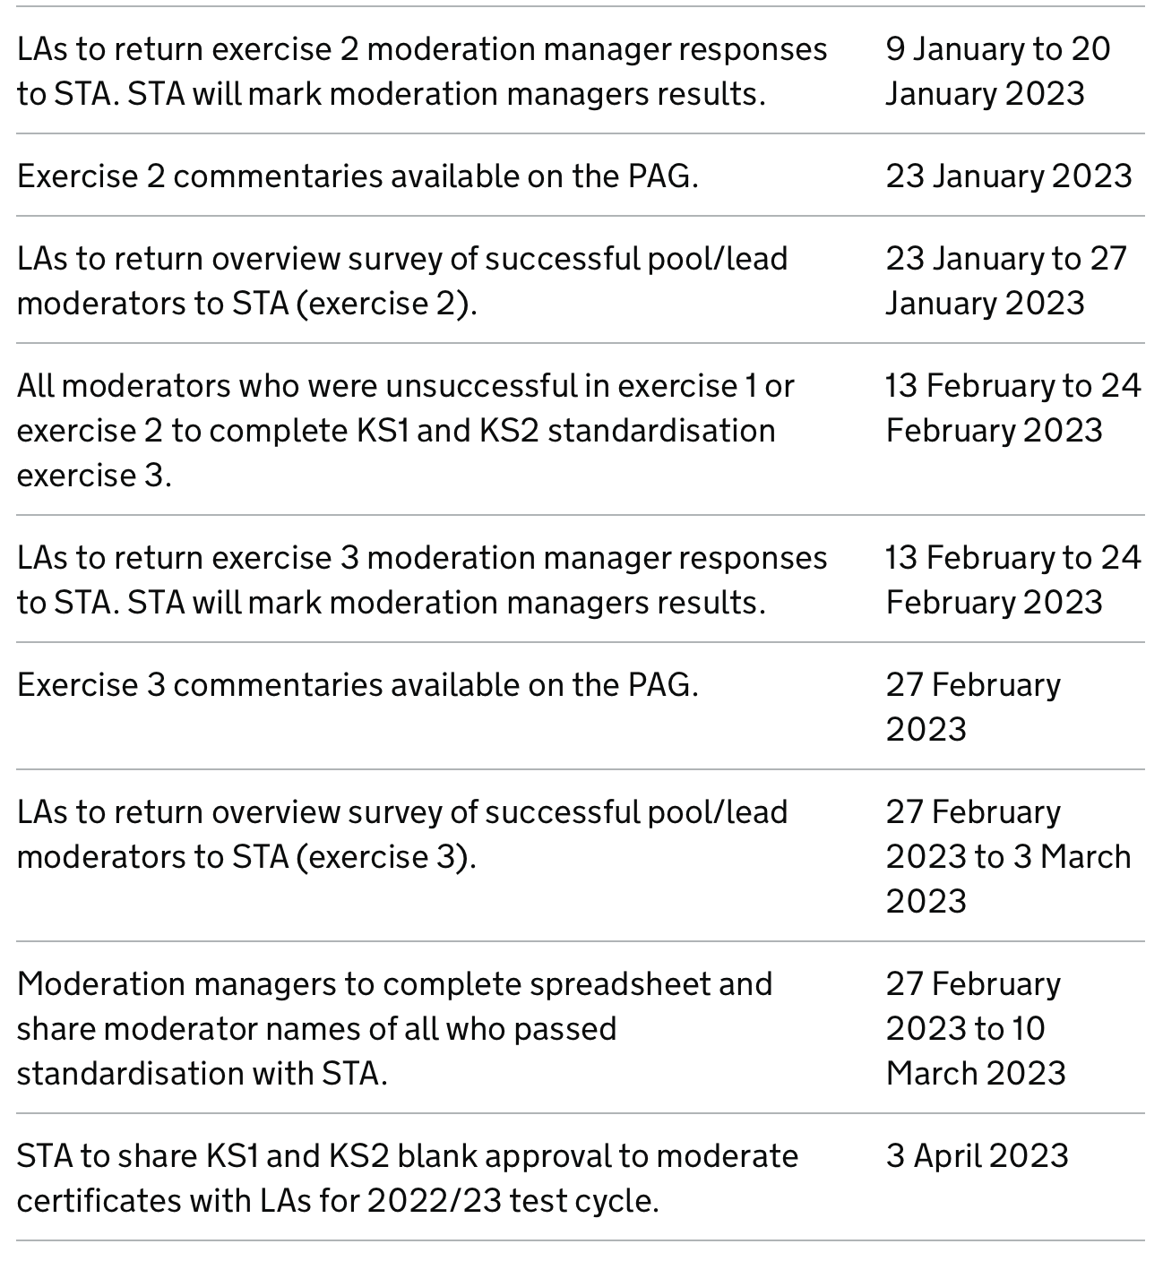

Academies, free schools and independent schools

Each key stage is moderated annually. We are required to moderate at least 25% of maintained schools and 25% of academies and participating independent schools, that have opted into the LA’s external moderation process.

These are some of the important dates linked to teacher assessment in the spring term 2023.

Date | Action
Monday 13th February | Pupil registration form available on the PAG for all schools (including special schools) to complete for the end of KS2 tests (see section 6.2)  Forms available on the PAG for schools to make applications for:  - early opening  - compensatory marks for spelling  - additional time  - timetable variations
Friday 10th March | Deadline for all schools (including special schools) to complete pupil registration for the end of KS2 tests and if applicable submit applications for early opening
Monday 13th March | KS2 test administration guidance published
Monday 10th April | Deadline for schools to be notified of early opening application outcomes on the PAG (Primary Assessment Gateway)

I thought I would put this in. A school writing about the Diamond Jubilee and now having a new king.

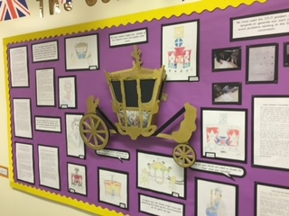

Assessment and reporting arrangements

Assessment and reporting arrangements have been issued for both key stage 1 and 2.

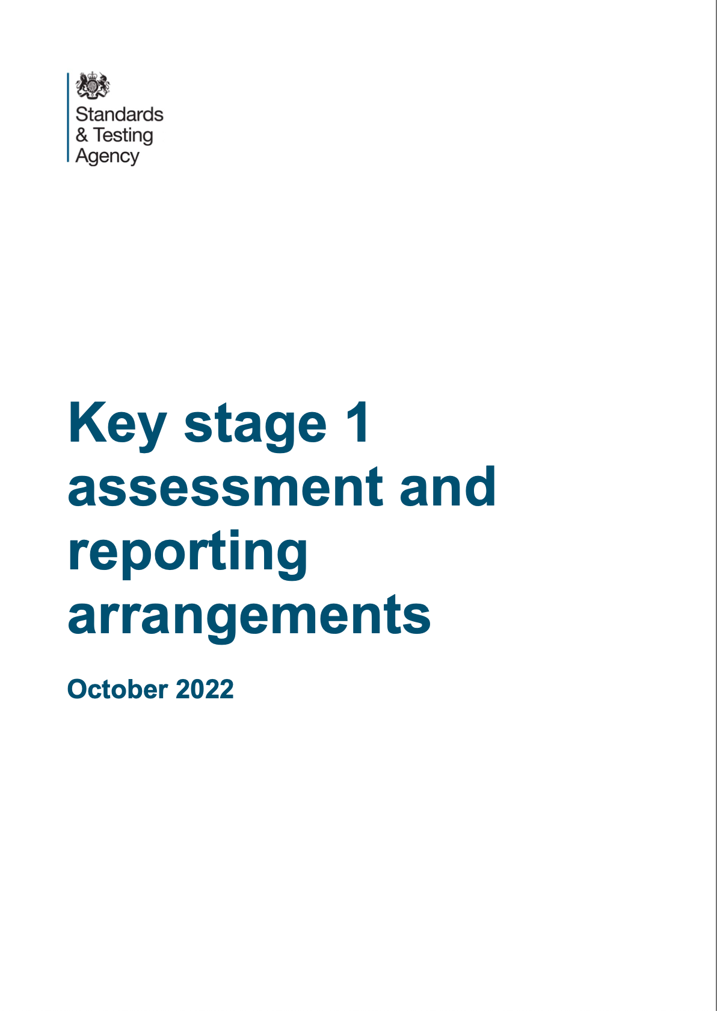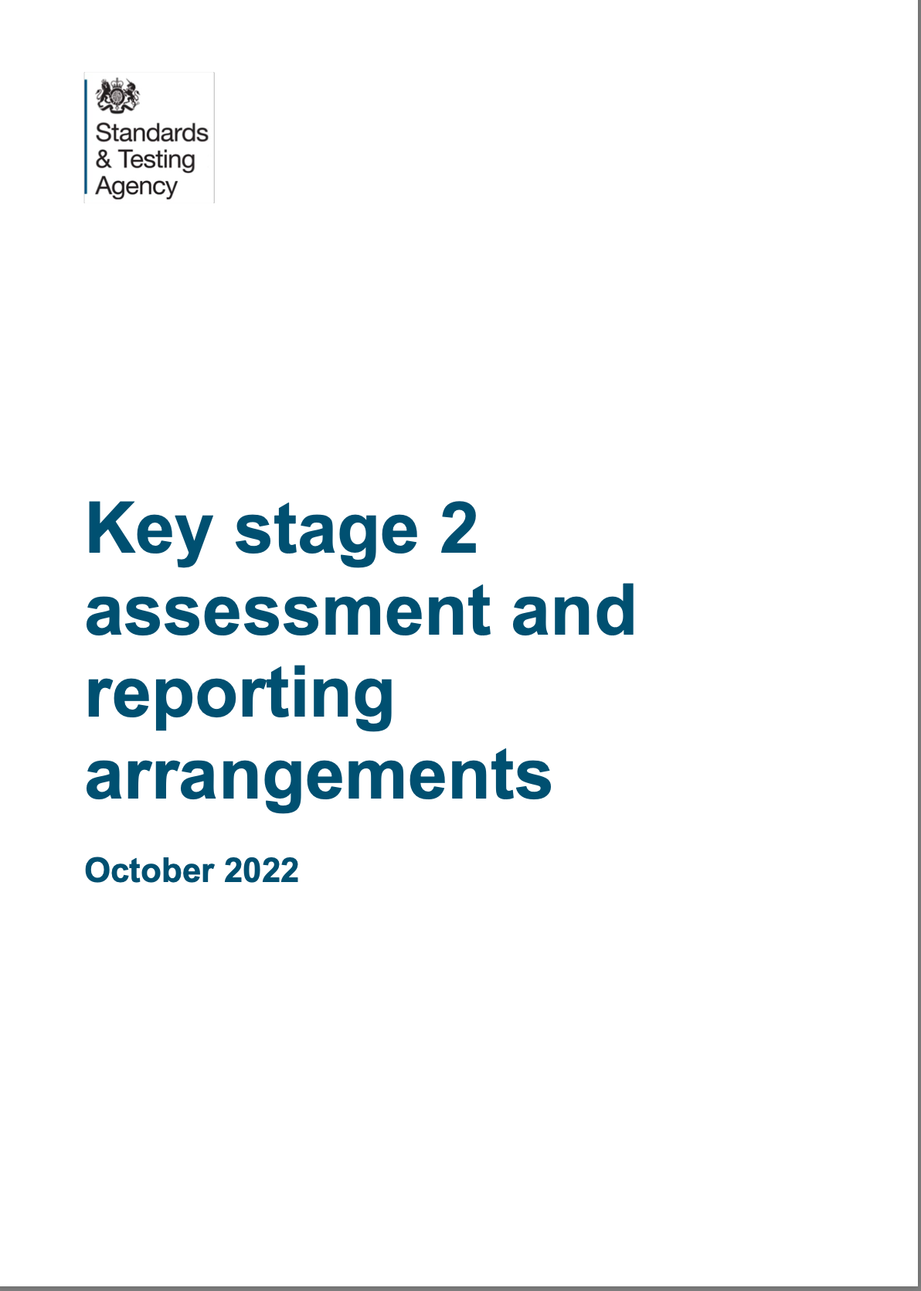
They are available at:
https://assets.publishing.service.gov.uk/government/uploads/system/uploads/attachment_data/file/1110106/2023_key_stage_1_assessment_and_reporting_arrangements.pdf

https://assets.publishing.service.gov.uk/government/uploads/system/uploads/attachment_data/file/1110107/2023_key_stage_2_assessment_and_reporting_arrangements.pdf

Timetable of events for Key stage 1 and 2 assessments.

Key stage 1
Date | Activity
May 2023 | Key stage 1 test period
Commencing 12th June | Phonics screening check
Key stage 2
Tuesday 9th May | SATs week
Monday 5th June within 2 weeks | Year 4 timetables check
Key stage 1 and 2
Monday 12th May | LAs begin informing schools if they will receive an external moderation visit for teacher assessment
Monday 5th June | LAs undertake external moderation of KS1 for English reading and writing and mathematics. KS2 English writing teacher assessment.

Training for moderators

There will be moderator training in the new calendar year in January 2023.
There is separate training for Key stage 1 and Key stage 2 and they will be at different venues.
Debbie will lead Key stage 1 training
Jamie will lead Key stage 2 training.
The courses will be on Eventbrite. Those who would like to be a moderator this year need to have had permission from their headteacher.
At the end of the training day, the standardisation exercise will need to be completed.

If you or someone in your team is interested in becoming a KS1 moderator there is still time to apply. To express interest candidates should;
- be qualified teachers with recent experience of teaching in Y2 (KS1) or Y6 (KS2)
- have recent experience of being a moderator or being moderated
- be available to attend moderation training and briefings - usually held as twilights
- be available to moderate in other schools on 3-4 dates in June 2023 - reasonable travel and supply costs can be claimed to cover this.
- have the support of their headteacher to take this role.
- pass the standardisation exercise

Training opportunities

Date: 18th January 2023

Audience: For experienced Year 2 and Key stage 1 teachers.
An opportunity, for teachers to become moderators to support the LA with the verification of standards when schools receive moderation visits in the summer term.
The training is face to face. Lunch is provided and refreshments are available.
Please note there is no parking on site
Time: 9.30– 4pm – to include standardisation
Facilitator: Debbie Powell
Venue: Holy Family Catholic School
Cost: £120 per delegate

Date: 19th January 2023

Audience: For experienced Year 6 and Key stage 2 teachers.
An opportunity, for teachers to become moderators to support the LA with the verification of standards when schools are to be moderated this year.
Please note there is no parking on site and you will need to bring lunch with you.
Refreshments available
The training is face to face.
Time: 9.30 – 4pm – to include standardisation exercise.
Facilitator: Jamie Hassan
Venue: Our Lady of Peace School
Cost: £120 per delegate
Date: 1st February 2023

Audience: For ECTs teaching year 2 and teachers new to year 2
Attendance is highly recommended for teachers in all schools to ensure that they are familiar with arrangements for end of Key Stage 1 assessment this year
The training is face to face. Lunch is provided.
Please note there is no parking on site
Time: 9.30 – 3.30pm
Facilitator: Debbie Powell
Venue: Holy family Catholic School
Cost: £120 per delegate

Date: 2nd February 2023

Audience: For ECTs teaching year 6 and teachers new to year 6
Attendance is highly recommended for teachers in all schools to ensure that they are familiar with arrangements for end of Key Stage 2 assessment this year.
Please note there is no parking on site
Lunch is provided and refreshments are available.
The training is face to face.
Time: 9.30 – 3.30pm
Facilitator(s): Jamie Hassan
Venue: Our Lady of Peace School
Cost: £120 per delegate

Courses will be advertised on the slough website called https; thelink.slough.gov.uk. There is a page called Statutory Moderation and Assessment. This is where training will be advertised and also on the same website LA Services/school effectiveness services

Cross moderation opportunities
These are opportunities where teachers from different schools can share their childrens work to see if they are likely to meet the standards required at the end of each key stage

Key stage 1

Date: 1st March 2023
Time: 4 – 5pm
Focus: Reading
Facilitator: Debbie Powell
Venue: Holy Family Catholic School
Cost: Free

Date: 29th March 2023
Time: 4 – 5pm
Focus: Writing
Facilitator: Debbie Powell
Venue: Holy Family Catholic School
Cost: Free

Key stage 2

Date: 2nd March 2023
Focus: Writing
Time: 4 – 5.30pm
Facilitator: Jamie Hassan
Venue: Our Lady of Peace Catholic School
Cost: Free

Date: 22nd March 2023
Focus: Writing
Time: 4 – 5.30pm
Facilitator: Jamie Hassan
Venue: Our Lady of Peace Catholic School
Cost: Free

We look forward to seeing you in the New Year.
Have a happy Christmas and a restful break.
Jamie and Debbie

