Thames Valley Police
Partnership Agency Intelligence Sharing Submission Form
Please complete all 3 sections of this form and return to the relevant county e-mail address listed at the bottom of the form.
Reporting Person Details
Reporting Person Name
Reporting Person Job Title & Organisation
Reporting Person E-mail Address
Reporting Person Telephone

Source Details
Does the information originate from the person above?
If no please provide the source details below. This will be held securely and not released.
Source Name and Date of Birth
Source Address
Source Telephone
Source E-mail
Do you believe the source is willing to be contacted by police?

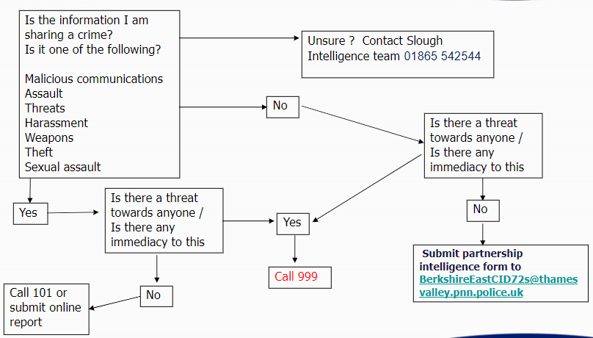

Intelligence Report
Date of Report
Additional Information

Once completed e-mail to the below email addresses:
BerkshireEastCID72s@thamesvalley.pnn.police.uk

