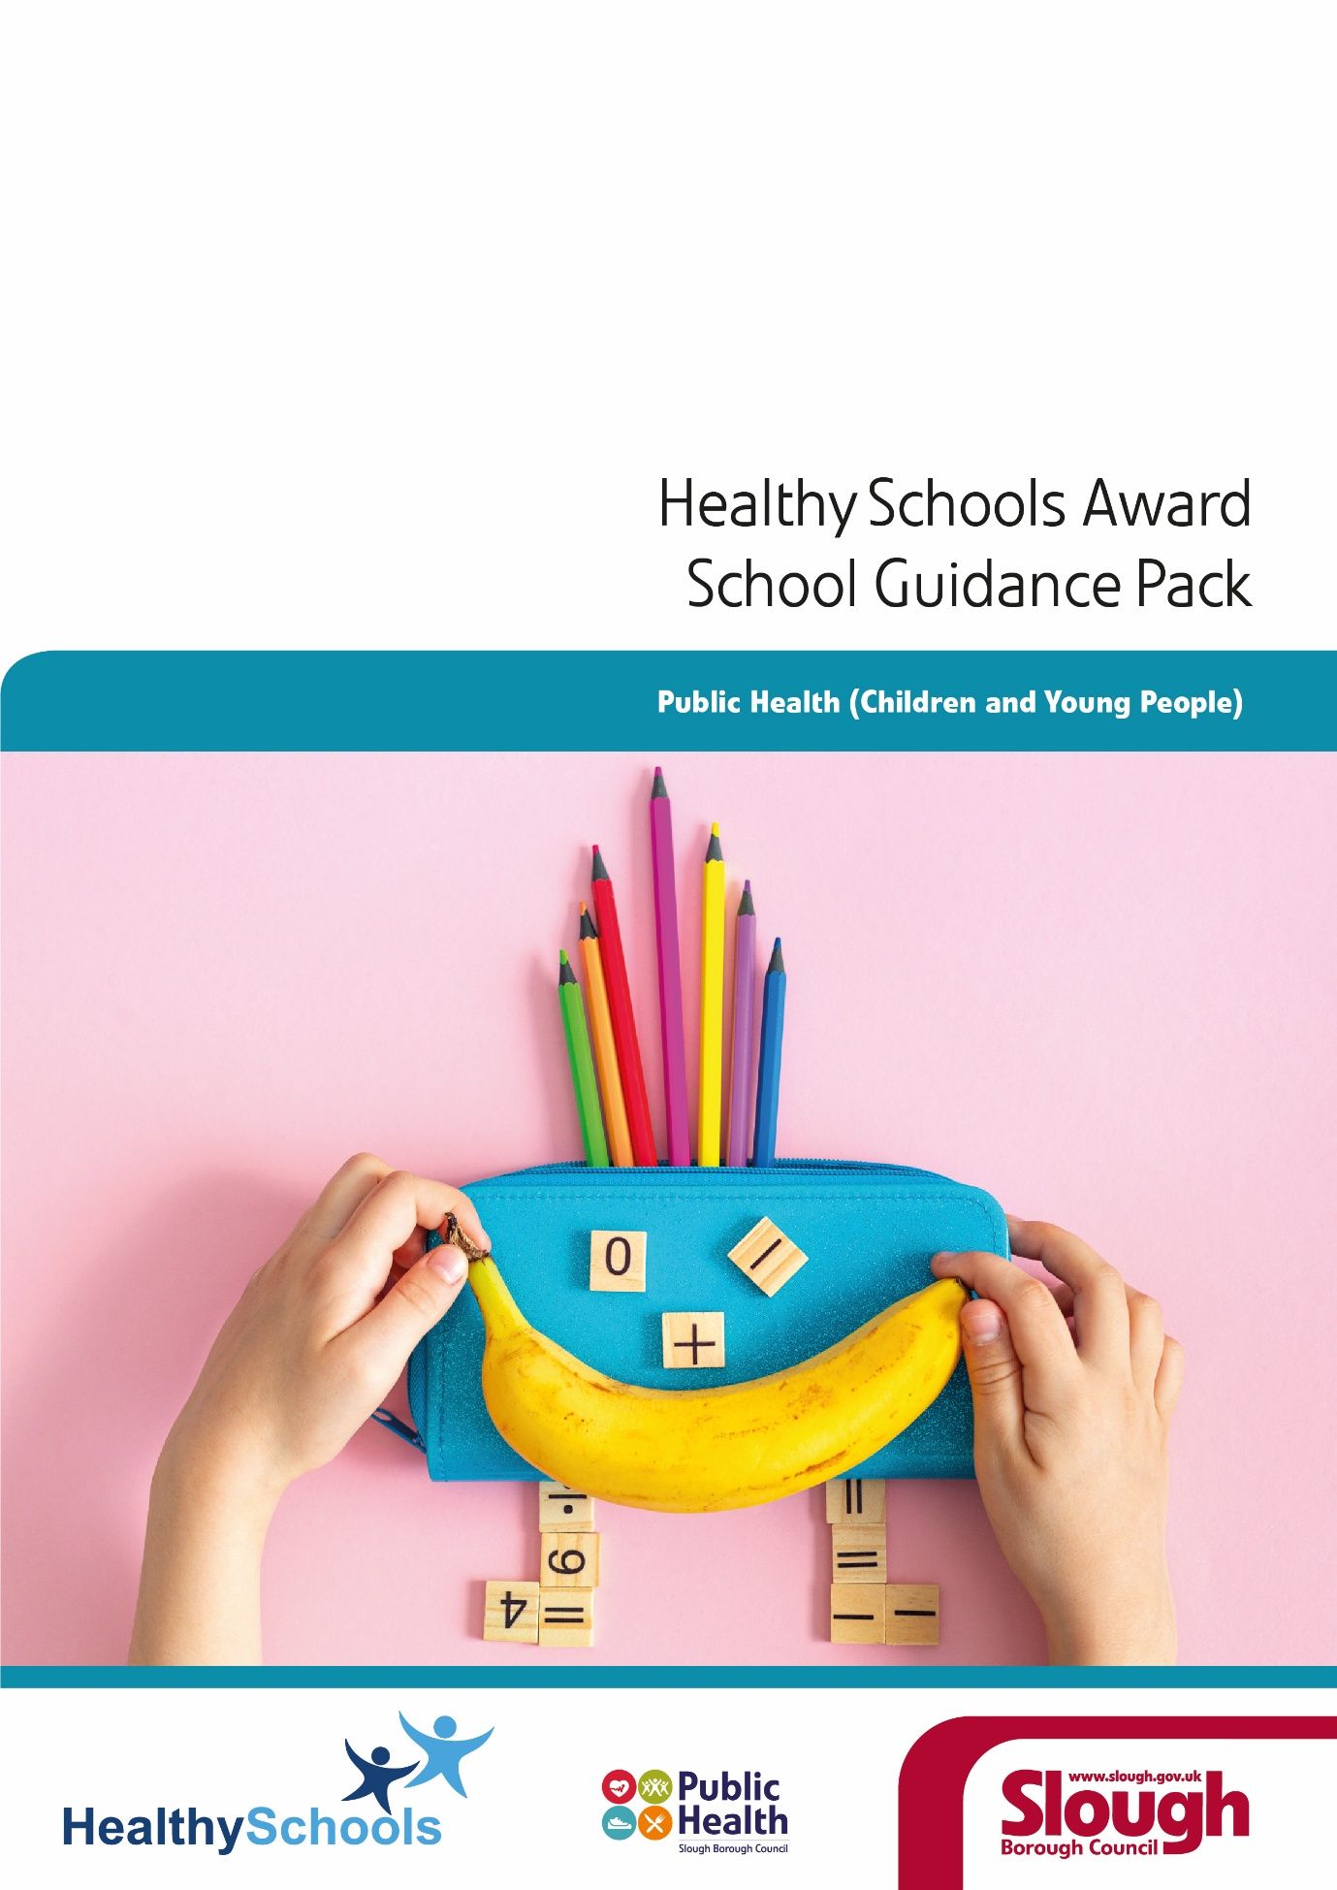
Welcome Pack
Thank you for registering your interest in Slough Healthy Schools Award (HSA) Programme.
This document provides background on the Healthy Schools Award (HSA) and offers guidance to help you on your journey to achieve Healthy Schools Status.
We hope you find the process rewarding and that the award not only highlights the excellent work you are already doing to support children’s health and wellbeing but also strengthens your practice in preparation for future Ofsted inspections

Contents
Introduction and Healthy Schools…………………………………………………Pg 3
Healthy Schools Programme……………………………………….....................Pg 4
Healthy Schools Award …………………… ……………………………………...Pg 5
What is the process?........................................................................................Pg 7
Working through and completing the school health check...............................Pg 8
Action Plan for further development………………………………………………Pg 9
Submission and Celebrating Success…..........................................................Pg 10

Introduction
Good mental and physical health are essential for children and young people to flourish, both in school and beyond. Wellbeing plays a central role in pupils’ happiness, confidence and ability to learn.
Research shows that when schools are supported and services work together effectively, outcomes improve. Strong partnerships help pupils feel supported, achieve more and develop the skills they need to thrive.
By strengthening emotional, mental and physical wellbeing, we can improve long-term health, reduce inequalities and promote inclusion, benefiting pupils, families and the wider community. Slough Healthy Schools approach can significantly impact upon reducing inequalities and ensure increasingly positive outcomes for children, young people and the wider school community.
Healthy Schools
Healthy Schools supports schools to take a whole-school approach to promoting physical, emotional and mental wellbeing. It reflects a commitment to personal, social and health development and recognises the link between wellbeing, behaviour and achievement across all aspects of school life.
Slough Healthy Schools approach provides a collaborative framework for promoting the health and wellbeing of children and young people, supporting schools while connecting them with county-wide services and partners. It supports schools in accessing resources, fostering partnerships, and improving outcomes, so that every child can thrive and inequalities are reduced.
Our approach supports Slough Borough Council’s Corporate Plan 2023-2027; [1] Corporate plan – Slough Borough Council and its strategic objectives including the Slough Places Strategy 2022-2027; [2] School Places Strategy 2023-27, Slough Wellbeing Strategy; [3] Slough Wellbeing Strategy 2021-2026, SEND and Inclusion Strategy; [4] SEND and Inclusion Strategy and Early Help Partnership Strategy; [5] Strengthening Families; Strengthening Communities; Slough Early Help Partnership strategy 2023-2025
Slough Healthy Schools is underpinned by an evidence-based framework that supports a whole-school approach to wellbeing and implementation and continuous development of effective practice.
The Healthy Schools self-evaluation tool ‘School Health Check’ provides a clear framework for reviewing and improving provision across personal development, behaviour, teaching and learning, and leadership and management, aligned with the Ofsted Inspection Framework, and Slough Borough Council’s Health and Wellbeing Strategy.

The Healthy Schools Programme
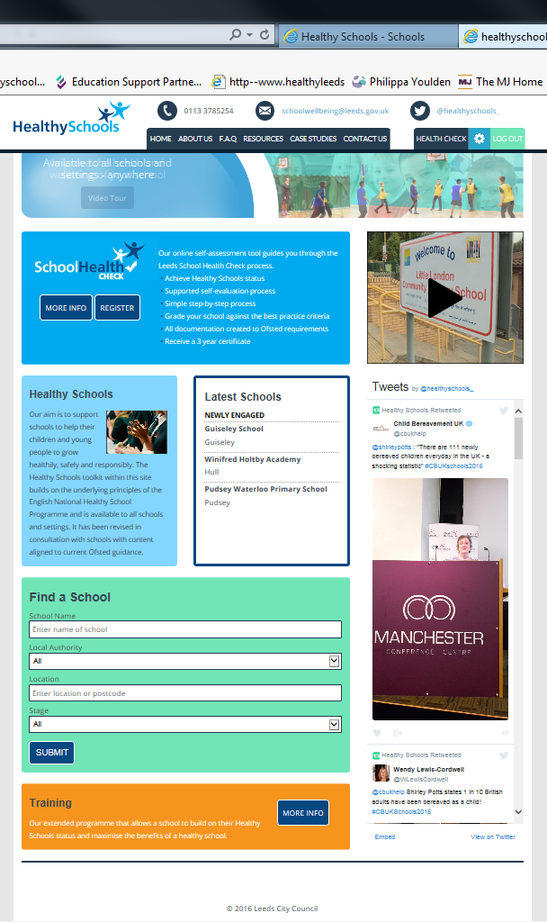
The Healthy Schools Programme supports schools and settings to achieve Healthy Schools status using an online ‘School Health Check’.
The Healthy School website The Healthy Schools website:
- Provides an online self-evaluation tool to support schools to gain and maintain healthy schools status
- Facilitates a whole school approach
- Builds on the underlying principles of the English National Healthy Schools Programme and is available to all schools and settings
- Has been created and revised in consultation with schools and content aligned to current national guidance and health and wellbeing best practice.
Schools can:
- Self-evaluate and plan across 4 key health themes (PSHE, School Food, Healthy Lifestyles and Social, Emotional & Mental Health).
- Identify strengths and areas for development using grade descriptors and the latest national guidance.
- Use the tool to work towards self-validated status in key areas: PSHE Friendly, School Food Friendly, Healthy Lifestyles Friendly and Hearts and Minds/MindMate Friendly.
- Achieve full Healthy Schools self-validation status by completing all four strands and receive a certificate and official logo in recognition of your status.

Healthy Schools Award
The Healthy Schools Award is part of the ongoing work of Slough Public Health team to support high-quality PSHE, Personal Development, statutory Health, and Relationships/RSE education and to improve health outcomes for children and young people.
The Healthy Schools Award and the support provided by the Slough Public Health CYP team will enable schools to evaluate and strengthen good practices and improve the health and wellbeing of children and young people.
Our approach includes providing advice, guidance, signposting to high-quality resources and services, CPD, collaborative working, sharing good practices, support with compliance with statutory duties, and funding targeted initiatives for children and young people.
Who is eligible to take part in the Healthy Schools Award?
All state-funded schools in Slough can achieve Slough Healthy School status by completing the research-backed, national and internationally used School Health Check.
The School Health Check is free to all non-fee-paying schools in Slough. This framework helps your school in developing Slough Healthy Schools approach.
How can schools get involved?
The School Health Check is an online toolkit to help schools self-validate against the 4 core health themes of Healthy Schools:
- Personal, Social, Health and Economic (PSHE) Education
- School Food
- Healthy Lifestyles
- Social, Emotional and Mental Health (SEMH).

Each theme is linked to 10 strands identified in the whole-school approach.
Leadership | Policy
Curriculum | Teaching and Learning
Assessment | Pupil Voice
Support Services | Professional Development
Partnership | School Ethos
- Each key strand has descriptors (aligned to Ofsted descriptors).
- Schools can use the tool to identify and celebrate strengths and areas in need of development. From this, schools can identify clear next steps which are automatically put into an online action plan.
Key benefits to schools:
- Achieve Healthy Schools Status
- Follow a step-by-step, supported evaluation
- Benchmark against best-practice criteria
- Align with Ofsted and 2025 statutory RSE & Health Education guidance
- Developed with a Trauma-Informed Approach
- Receive a certificate and logo valid for three years
‘The Healthy Schools Programme helped us to focus on priorities and identify next steps. It is a valuable program.’ (Teacher, Leeds 2025)
“An intuitive and sensible system… ‘refreshing’ to see something that makes sense for teachers!” (Teacher, Bradford 2022)

What is the process?
Outlined below are the steps you will need to take over the coming months to achieve the Healthy Schools Status.
Phase 1
Getting started:
- Nominate a lead staff member We strongly recommend appointing a Healthy Schools Coordinator to lead and coordinate the implementation process within your school.
- TheLink Registration It is highly recommended that schools create an account on The Link. It will serve as the main hub for communications, information, and support related to the Slough Healthy Schools Award. It will provide access to high-quality resources, examples of best practice in school health and wellbeing initiatives, and signposting to key services. If you are not already registered on The Link, please register using this link Log in | The Link
- Queries In the interim, if you have any questions on Healthy Schools or require further clarifications, please email PublicHealthSlough@slough.gov.uk. You can also visit the FAQs page Frequently Asked Questions | Healthy Schools
Next steps:
- Healthy Schools School Health Check Registration You will receive an email when registration goes ‘live’ in January 2026. Follow Registration Page. It takes you to the page where you complete all fields. As a school in Slough, you just need to add in your Local Authority in the Billing details to gain access to all four themes.
- Training All schools working towards achieving Healthy Schools Status are required to attend a training session and FAQs briefing to support the development of their Healthy Schools approach. Training sessions will be available to book via The Link. Schools that have expressed an early interest will also receive an email reminder to book their session.
- Confirmation Once you complete your registration, on the Registration Page, you will receive an email confirmation that your school registration has been approved and access to the School Health Check has been granted. Please allow 5-10 working days before contacting the Health and Wellbeing Service, Leeds City Council via phone number 0113 3785254 or email schoolwellbeing@leeds.gov.uk or Contact Us | Healthy Schools

Phase 2
Working through and completing the School Health Check:

- Log into the portal After gaining access, log in to the School Health Check (Overview Page) to view the four health themes.
- Theme Leaders Assign a leader for each health theme (e.g., subject leaders). Provide their email address to complete this step.
Please note: It is best practice for individual sections to be completed in partnership and collaboration with the most appropriate coordinator/person/people for each theme.
For example, the physical activity lead/coordinator may complete the physical activity section, in order to adopt a whole school approach. These groups may also include pupils, parents and governors, where appropriate.
- Audit the Themes Each theme includes ten strands, covering areas such as Leadership, Policy, Curriculum and Pupil Voice. Grade each strand using a "best fit" approach using the drop-down menu at the bottom of the page and click save.
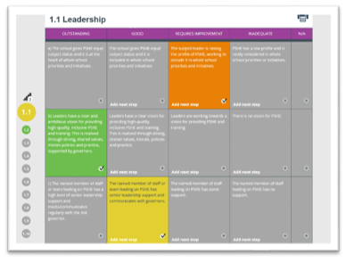
- Within each strand there are a number of statements that schools use to assess their practice using grade descriptors ranging from ‘Outstanding’ to ‘Inadequate’.
- For each row of grade descriptors schools adopt a ‘best fit’ approach using their judgement to choose the statement that best describes their school.
- To do this simply ‘click ’on the small circle in the bottom right of the chosen box that best suits your school. The box changes colour automatically, and a tick appears. (Schools can go back in and change this at any time).
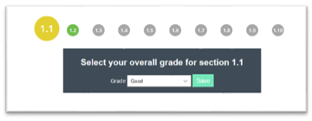
- If schools do not feel that a criteria row is relevant for their setting, they can use the not applicable (N/A) box, but they must ensure they add an explanation why.
- At the end of each strand the school is asked to select an overall judgement; each row needs to be graded otherwise they will not be able to grade the strand at the bottom of the page.
Phase 3
Action Plan for further development:
- Use the "Next Steps" tool to record actions for improvement and assign responsibilities.
- Once you have graded all ten strands, go to the summary page and select an Overall grade using the drop-down menu under the theme heading.
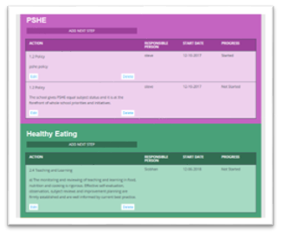
- Any criteria that judged to be ‘Requiring improvement’ or ‘Inadequate’ will pull through into a separate document page which helps schools to identify their ‘next steps’ for their action plan.
- When deciding on a grade for each row, however, the school may decide they want to improve on what they have chosen in the future so these can also be put into the action plan by clicking ‘add next step’.
- To encourage schools to continue to seek ways to improve and embed good practices, schools must add at least one next step to each theme before submitting their action plan. The action plan states the strand, the action, responsible person, start date and progress.
- As schools are prompted to add at least one next step to each theme in their action plan prior to submitting their Health Check to achieve self-validation they are automatically encouraged to review their audit and actions plans on a regular basis.

Phase 4
Submission:
We recommend a school only submits for self-validation where the majority of the 40 strands are selected overall to be at least ‘good’.
If the school has graded any of the 10 strands within a theme as ‘Inadequate’, they will be unable to submit that theme and unable to self-validate.
Before you submit a theme ensure that you have:
- Selected a grade for every criteria row within a strand.
- Selected a grade for each of the ten strands within a theme.
- Ensure all 10 strands across the theme are graded better than Urgent Improvement.
- Selected a grade for the theme of better than Urgent Improvement.
- Added a Leader for each theme along with an email.
- Added at least one Next Step for each theme.
- Added a Next Step for any criteria graded as Urgent Improvement.
- Added a Note for any criteria row graded as Not Applicable.

Gaining the Healthy School Status
- After all four themes are successfully submitted and reviewed, schools achieve self-validated Healthy School Status, which is valid for three years.
- A certificate and logo will be emailed to the main contact. They are also saved in the Documents page.
- On the Documents page a copy of the Overview page and the Submit Page are also saved here as a baseline

Celebrating and sharing success of Healthy School Status
When your school successfully develops a Healthy Schools approach, it is important to celebrate and share your achievements. Let others know about your good news, the hard work involved, and the positive impact of your practice.
How you choose to do this is up to you. However, you may wish to consider the following options:
- Display your Healthy Schools certificate in a prominent location within the school
- Add the Healthy Schools logo to your stationery, website, and prospectus
- Create a dedicated Healthy Schools section on your school website
- Include your work and achievements in school newsletters and other communications
- Promote your success through your school social media accounts
- Share effective practice and learning with other schools
- Create a Healthy Schools display or noticeboard
- Issue a press release to local media outlets
- Explore other creative ways to showcase your work and promote positive health, wellbeing, and achievement

Maintaining a Slough Healthy Schools Approach
After 3 years your Slough Healthy Schools approach can be maintained by:
- ensuring that the self-evaluation tool is up to date
- ensuring that it meets the above requirements
- informing the Slough Public Health team that process is complete and has been updated as appropriate during the subsequent 3 years by emailing PublicHealthSlough@slough.gov.uk

